Bee-Bot Belt Directions
  - Muteb Alqahtani and Jacob A. Hall, State University of New York College at Cortland

Printing the Bee-Bot Belt
If you plan to print the Bee-Bot belt without making any changes, please follow the instructions below.
- Identify the file extensions which can be used by your 3-D printer. The file extensions included with this manuscript are .stl and .obj.
- Download the Bee-Bot Belt file.
- Send the file to the 3-D printer.
  - This process can vary based on your 3-D printer model, setup configuraitons, or your institution’s policies. For example, we cannot send files directly to a 3-D printer at our institution. Instead, we complete a form about the requested file to be printed, upload an .stl file with the form, and submit them for review by staff who will operate the 3-D printer.
- Print the file.

Revising the Bee-Bot Belt
If belt modification is needed, the following steps outline how to use the Tinkercad program to adapt this accessory. The scope of this manuscript does not encompass the knowledge and skills needed to work in Tinkercad, but we encourage new users to explore Tinkercad’s series of free, hands-on, scaffolded tutorials.
- Download the Bee-Bot Belt file. Either of the two file extensions will work.
- In your browser, navigate to the Tinkercad website.
- Login or sign up for a Tinkercad account.
- Click on the New button in the upper right corner of the screen. A menu will drop down.
- In this dropdown menu, click on the 3D Design option (see Figure 1).
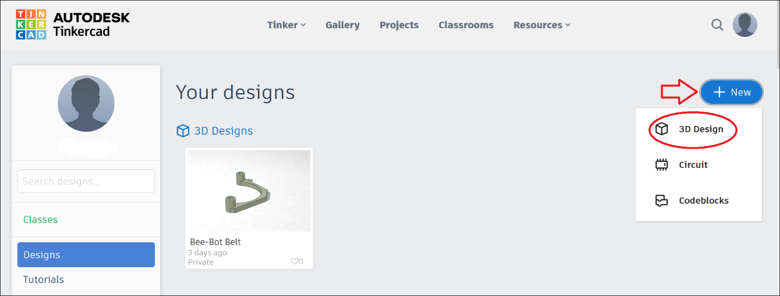
Figure 1. Screenshot of the Tinkercad interface.

The screen should now display a blank work plane (see Figure 2).
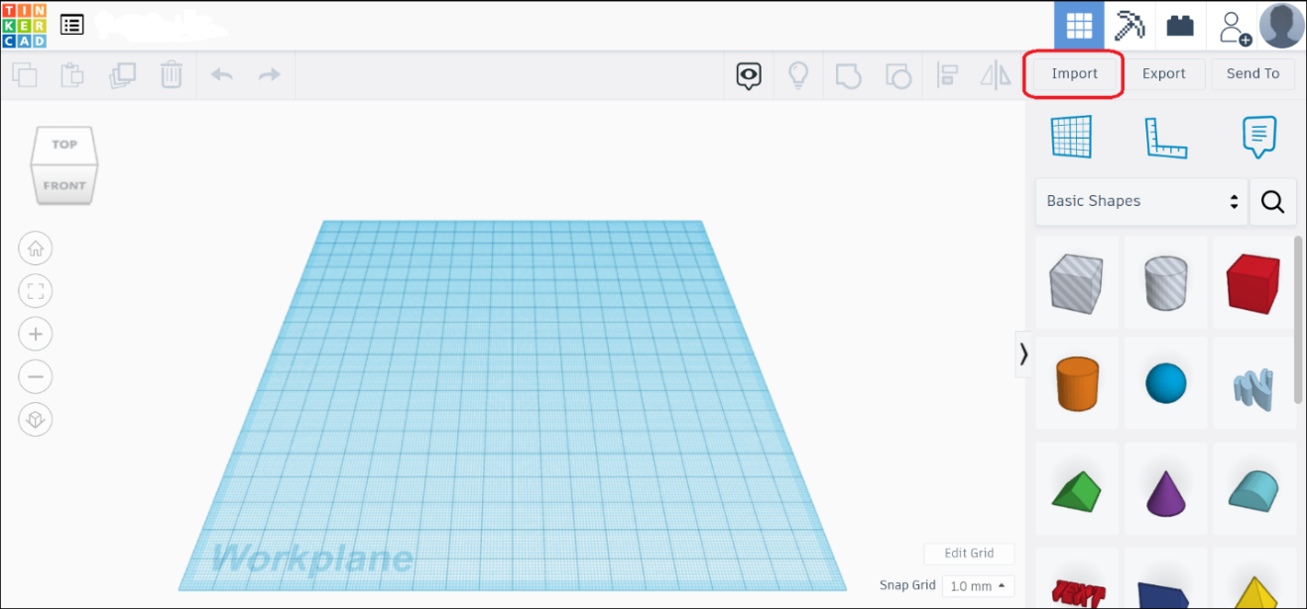
Figure 2. Screenshot of Tinkercad workplane with the Import button highlighted.
- In the upper right corner of the screen, click on the Import button (see Figure 2).
- Upload the Bee-Bot file which was previously downloaded (see step 1).
- Begin tinkering with the file after it has been imported. Once ready to print, please refer to the above steps for printing.

Prepping the Belt and the Bee-Bot
After printing the Bee-Bot belts, refer to these instructions to securely fasten them to the robots.
- Place a hook and loop self-adhesive dot on the robot’s plastic casing directly above each wheel (see Figure 3).
- Place the corresponding hook and loop self-adhesive dot inside each end of the belt. The adhesive dot should wrap around the curved portion of the belt that holds the marker.
- Check the belt for proper fit. The back of the belt should rest on the back end of the Bee-Bot. If properly attached, the hook and look adhesive should hold the belt securely enough for a child to pick the robot up by grabbing the belt. Since learners will try to pick the robot up this way, it is important to ensure a good fit. Securing the Bee-Bot accessory now will reduce implementation interventions to adjust/reattach a belt.
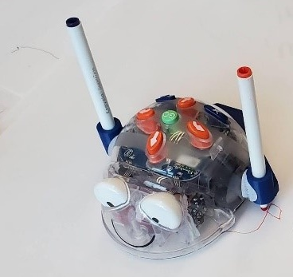
Figure 3 Blue-Bot with belt attachment.

