Micro:bit Hero: Using MakeCode to
Replicate Popular Songs
  - Brian T. Johnson, Lakeside Jr. High, Springdale Public Schools, Arkansas

Overview
This lesson begins by introducing how to program the Micro:bit using block code to play music using the piano keyboard embedded in the music section of Micro:bit MakeCode. In this lesson, students explore making music using this feature and learn how to program the Micro:bit using MakeCode to incorporate rests and different notes (quarter, half, and full) to replicate nursery rhymes or popular songs. The lesson concludes with a discussion of the challenges and limitations of coding the Micro:bit to play music. Students shared their musical creations with peers through a “Name that Tune” game where they attempted to guess which popular song or nursery rhyme their peers replicated in MakeCode.
Topics: Block Coding, Music, Computational Thinking, Rest, Notes (quarter, half and whole)
Time: 30-45 minutes

Materials
- Micro:bit Version 1.0 or 2.0 microcontrollers (1 per student)
- LCD Projector/Television
- Computer with internet (for presenter)
- Headphones for each student (with Micro:Bit 1.0)
- Student computers or smartphones
- MakeCode (website or app)
- Microbit-MHALL-Code.hex file
- Guess the 100 Songs (name that tune; PianoMan333, 2021)
- Twinkle Twinkle Little Star (Kids Nursery Rhymes Easy Piano, 2016)
- Europe–The Final Countdown (PHianonize, 2020)
- Easy Piano Songs for Beginners YouTube Search
- Micro:bit Hero Facilitator Presentation

Context at a Glance
Setting
Students at a U.S., suburban, public junior high.
Modality
Face-to-face delivery
Class Structure
This lesson is one in a series of student-selected Makerspace activities offered during the Enrichment class period in the school library makerspace. It is available to all students who are not summoned by another teacher for remedial instruction.
Organization Norms
This activity is one of several elective sessions offered during the school year. In sessions, students complete ungraded hands-on, inquiry-based learning activities such as crafting and engineering. Students are generally familiar with inquiry processes.
Learner Characteristics
15-20, 8th-9th grade students who selected this course from a list of alternatives.
Instructor Characteristics
One librarian taught this course. Previously he provided makerspace elective activities. He was familiar with the technology and has led professional development for teachers on using the Micro:bit.
Development Rationale
The instructor leveraged students’ interest in Guitar Hero to create music through coding the Micro:bit.
Design Framework
Gagne’s Events of Instruction
Inquiry Question
What are the best ways to recreate popular music with Micro:bit MakeCode?

Setup
Prior to the start of instruction, set up a flat space where students can construct code on their computers/tablets to play music with the Micro:bit microcontrollers. Ensure the flat space is in view of the presenter’s screen. Create Micro:bit kits for each student in a Ziploc bag. Include a Micro:bit, a USB mini connector cable, battery pack, and 2 AAA batteries in each kit (make sure the AAA batteries are disconnected from the battery pack prior to instruction). Include access to optional headphones so that students can test their musical creations individually prior to sharing them with their peers during the Name That Tune activity. Access and display the JTILT-Microbit Hero Music Facilitator Presentation (Johnson, 2022). Set up should take approximately 15 minutes.

Standards
The International Society for Technology in Education (ISTE; 2017) Standards for Educators 2.1.a, 2.5.a, 2.5.b, 2.5.c, 2.6.a, 2.6.b, and 2.6.d were used for this lesson.

Context and Setting
This lesson was developed as a part of an ongoing elective option available to all students in 8th and 9th grades at a large, suburban public school in the South Central region of the United States. The class was delivered in a makerspace room in a school library. This space also houses a variety of curricular materials for students and teacher use. The makerspace houses a variety of STEM materials including Makey Makey devices, Finch Robots, littleBits, Legos, as well as crafting and building materials.
This class was provided during an elective period offered four out of five days each week of school as an enrichment activity. Students are summoned by teachers for additional remedial instruction, or, if they are not summoned, they select an enrichment session during this period. Activities completed during this enrichment class period are not graded. Students are expected to attend and participate in sessions they select. The library has provided this type of enrichment instruction for several years, so most students are familiar with this type of informal, inquiry-based instruction. Classes typically have 15-20 students. Student participants are not required to have previous experiences coding. Some students have completed previous enrichment activities with the librarian.
It was delivered in a face-to-face setting within a multi-use library that included two stationary computer labs, various worktables, a seated group discussion area, and a makerspace room. It was taught by a school librarian who had previous experience leading students in block coding activities and has presented several professional development sessions to K-12 teachers on how to employ block coding techniques in their classroom instruction.
Each session utilized an informal inquiry-based instructional approach. Sessions are focused on students developing solutions to inquiry-based problems. Sessions included an opening instructional input followed by time for students to implement/practice new learning and iterate their designs to explore and develop answers to the session’s inquiry question.

Learning Representation

Gain Attention (3 min.)
Ask learners if they have ever played the video game Guitar Hero. Survey if students have experience playing the piano or reading music. Play a round of “Name that Tune” with students using the Microbit HEX code file to guess the nursery rhyme being played using Micro:bit MakeCode (see Figure 1 Mary Had a Little Lamb Code). The Microbit HEX code file needs to be uploaded into the MakeCode website. View a video tutorial on how to upload the file into the MakeCode website (Reid, 2020).

Inform Learners of Objectives
Objectives for this lesson are:
- Use a Micro:bit to play music with rests and single, half and quarter notes.
- Create a nursery rhyme tune using Micro:bit MakeCode.
- Use MakeCode and Easy Piano Songs for Beginners on YouTube to replicate popular songs with the Micro:bit.
- Play Name That Tune with MakeCode creations.
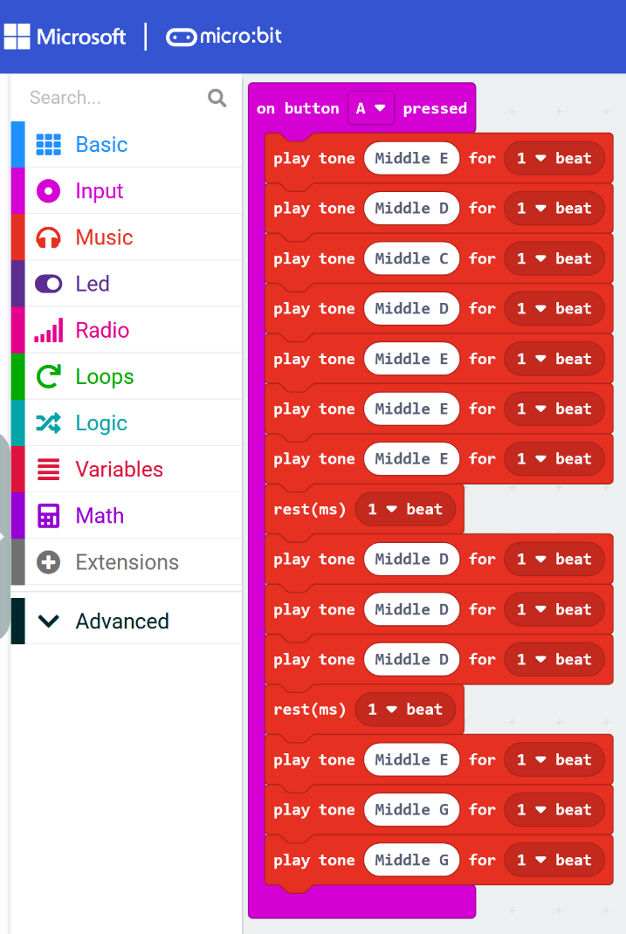
Figure 1. Screenshot of Mary Had a Little Lamb code.

Stimulate Recall of Prior Learning
During this lesson, italic text identifies questions or prompts for the learners.
Remind the learners of their past experiences with music courses either in elementary school or currently through orchestra, choir, or band classes.
Ask learners: What is rhythm?
Ask learners: What is a rest?
Verbally reference the role of counting of notes into rhythm (whole, half, and quarter notes) and rests. Practice this skill by clapping out the rhythms of one of the familiar nursery rhyme songs (such as Mary Had a Little Lamb) on screen to illustrate this.

Present the Content
Demonstrate for students on the large screen how to access the MakeCode website and share the link with the students on the large screen (www.microbit.org/makecode).

Provide Learner Guidance
Once all students have accessed the Micro:bit website, model for them how to delete, locate and add various blocks needed to create Micro:bit music on the large screen. Demonstrate how to find the notes on the piano and how to match them up with the notes of the musical notations from the Choose Piano Lessons website (Singh, 2011).

Elicit Performance (Practice)
Students then will vote on which of the nursery rhyme songs they wish to practice creating as a group. They will apply their learning of using the MakeCode website to create the nursery rhyme song the group selected through writing a program for their Micro:bit. Pass out the headphones to students prior to their practice performances. The sample code for the practice song should be posted on the large screen for students to implement their practice.

Feedback and Challenge
When learners have created the nursery rhyme tune, have them unplug the headphones and share their creations with the group. Ensure that all students have written their code correctly and included the correct notes to successfully create the song. Provide opportunities for both peer and instructor feedback to students on their creations including their use of rhythms and rests in their code. Ask students what the challenges and successes were that they experienced in this practice activity.
Challenge students to search YouTube for “Easy Piano Tunes“ to find a popular song and recreate it to apply their skills creating music including the proper rhythms and rests using Micro:bit MakeCode (see Easy Piano Songs for Beginners YouTube search).
Show students the sample version of The Final Countdown (https://www.youtube.com/watch?v=1_k-C9nxsiM) and reference the similarities between the YouTube video and the video game Guitar Hero noting that the longer the notes play, the longer the colored lines will be on the screen (see Figure 2). Remind students to adjust their code so that it accurately reflects the actual notes (whole, half, and quarter), rhythms and rests in the popular song they selected (see Figures 3 and 4). Remind them that their creations will be featured in a Name That Tune contest where they will be sharing their recreations of popular songs with their peers. Suggest to students that they may plug their headphones back in as they are testing/perfecting their creations.
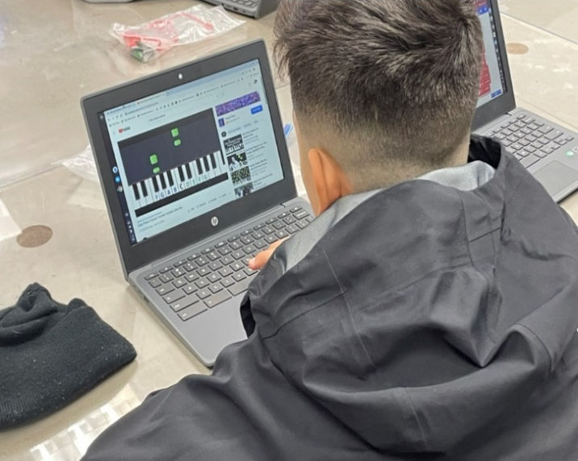
Figure 2. Easy piano code on YouTube.
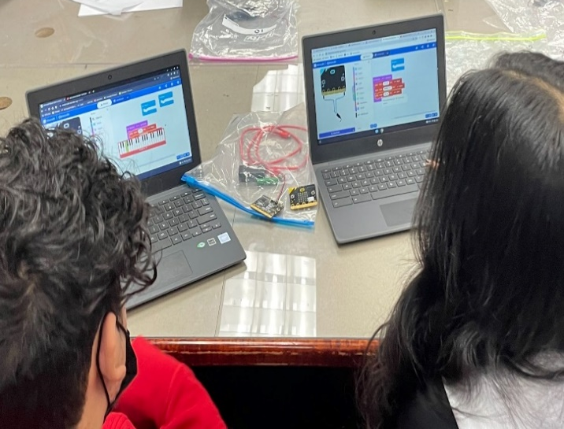
Figure 3. Micro:bit MakeCode piano function.
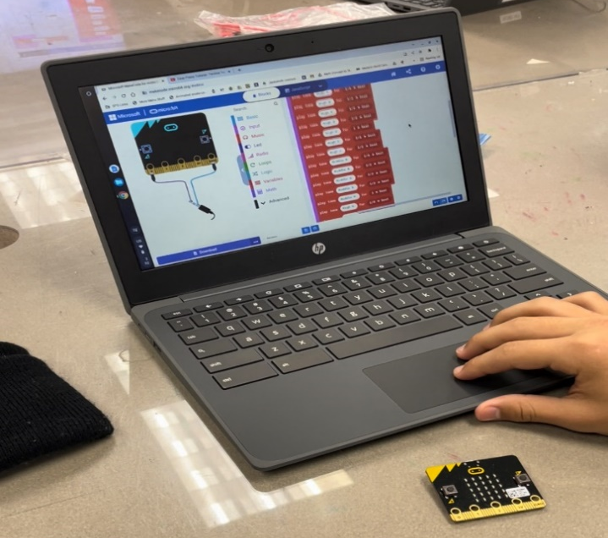
Figure 4. Micro:bit MakeCode sample.

Assess Performance
This activity will be informally evaluated through a performance assessment. To assess student performance, the instructor and student peers will listen to student creations using the Micro:bit MakeCode website to replicate music found on YouTube through searching for Easy Piano creations.
Students can also complete extension activities where they code other popular songs in MakeCode or code the Micro:bit so its 25 LED lights change as musical notes are played (see Figure 5).
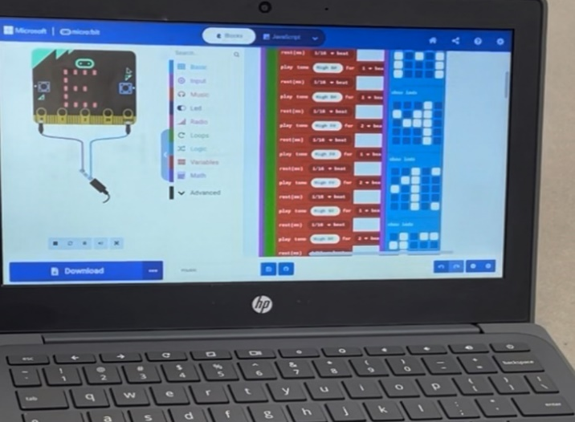
Figure 5. Micro:bit Hero: MakeCode Minecraft theme with accompanying lights.
An example project with LED lights can be seen in the JTILT Micro:Bit Hero Minecraft MakeCode Theme video (Johnson, 2022).

Grading Criteria
Although this activity was not graded during implementation, grading criteria could include:
- Learner was able to code a version of a nursery rhyme song including the appropriate rhythms, notes and rests using Micro:bit MakeCode.
- Learner was able to replicate a popular song using Micro:bit MakeCode.
- Learner was able to listen and identify the popular song(s) created by their peers using Micro:bit MakeCode.

Enhance Retention and Transfer
Complete the lesson with reflection questions either through a whole group discussion, an exit ticket, or through an online discussion board such as Padlet . Prompts could include:
- In this activity, it was difficult to …
- In this activity, my greatest success was…
- A tip or trick that helped me today was…
- It was fun to …
- One limitation of today’s activity was…

Critical Reflection
This lesson has been implemented multiple times in the library makerspace setting described above as well as with a junior high school choir class. With each implementation, the content of the lesson was adjusted slightly. In each session, students quickly learned how to use Micro:bit MakeCode to create sounds. They were also able to successfully incorporate rests and different lengths of notes into the songs that they were coding.
In the initial implementation of this lesson, students were asked to locate and code the song The Final Countdown after seeing it coded with the Micro:bit piano function of MakeCode by the instructor. This was less successful due to the degree of difficulty completing this activity and the lack of scaffolding.
Later iterations of this lesson that included the scaffolded nursery rhyme creation first were more successful as students gained confidence writing block code. Students’ increased success coding the nursery rhyme songs could be attributed to the names of the actual notes appearing above the song’s words themselves. Incorporating choice into the lesson through letting students vote on the nursery rhyme to recreate with MakeCode also improved student motivation for the activity.
As students developed their block coding skills, they were often self-conscious about sharing their progress with their peers. Providing headphones in later lesson implementations for students to use as they practiced coding the nursery rhymes and popular songs helped to overcome this barrier. When students had access to headphones to practice and perfect their code, student confidence increased, and the quality of their coded songs improved.
Searching YouTube for Easy Piano also led to additional challenges. Some students were distracted by the search that led them to a piano that they could play on screen without writing MakeCode for a popular song. Although providing students options to choose an Easy Piano song increased motivation, to avoid the distraction of such a broad search, curating and sharing links to specific songs or playlists of Easy Piano songs (e.g., https://youtu.be/DCUAZfwydqo) is recommended.
Employing MakeCode to write block code versions of popular songs also has limitations. First, the keyboard on the MakeCode website is limited to approximately 40 keys near the middle of the piano keyboard instead of 88 on a traditional piano, making it difficult for students to play songs that feature notes far above and below middle C. MakeCode will allow for higher/lower notes to be played if students enter higher numbers into the code-but students cannot see the note name in these areas of the keyboard.
The MakeCode keyboard also shows the sharps (such as A-sharp- A#) but does not enumerate flats (such as B-flat) on the keyboard which can lead to student confusion. This conclusion aligns with the previous findings of Cederqvist (2019) that students may struggle to link abstract concepts (such as flats and sharps) that are connected to the coding materials. Finally, MakeCode currently does not allow for chords to be played, only single notes limiting students’ choices of songs to recreate.
Future iterations of this activity may include incorporating the Micro:bit 2.0. This would change the implementation so that students did not have to keep the Micro:bit plugged into their computer throughout the coding activity to play their songs since the 2.0 version has its own speaker. Employing the Micro:bit 2.0 would also allow for the Name that Tune activity to be set up in stations around the room for each song as a gallery walk activity instead of having students play the Micro:bit songs directly from their computer’s speakers. In a possible future extension activity, students who master coding music in MakeCode could recreate songs in Python code instead.

References
Cederqvist, A.-M. (2019). Pupils’ ways of understanding programmed technological solutions when analyzing structure and function. Education and Information Technologies, 25, 1039-1065. https://doi.org/10.1007/s10639-019-10006-4
International Society for Technology in Education. (2017). ISTE Standards: Educators. Retrieved July 1, 2022, from https://www.iste.org/standards/iste-standards-for-teachers
Johnson, B. T. (2022, March 22). JTILT-microbit hero music [Microsoft PowerPoint]. https://journals.uwyo.edu/index.php/jtilt/article/view/7057/5855
Johnson, B. T. (2022, March 30). JTILT Micro:Bit hero Minecraft MakeCode theme [Video]. YouTube. https://youtu.be/EQVjwiDsSzs
Kids Nursery Rhymes Easy Piano. (2016, February 3). Twinkle Twinkle Little Star | Nursery rhymes collection | piano. [Video]. YouTube. https://youtu.be/DCUAZfwydqo
PHianonize. (2020, August 31). Europe - The Final Countdown | Easy piano tutorial [Video]. YouTube. https://www.youtube.com/watch?v=1_k-C9nxsiM
PIanoMan333. (2021, December 10). Guess the 100 songs on piano! 100K subscriber special (games, movies, classical, and more!) [Video]. YouTube. https://youtu.be/e5sz3wvjWus
Reid, S. (2020, January 8). Importing files in MakeCode [Video]. YouTube. https://www.youtube.com/watch?v=zCW1wuwfIp4
Singh, C. (2011). Simple kids songs for beginner piano players. Choose Piano-Lessons.com. https://www.choose-piano-lessons.com/kids-songs.html

About the Author
Brian T. Johnson is a School Library Media Specialist at Lakeside Junior High School in Northwest Arkansas by day. At night, he serves as an adjunct professor for the University of Memphis in the Instruction and Curriculum Leadership department and in the Online Teaching Academy program at the University of Central Arkansas. His research interests include information literacy, coding in K-12 education, makerspace environments, successful technology implementations, professional development for adult learners, and flipped learning. He can be contacted about this lesson at b.t.johnson16@gmail.com .

