# Maker Activities and Academic Writing in A Middle School Science Class

By Ashley Stewart1 and Jiangmei Yuan2  
1University of Pittsburgh, 2West Virginia University

## Overview

Academic language is an important focus area in middle school. However, academic writing in science classes is challenging for middle school students. Maker activities can contribute to students’ academic language development through artifact creation with tangible resources (Own, 2018). This makerspace and academic writing project, codesigned by a science teacher and a technology integration specialist, invited middle school science students to work on academic writing through maker activities.

Topics: Maker Activities, Academic Language, Science Learning

Time: In-class time took a total of six, 50-minute sessions. Outside-class time took ~2.5 hours and included pre-writing before class activities and revisions after class activities.

### Materials

* Student devices (e.g., cell phones, tablets) to take pictures of content vocabulary representations.
* A Computer for the technology integration specialist to upload student pictures to a website.
* Student Chromebooks to type/revise writing.
* Makerspace materials (e.g., Cricut, fabric, sewing machine, circuitry kits, clay, paper, glue, markers).
* [8th-grade science core-content vocabulary words](https://www.sealyisd.com/common/pages/DisplayFile.aspx?itemId=2339209) (Sealy Independent School District, n.d.).
* [Academic vocabulary slides](https://docs.google.com/presentation/d/1BoIqEtjT2r7OqegQpkJwuxn2TXdItnp96Vvpy4sKyj4/edit?usp=sharing)
* Laminated evolution paragraph poster with colloquial expressions (see Poster Text section).
* [Discourse and explicit marker List](https://www.myenglishteacher.eu/blog/list-of-sentence-connectors-in-english/) (Makkos, 2018)
* [Blocks with phrases/sentences](https://journals.uwyo.edu/index.php/jtilt/article/view/6869/5871) (e.g., expanded noun phrases, non-restrictive relative clauses).
* [Grading Rubric](https://journals.uwyo.edu/index.php/jtilt/article/view/6869/5873)
* [Makerspace Activity Directions Document](https://journals.uwyo.edu/index.php/jtilt/article/view/6869/5869).

Context at a Glance

**Setting**Eighth-grade science class in the United States.

**Modality**Face-to-face

**Class Structure**Students did pre-writing individually outside of the class. In class, students worked in groups on each of the six maker activities. These were followed by writing revisions where students worked individually to complete final drafts for each activity.

**Organizational Norms**The Makerspace and Academic Writing Project was implemented before the outbreak of the COVID-19 pandemic. Students were able to attend classes in person.

**Learner Characteristics**Learners were 32 eighth-grade students in the Appalachian region of the United States.

**Instructor Characteristics**The project was codesigned by the regular science teacher and the technology integration specialist working for the middle school.

**Development Rationale**Academic language is important in education. Through constructionism, Own (2018) maintains that maker activities have the potential to contribute to the development of students’ academic language because students are able to create and share external artifacts in a makerspace.

### Setup

Two rooms were used so that there was enough space for each group. These two rooms are adjoined by a door, which stayed open during the activity. Students freely walked back and forth and had access to the same materials. One room offered more surface space and seating than the other. The furniture in the makerspace was lower to the ground than that in classrooms and it was padded. The setting felt more like spending time with a friend in a “coffee shop”, according to the science teacher. The science teacher was in one room, and the technology integration specialist was in the other room.

Before each activity, the teacher prepared eleven manila envelopes containing instructions for the current activity, clean-up procedures, prompts to guide writing revisions, and any paper materials relevant to the day’s activity (e.g., list of transitional phrases).

At the beginning of each class period, the teacher explained the day’s activities to students (see Instructions in see the [Makerspace Activity Directions Document](https://journals.uwyo.edu/index.php/jtilt/article/view/6869/5869)). One representative from each group approached the teacher to retrieve the group’s manila envelope. Once all the groups received their envelopes, the teacher displayed a timer on the main board and passed out each student’s writing piece.

During the activity, the science teacher and the technology integration specialist circulated the room to facilitate learning. When the timer expired, they prompted students to clean up their areas and return their envelopes. Students returned to their original seats and were prompted to revise their papers according to the academic language feature practiced in the activity. At the very end of the period, students’ writing pieces were collected.

### Standards

West Virginia Science Standard, S.6-8. L.12:   
Students will write informative/explanatory texts, including the narration of historical events, scientific procedures/experiments, or technical processes:

* use precise language and domain-specific vocabulary to inform about or explain the topic.
* establish and maintain a formal style and objective tone (West Virginia Department of Education, n.d.).

Context and Setting

Makerspace Context

This Makerspace and Academic Writing Project was implemented in an eighth-grade science class in Spring 2020 in the Appalachian region of the United States. The school was a 6th-8th grade school with approximately 500 students. The makerspace was a room with various stations along three walls for the following: sewing; jewelry making; vinyl; paper; and fabric cutting; construction (construction bricks, blocks, newspaper connectors, cardboard connectors); consumable and reusable materials; and electronics. The makerspace contained some technological tools such as Cricut, Makey Makeys, free-style circuitry kits, and a littleBits kit. However, it primarily housed low technologies. Interspersed among stations were a standing desk and three tables for workspace. The remaining wall was lined with a chalkboard, white board for a projector, and low shelves for project and material storage. In the middle of the makerspace were two, round, dry-erase tables with stools. The makerspace was adjoined to a kitchen that provided additional counter surfaces, seating, and sinks for clean-up.

Participants

As third-year students at the school, most of these eighth-grade students were familiar with the makerspace, having engaged in the space in sixth and seventh grades. Additionally, the science teacher had utilized the makerspace briefly for students to obtain materials and work in groups on previous projects. However, the science teacher had not conducted a formal, whole-group class in the space. While students were familiar with the space and tools of the learning context, not all of them were accustomed to comporting in a formal learning event within the makerspace.

Before meeting in a makerspace, the teacher should provide a tour to acclimate students to the new setting and to establish rules and expectations for working in a collaborative environment.

### Project Goal

The project was for students to improve their academic writing. Since this activity began before the March 2020 outbreak of the COVID-19 pandemic, the students were able to work on the project at school. The features of academic language include lexical features (the use of content vocabulary and academic vocabulary; Fang & Park, 2019), organizational strategies (Snow & Uccelli, 2009; Uccelli et al., 2013), authoritative indicators (Snow & Uccelli, 2009; Uccelli et al., 2013), and complex syntactic structures (Fang & Park, 2019; Uccelli et al., 2013). Two activities for content vocabulary and one for each of the other four aspects (lexical features, organizational strategies, authoritative indicators, and complex syntactic structures) were created for the students, totaling to six activities.

### Instructor Expertise

To implement the activity, practitioners should have a firm understanding of makerspaces and the design process (e.g., students out of the seats, talking, and making a mess). Being prepared to facilitate and not dictate each instructional stage is essential.

Expertise in academic language is also required. Although this may seem daunting to non-ELA teachers, academic writing is a complex construct that can be broken down into components, as demonstrated by these activities. Once individual features are mastered, the teacher should be able to integrate specific content knowledge.

### Setting up the Makerspace

Students worked in groups of three or four and stayed in the same group throughout the project. The teacher formed each group to include learners of diverse academic performance. All students completed the same activity each day.

## Learning Representation

The Makerspace and Academic Writing Project consisted of two parts. Part One was pre-writing. Part Two was maker activities and writing revisions.

Part 1: Pre-Writing Activity

Upon completion of a unit on evolution, students were asked to produce a piece of academic writing on paper outside of class time. They were provided with the following prompt:

Hospital Website: Appendectomy

You have been hired by a hospital to write material for a website intended for patients who are recovering from surgery. This site provides information about recovery as well as the actual operations. You have been assigned the section on appendectomies. You must explain how the appendix, unlike most other organs in the body, probably serves a non-essential purpose for humans, so the patient does not have to worry about losing this organ.

Use what you have learned in class about how biological evidence supports evolution to explain why the human body has an appendix even though the organ probably serves no important purpose.

Part 2: Activities & Writing Revisions

The series of six maker activities lasted five days. One activity occurred each day, except for the third day where students completed two activities because of a snow day interruption. After groups completed the maker activities, students individually revised their writings every day except for the first day. Students spent 50 minutes on each activity and writing revision.

#### Day 1

On the first day, each student individually created a representation of a content vocabulary word related to the previously studied science subject, evolution (see the [Makerspace Activity Directions Document](https://journals.uwyo.edu/index.php/jtilt/article/view/6869/5869)).

Day One materials included [eighth-grade science core content vocabulary words](https://www.sealyisd.com/common/pages/DisplayFile.aspx?itemId=2339209) (Sealy Independent School District, n.d.) and materials available in the makerspace (e.g., a Cricut, sewing machine, Makey Makeys, circuitry kits, construction bricks, pipe cleaners, clay, paper, glue guns, fabric).

Each group received three to four index cards with eighth-grade science core content vocabulary words. The root word was underlined and defined. Students could use all materials available in the makerspace to create a representation of the entire word. The design was open in that there were no design parameters provided.

The technology integration specialist took pictures of students’ representations and uploaded the pictures to a website, which would be visited by students on the third day of the project. See Figure 1 for representations of student products from Day One.

#### Day 2

The activity on the second day was called Unscramble (see the Day 2: Unscramble section of the [Makerspace Activity Directions Document](https://journals.uwyo.edu/index.php/jtilt/article/view/6869/5869)). This activity helped students practice organizational strategies, which used explicit (e.g., “First…, Second …,” “In summary”) and discourse (e.g., “For example,” “Additionally,”) markers, to organize information. Using organizational strategies is an important feature of academic language (Snow & Uccelli, 2009; Uccelli et al., 2013).

Day 2 materials included index cards with an organizational marker (i.e., a sentence or part of a sentence). Each group received several index cards. To make it easier to understand this activity, teachers called each card with an organizational marker“ a *part*.” Students put the parts together to make a paragraph. Because all maker activities were themed around evolution, the sentences written on index cards were associated with the human appendix and evolution (see Part 1: Pre-writing Activity section).

After putting the parts together, students followed the instruction to revise their pre-writing: *Revise your hospital website content to include some connective words, such as the ones used in the scrambled paragraph* (see Part 1: Pre-writing Activity prompt for hospital website content).

#### Day 3 and Day 4

On the third day, due to a prior snow day when classes were cancelled, students worked on two activities, Day 3: Creation Gallery and Day 4: Tabletop Grammar (see the [Makerspace Activity Directions Document](https://journals.uwyo.edu/index.php/jtilt/article/view/6869/5869)).

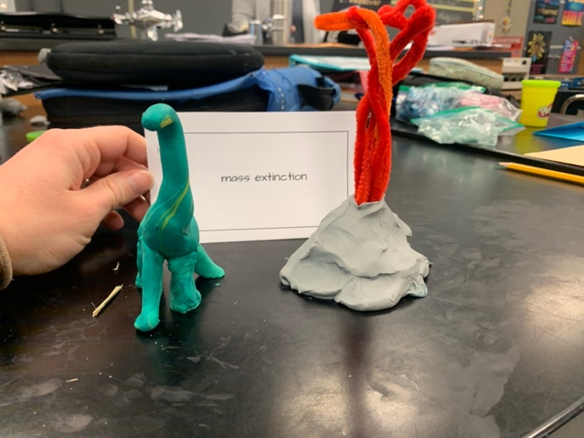

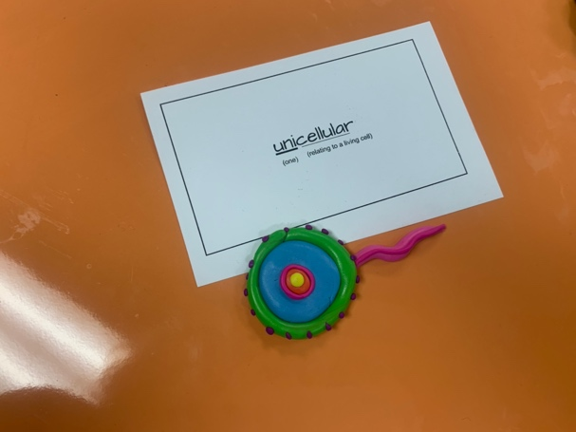

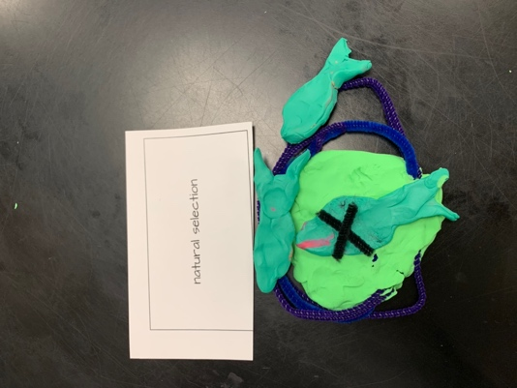

Figure 1. Three examples of representations created by students.

By using computers in the makerspace, students visited the website where the technology integration specialist had uploaded pictures of their representations (created on Day One). Students individually selected one creation they thought best represented the content vocabulary word. Afterwards, they discussed with their groups which picture they selected and why.

Day 3: Creation Gallery materials included Chromebooks that students used to visit the website where their creations from Day One were uploaded.

The Day 4: Tabletop Grammar activity (see the [Makerspace Activity Directions Document](https://journals.uwyo.edu/index.php/jtilt/article/view/6869/5869)) focused on authoritative markers. Although not a maker activity, this activity was designed for students to practice authoritative indicators, the use of which is an important feature of academic language (Schleppegrell, 2001). These indicators (i.e., words or phrases that show an authoritative stance), include words such as “undoubtedly,” “obviously,” and “unlikely.”

Students received a laminated poster of a paragraph on evolution that included colloquial language (see Poster Text below). They needed to use tools available in the makerspace (e.g., dry erase markers) to replace informal language with authoritative markers. Thus, for Day 4: Tabletop Grammar, materials included a laminated poster of the paragraph on evolution and dry erase markers.

Poster Text

Do you know about vestigial structures and organs? Let me tell you. In the bodies of whales, there are small leg bones that are vestigial. And skeletons of snakes have traces of leglike structures that are not used. Well, these vestigial organs help them see how some modern organisms are related to ancestors that had, like, similar structures.

We know that vestigial structures can tell us something about evolution. Scientists studying the anatomy of living things have also noticed that many different species share structures that are kinda similar. But these structures are used differently by each species. Like, today you can see the process of natural selection caused the variations in form and function.

#### Day 5

The activity for the fifth day was Day 5: Blocks to Blocks (see the [Makerspace Activity Directions Document](https://journals.uwyo.edu/index.php/jtilt/article/view/6869/5869)), for which the instructor provided blocks that had phrases or sentences on them (see the [Block Phrases Document](https://journals.uwyo.edu/index.php/jtilt/article/view/6869/5871) for phrases used on Blocks in the Blocks activity). Phrases included:

* expanded noun phrases (e.g., “The last remaining ancient artifact”),
* non-restrictive relative clauses (e.g., “The paper, which was written last semester”),
* nonfinite clauses (e.g., “Assigned to the experimental group, the students …”), and
* appositives (e.g., “The bird, an extinct species, …”).

Students arranged the blocks to make complex sentences (see Figure 2).

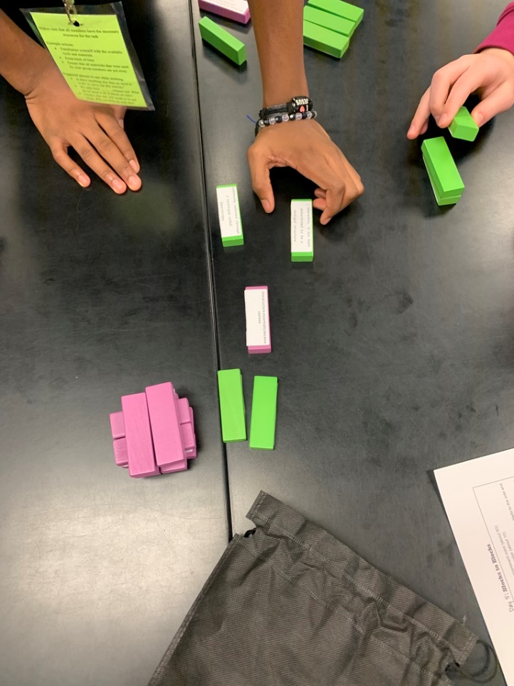

Figure 2. A picture of the blocks.

#### Day 6

The material for the last day activity, Day 6: Graffiti Wall (see the [Makerspace Activity Directions Document](https://journals.uwyo.edu/index.php/jtilt/article/view/6869/5869)), included academic vocabulary words. Student groups were provided with academic vocabulary words (i.e., terms used across domains, such as “component,” “malignant”; see [Academic vocabulary slides](https://docs.google.com/presentation/d/1BoIqEtjT2r7OqegQpkJwuxn2TXdItnp96Vvpy4sKyj4/edit?usp=sharing)) and tasked with creating word walls. Each group member contributed to their word wall by generating examples and non-examples of the word or drawing a picture related with each word. For example, for the word *remnant*, a student wrote “small remaining quantity of something.” Another student in the group drew a picture of leftover pizza crust. After completing the word walls, students viewed the walls created by other groups.

Following the Day 6: Graffiti Wall activity, students typed their post-writings outside of class and submitted them to the teacher. The teacher insisted that students type their final drafts on Chromebooks for submission purposes because it was easier to view and directly input grades into the learning management system.

## Critical Reflection

Students were able to effectively carry out the maker activities. Although students were told that they could use anything in the makerspace, the majority used low technologies (see Makerspace Context). One possible reason was that the makerspace that students used for this project primarily housed low technologies.

The project developed with little to no learning interruptions or behavioral interferences. Students had to work in two rooms so that there was enough space for movement. The science teacher and the technology integration specialist facilitated this project, allowing for one facilitator in each room. In the future, if the technology integration specialist is not available, limited space could pose a challenge for activity facilitation.

In terms of collaboration, teachers observed that students were comfortable with collaborating in the makerspace, probably because of the type of “coffee shop” setting. However, it seemed that in some groups, students did more work than others. According to the science teacher’s observation of middle school students’ group work, this tends to be an issue when middle school students collaborate with their peers. One strategy that teachers can use to address this issue is to emphasize that students need to help each other learn and that all students should contribute to the task, prior to beginning group work (Gillies, 2004). Another strategy is to assign roles to students (Chang & Brickman, 2018). In this context, roles can include a group leader who makes sure that all students contribute, an activity facilitator who makes sure that group members understand the activity directions, and a materials facilitator who makes sure that all members have the necessary materials.

There were two observations related to writing. First, although students were supposed to revise their writing pieces individually, they provided feedback on their group members’ writings. Second, the academic language and content of students’ writing pieces were improved. The [rubric](https://journals.uwyo.edu/index.php/jtilt/article/view/6869/5873) used to evaluate pre-writings and the final version of students’ writings consisted of criteria of lexical choices (e.g., content vocabulary, academic vocabulary, and lexically dense terms), organizational strategies, complex syntactic structures, authoritative indicators, and content.

The writing improvement echoed Tham’s (2019) argument that maker activities can be an effective pedagogical practice for teaching writing. The improvement in content was unanticipated because the maker activities focused on academic language, not science content knowledge. The possible reason that the content aspect was improved is that all activities were themed around the human appendix and evolution.

References

Chang, Y., & Brickman, P. (2018). When group work doesn’t work: Insights from students. *CBE—Life Sciences Education, 17*(3), 1–17. <https://doi.org/10.1187/cbe.17-09-0199>

Fang, Z., & Park, J. (2019). Adolescents’ use of academic language in informational writing. *Reading and Writing, 33*, 97–119. <https://doi.org/10.1007/s11145-019-09937-8>

Gillies, R. M. (2004). The effects of cooperative learning on junior high school students during small group learning. *Learning and Instruction, 14*(2), 197–213. <https://doi.org/10.1016/S0959-4752(03)00068-9>

Makkos, M. (2018, July 10). Linking words: List of sentence connectors in English with examples! <https://www.myenglishteacher.eu/blog/list-of-sentence-connectors-in-english/>

Own, C.-M. (2018). Making without makerspace, another study of authentic learning with augmented reality technology. In T.-W. Chang, R. Huang, & Kinshuk (Eds.), *Authentic Learning Through Advances in Technologies* (pp. 189–201), ΩSpringer Singapore. <https://doi.org/10.1007/978-981-10-5930-8_11>

Sealy Independent School District (n.d.). 30 word core content vocabulary list. <https://www.sealyisd.com/common/pages/DisplayFile.aspx?itemId=2339209>

Schleppegrell, M. J. (2001). Linguistic features of the language of schooling. *Linguistics and Education, 12*(4), 431-459. <https://doi.org/10.1016/S0898-5898(01)00073-0>

Snow, C. E., & Uccelli, P. (2009). The challenge of academic language. In D. R. Olson & N. Torrance (Eds.), *The Cambridge Handbook of Literacy* (pp. 112–133). Cambridge University Press.

Tham, J. (2019). *Multimodality, makerspaces, and the making of a maker pedagogy for technical communication and rhetoric* [Doctoral dissertation, University of Minnesota). University of Minnesota Digital Conservancy. <http://hdl.handle.net/11299/206361>

Uccelli, P., Dobbs, C. L., & Scott, J. (2013). Mastering academic language: Organization and stance in the persuasive writing of high school students. *Written Communication*, *30*(1), 36–62. <https://doi.org/10.1177/0741088312469013>

West Virginia Department of Education. (n.d.). Science – grade-6 standards. Retrieved July 1, 2022, from <https://wvde.us/tree/middlesecondary-learning/science/science-grade-6-standards/>

## About the Authors

**Ashley Stewart** is a former Technology Integration Specialist and Academic Coach for a public school district in West Virginia. She is now an instructional designer at the University of Pittsburgh School of Pharmacy, where she develops online continuing education for medical professionals. Her research interests include makerspaces, language learning, pharmacogenomics education, and micro credentialing. Correspondence concerning this article should be addressed to Ashley Stewart, 3501 Terrace St., 09055 Salk Hall, Pittsburgh, PA 15261 / EMAIL ashley.stewart@pitt.edu

**Jiangmei Yuan** is an Assistant Professor of Instructional Design and Technology in the School of Education at West Virginia University. She studies how to improve STEM teaching and learning. Specifically, her research focuses on computer science education, teacher learning of engineering design, engineering students’ learning in foundational courses, as well as how to use peer assessment to improve STEM learning.