Introduction to Series and Parallel Circuits
  - Craig E. Shepherd, University of Memphis and Shannon M. Smith, Boise State University

Overview
This lesson begins with an introduction on electricity and how it is formed at the molecular level. It then lets learners explore and define a circuit. This introduction is followed by an exploration where learners develop series and parallel circuits using LED lights and motors. Learners then consider what constitutes a series and parallel circuit, open and closed circuit, and a short circuit. The lesson concludes by having learners consider advantages, limitations, and instructional uses of various electronics kits (e.g., Snap Circuits, littleBits, LilyPad, paper circuits, conductive dough) based on their ability to display circuit paths.
Topics: Conductor; Insulator; Open, Closed, Series, Parallel, and Short Circuits; Load; Switch
Time: 80 minutes with assessment (50 without)

Materials
- Snap Circuits electronic sets (or other electronics sets that allows users to develop series and parallel circuits with switches, light bulbs, motors, and other loads)
- LCD Projector
- Computer with Internet
- White board and dry erase markers
- Youtube video explaining simple circuits (https://youtu.be/VnnpLaKsqGU)
- YouTube video describing series and parallel circuits (https://youtu.be/RQ3djos_LY8)

Setup
Prior to instruction, setup an area where learners can build circuits with various components. Also setup an area to discuss ideas in whole class and small groups and showcase work. Create circuit kits for each student that include a battery pack, three lights, a motor, wires to connect components.

Context at a Glance
Setting
3-8 grade students at a rural, public, elementary school
Modality
Face-to-face delivery
Class Structure
The first lesson in a student-selected, 8-week, 50-minute, ungraded, Friday elective course taught in a school library setting
Organization Norms
One or several 8–9-week Friday elective courses offered three times a year. Courses focused on ungraded, hands-on, guided inquiry. Most students were familiar with inquiry processes.
Learner Characteristics
10-15 students selected this course from a list of alternatives. Male and female students from mixed grade levels were represented.
Instructor Characteristics
One librarian and a university faculty member co-taught this course. They had previously provided electives regarding robotics, circuits, and coding. Both were familiar with the technology.
Development Rationale
Instructors were interested in combining coding concepts (learned in previous electives) with circuitry through Sparkfun Inventor kits and LilyPad circuits. This unit bridged these topics, beginning with basic circuit lessons before exploring coding with circuits through Sparkfun kits (with Arduino software) and wearable circuits through LilyPad.
Design Framework
Gagne’s Events of Instruction

ISTE Standards for Educators
2.1a: Set professional learning goals to explore and apply pedagogical approaches made possible by technology and reflect on their effectiveness (ISTE, n.d.)
2.5.c: Explore and apply instructional design principles to create innovative digital learning environments that engage and support learning
2.6.b: Manage the use of technology and student learning strategies in digital platforms, virtual environments, hands-on makerspaces or in the field.

Context and Setting
This lesson was developed as part of an eight-week, 50-minute, Friday elective course about wearable circuits for 3-8 grade students at a small, rural, public school in the Western United States. This school was housed within a university campus and enrollment was through a lottery system—with siblings of currently enrolled students gaining automatic entrance. The course was delivered in a school library setting that also served as a university library and housed various curricular materials for preservice teachers. In addition, it housed a variety of STEM materials placed in general circulation (e.g., Lego EV3 and Sphero robotics, Arduino kits, littleBits, Makey Makey Invention Kits, Vernier Probes). Per school mandate, elective courses were ungraded, though attendance and participation were captured. Each elective focused on student-directed, inquiry-based, hands-on learning activities. These activities had been facilitated over several years in the school, so most students were familiar with their structure and the inquiry process. Students were provided a list of possible electives and rank ordered their top three choices. School administrators used these lists to populate courses. Typical class sizes ranged from 10-15 students. Participating students did not need a background in circuits to complete this course. However, several students had completed previous electives with the instructors.
This lesson was developed to introduce the elective and was the first of eight lessons. It was delivered in a face-to-face setting within a multi-use library that included a stationary computer lab, various work/study tables, and a seated group discussion area. It was taught by a school librarian hired in part to integrate STEM instruction within the library curriculum. It was co-taught by a university instructor who taught technology integration courses within the college of education. When the elective was first taught, both instructors had limited prior knowledge with circuits—though they were familiar with series, parallel, and short circuits. Both instructors also felt intimidated with breadboards, Arduino and Sparkfun Red Board components, and programmable circuits. However, the inquiry-based approach to the course facilitated their ability to learn with their students as they tackled circuitry challenges. Most lessons were developed to provide short instructional episodes followed by one or more challenges where students used power supplies, leads, and wires to build, explore, and trouble-shoot simple circuits.
The library had several electronics kits in general circulation and many students had previously experimented with Snap Circuits, littleBits, Makey Makeys and other kits. While these kits helped students build workable circuits by following schematics or linking color-coded components, they did little to explain how the circuit worked. This lesson was developed to provide more guidance about the basics of circuit construction and how load placement influenced function.

Learning Representation

Gain Attention (3 min.)
Ask learners what is electricity (first essential question)? Allow them to describe it and take note of accuracies and misconceptions. Be sure to address the misconceptions as you complete the lesson. Introduce the lesson by stating that you will introduce concepts of electricity to help learners understand how it is used in everyday appliances. Then introduce remaining essential questions.

Essential Questions
- What is electricity?
- What is a circuit?
- Why does a burned-out light bulb ruin a string of Christmas lights but have minimal effect in a bedroom or home?
- What is a short circuit and why do we try to avoid them when using electricity?

Recall Prior Knowledge
Remind learners that atoms are composed of a nucleus of protons and neutrons surrounded by electrons in various clouds/shells. Protons have a positive charge. Electrons have a negative charge. Many times, the number of protons in an atom equals the number of electrons. However, the placement of some electrons in shells/clouds allows them to leave more easily. These free electrons can flow to atoms nearby, making the atom negatively charged. Normally, the exchange of these electrons happens randomly. However, when these materials are arranged correctly in a magnetic field, electrons begin to flow through the material in a particular direction (Kurtus, 2018). Current is the rate of flow of electrons over time (Fiore, 2020).
Some materials allow this flow of electrons to occur more easily than others. Materials that allow electricity to flow through them easily are called conductors. Conductor examples include copper, aluminum, gold, and silver. Materials that do not allow electricity to flow through them easily are called insulators. Insulator examples include plastic, air, rubber, paper, and glass.

Circuit Introduction (10 min.)
We learned that some materials allow electricity to flow through them easier than others. These materials can be combined to form electric circuits.
Ask learners: What is a circuit?
After you hear the answers, explain (if needed) that a circuit is a path through which an electric current flows. A complete or closed circuit begins at the power source (usually a battery for work completed in this lesson). Electricity flows from the battery through wires (composed of conductors surrounded by insulators) and loads (e.g., lights, motors, and so forth) and returns to the battery. Electricity will only flow if the path begins and ends at the power source—making a complete circle.
Show YouTube video explaining simple circuits (https://youtu.be/VnnpLaKsqGU).

Reading Circuit Diagrams
A circuit diagram is a schematic that demonstrates how electricity flows through the circuit (beginning at a power source and flowing through one or more loads before returning to the power source. Components are represented through various symbols. Below are a few symbols.
An energy source (usually a battery)
A light emitting diode (LED)
A switch in the open position
Draw a simple circuit (see Figure 1) on the whiteboard or computer and indicate the flow of electricity (Figure 2).
Figure 1. Circuit diagram with wires, power source, and LED
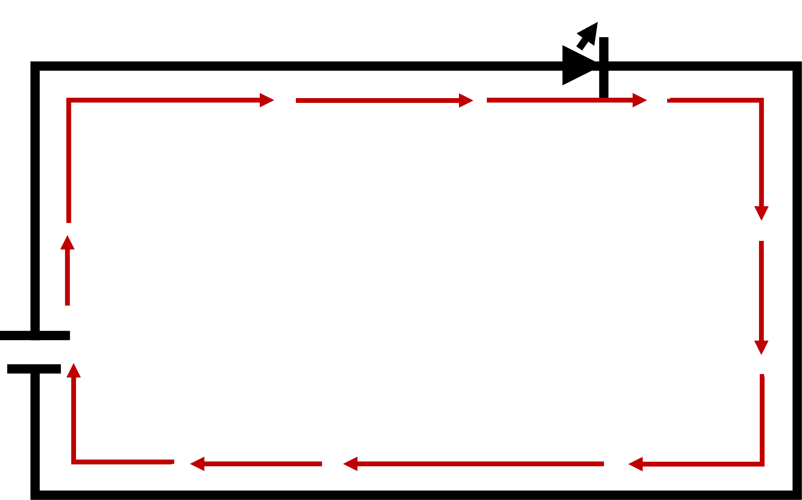
Figure 2. Circuit diagram depicting electricity flow
When a circuit does not form a complete path to and from the power source, it is known as an open circuit. Discuss the difference between a closed circuit (a complete circuit where electricity can flow) and an open circuit. Explain that open circuits are formed by switches. A switch is a physical mechanism that opens or closes a circuit (see Figure 3). 3).
Figure 3. Circuit diagram with wires, power source, LED, and open switch.
Once learners understand the difference between an open and closed circuit, discuss that users can add loads to circuits. A load is a device or part that uses electrical energy (e.g., lights, motors, buzzer). However, indicate that the manner you add those loads influences how the circuit functions.

Practice: Create a Circuit (8 min.)
Create a simple circuit without and with a switch.
Give learners a circuit kit. Learners (either individually or in small groups) should have the following components:
- Battery pack with sufficient batteries
- One or more lights—light emitting diodes (LEDs) or incandescent
- A motor (do not use a servo motor)
- Wires to connect components (e.g., power source and loads)
Using the information discussed thus far, ask learners to design a circuit that lights one light bulb (or one motor). If they use the motor, you may have them reverse the motor and describe what that does (it changes the spinning direction of the motor).

LED Polarization
LED lights are polarized. This means that electricity will only flow through them in one direction. If you use LEDs, make sure learners realize that the light will only work if the positive wire (or lead) from the component is connected to wires coming from the positive battery terminal (and the negative lead is connected to wires coming from the negative battery terminal). Incandescent lights are not polarized. They will light regardless of which lead is connected to which battery terminal.

Feedback and Challenge
When learners have completed the circuit, have them trace the path of electricity. Ensure that all learners understand how to trace the closed circuit.
Then give them a challenge to add a switch to their circuit. This will be done by adding the switch in series (along the same path) as their current circuit. Ask learners to specify when the circuit is open and when it is closed.
If needed remind learners that open circuits have incomplete paths (and therefore will not function). An open circuit is traditionally what we call a switch when it is “off.” Closed circuits are complete paths to and from the power source—allowing electricity to flow and loads to function. Closed circuits are traditionally what we call a switch when it is “on.”

Practice: Two Load Circuit (5 min.)
Next, challenge learners to make a circuit that lights two light bulbs or a light bulb and a motor. Learners will likely add these loads in series (or along the same circuit path). This may cause one loead (e.g., light or motor) to function well while the other functions sluggishly—if at all.
Ask learners to describe what is happening. Then ask them if they have the same problem at home when they plug two lights into an outlet. The answer will likely be “no.” Let them hypothesize what is happening and why they don’t have those problems in their home.

Feedback
After learners have discussed the problem, indicate that each load adds uses some energy and results in reduced current continuing through the circuit. In the light example, some electricity is converted into heat and light energy. In a motor, some energy is converted to motion and heat. This conversion results reduced power for later components. If power is increased, the loads will function better.

Series & Parallel Circuits (10 min.)

Series Circuits
Draw and describe a series circuit (see Figure 4). A series circuit is a circuit where all loads are in one path. Ask learners if they can think of other problems with a series circuit. If they can’t think of any, ask them what would happen to their circuit if light burned out. If they don’t know, draw a picture of an incandescent bulb and indicate that the filament splits, breaking (or opening) the circuit. If the circuit opens due to a burned-out bulb, what happens to the other loads on the path (e.g., additional lights or motors)? Learners should indicate that it will not receive power. Ask learners if they can think of a winter holiday item that uses this kind of circuit. They may state that Christmas lights function this way. This partially answers one essential question.
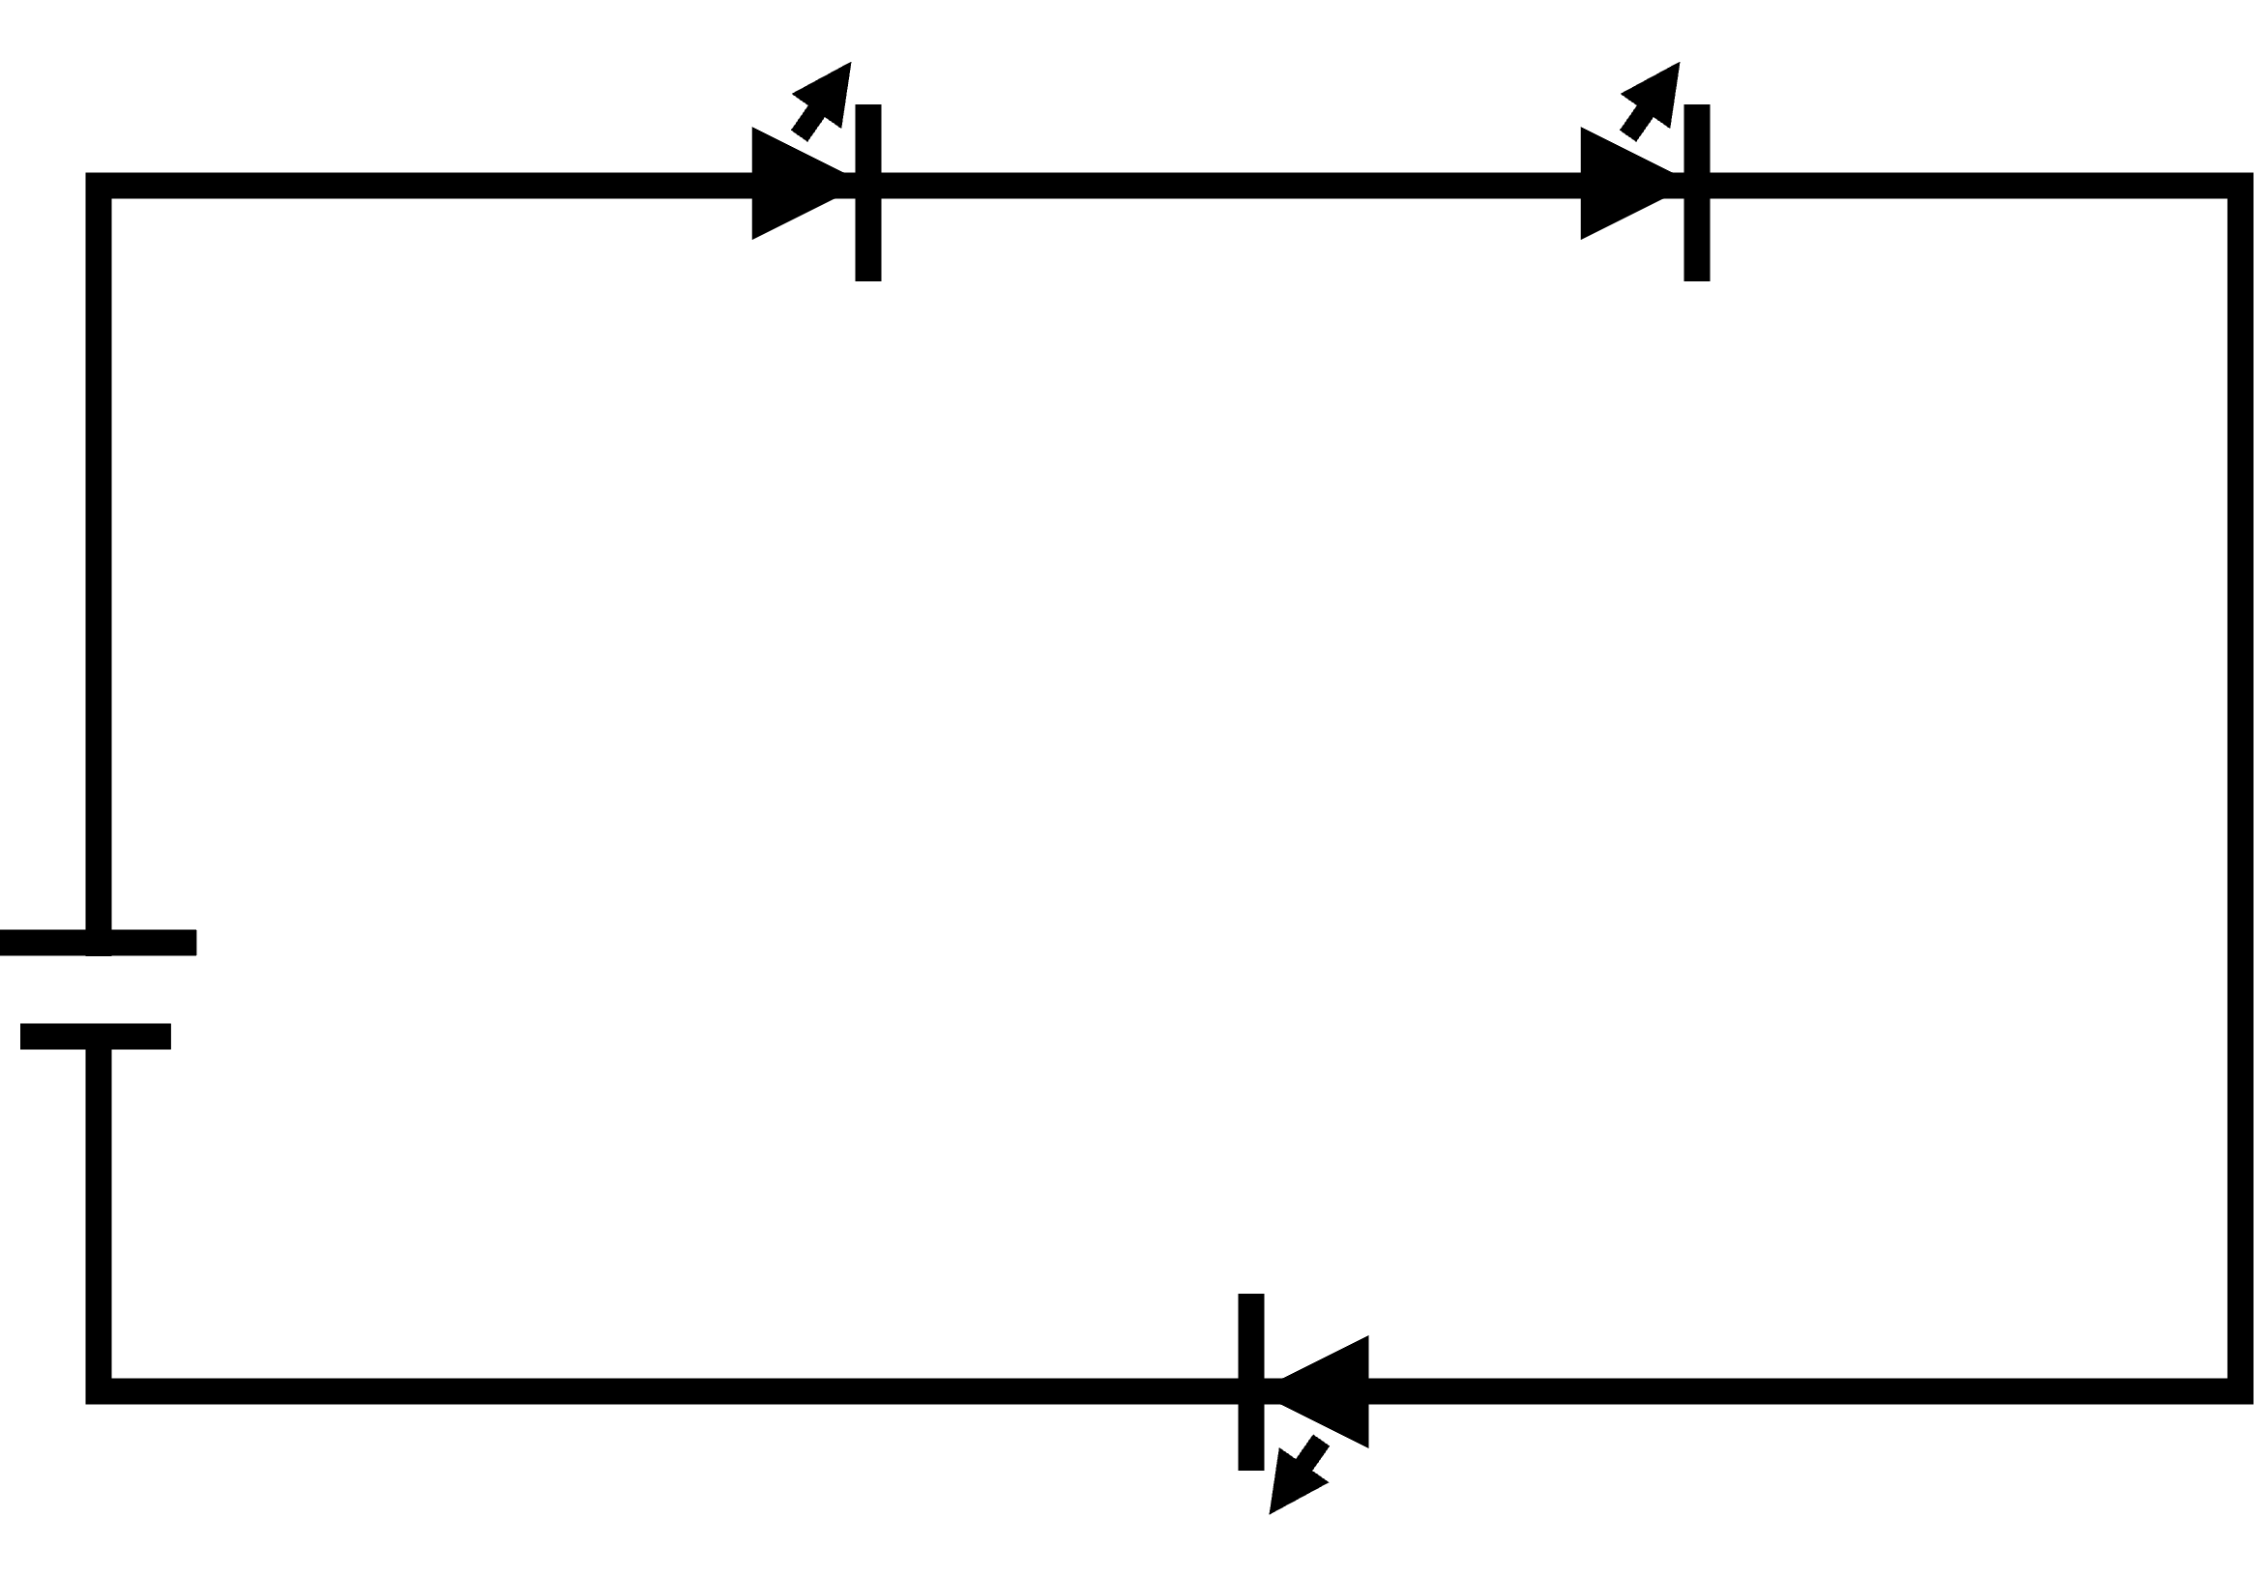
Figure 4. Circuit diagram where wires connect a power source to three LEDs connected in a series (one path).

Parallel Circuits
Once they realize that broken loads on a series circuit will affect the other loads, ask if this happens in their bedroom. Do they have to turn on the lights, their desk lamp, their radio, and other electronics to use a computer in their room? The answer is an obvious “no.” Then explain there is another way to create a circuit so that other loads work when one does not. It is a parallel circuit. Draw a parallel circuit (see Figure 5). Unlike a series circuit, a parallel circuit provides separate paths for each load. Show the YouTube video differentiating between series and parallel circuits (https://youtu.be/RQ3djos_LY8)
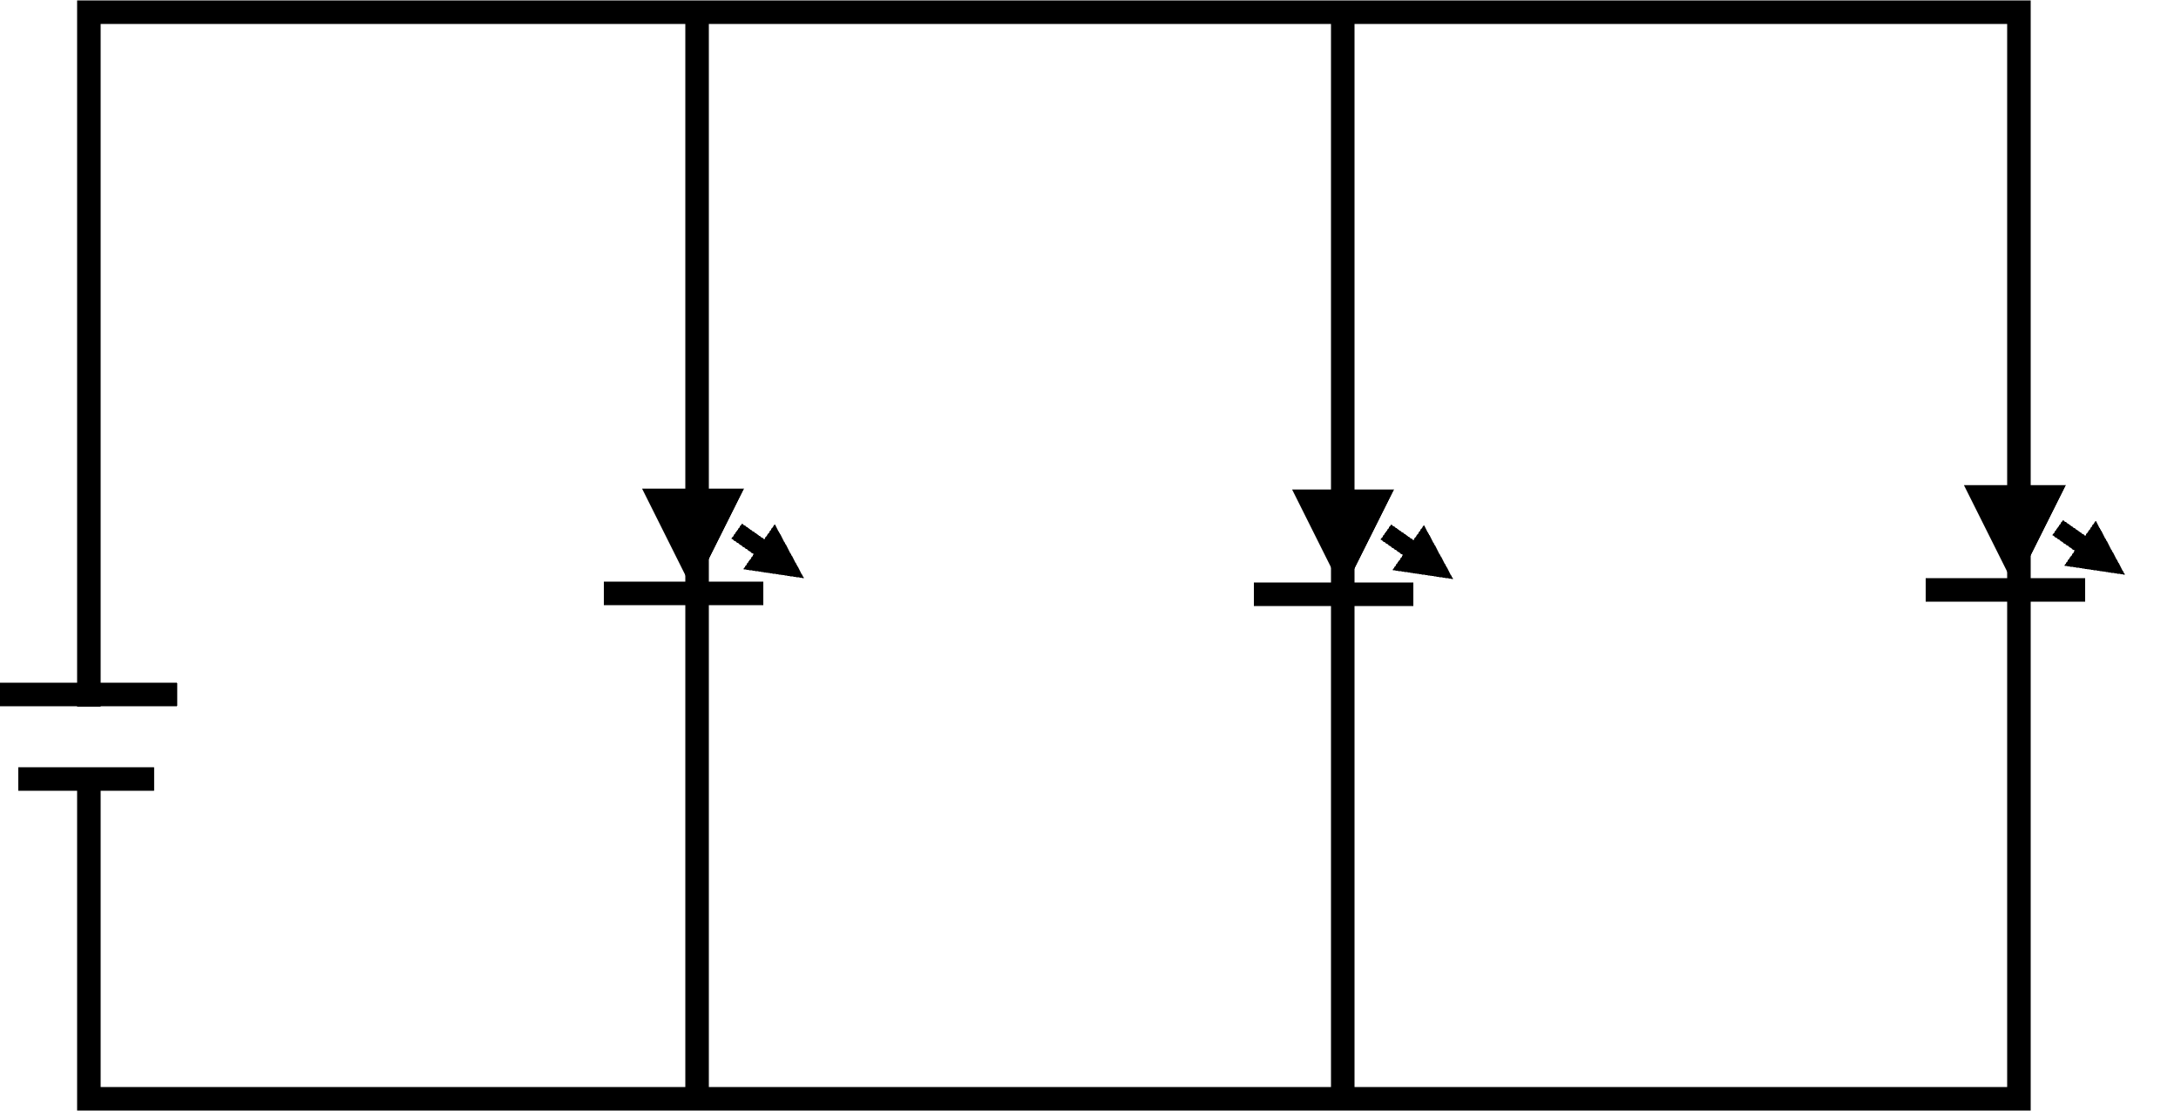
Figure 5. Circuit diagram where wires connect a power source to three LEDs in parallel (one path to each LED).

Practice (7 min.)
Ask learners to remake the circuit with two in parallel. Ask them to help each other so they can make this circuit. Then have them trace the paths of the circuit and consider how it functions (both loads should work properly). Indicate that providing loads in parallel provides full voltage to each circuit and thereby increases electricity to each load.

Challenge
After learners create a parallel circuit with two loads, challenge them to add a switch to the circuit. Keep in mind that switches need to be added in series (within the same path) to function properly. Some students may add the switch in series but some will likely add the switch in parallel—like they added their loads. A switch in parallel will not function as learners intend it to. It also introduces a short circuit (see below).

Short Circuit (5 min.)
Electricity flows through the path of least resistance. This means that electricity will choose the easiest path to flow through. If a path contains no loads, electricity will flow through that path. Unfortunately, letting electricity flow uncontrolled through a circuit quickly depletes batteries and often creates heat. If great enough, the heat can damage wires and cause fires. Whenever electricity flows through an unintended path that bypasses loads, it is called a short circuit. Draw and explain that when a switch is added in parallel, it shorts the circuit because when the path is open (switched “off”) electricity flows through the other loads (see Figure 6). When the switch is closed (switched “on”) electricity flows through the switch as a path of least resistance, bypassing all other paths and making the circuit appear “off.” This drains the battery rapidly and creates heat as a byproduct. Short circuits are never good!
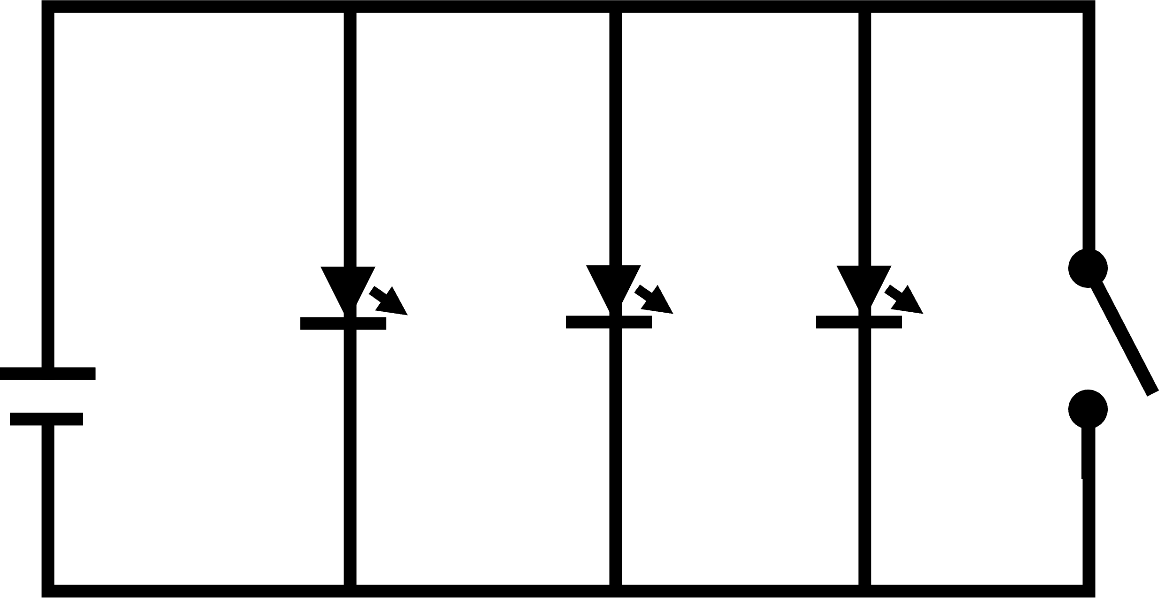
Figure 6. Circuit diagram where wires connect a power source to three LEDs connected in parallel. An open switch is also connected in parallel (shorting the circuit).
The switch (pictured above) acts as a short circuit, when “closed” it will short the circuit and the lights will go off. This is not how a light switch works. By shorting the circuit, electricity passes through the circuit, rapidly draining the battery and generating heat.

Feedback
Have students describe how electricity flows through a parallel circuit. Have them trace individual paths through the loads on their circuit constructions. Then have them demonstrate how the switch placed in parallel creates a short circuit. Ask them what a short circuit does and why it is unwanted (and potentially dangerous). Give feedback, including correction, as needed.
Remind learners that effective lessons on circuitry allow students to trace circuit paths and consider how loads affect each other. There are many kits available to explore basic electronics, but some are more useful than others. In the assessment, they will examine multiple kits and consider their benefits and limitations for learning.

Assessment (30 min.)
There are many ways to demonstrate basic electricity and circuits in classroom environments. Several STEM kits exist to facilitate circuit explorations. These range from more costly littleBits, Arduino kits, Snap Circuits, and wearables (e.g., Lilypad) to less expensive conductive dough and paper circuits.
Provide several circuit kits with components to complete series and parallel circuits with one or two loads.
Have learners complete a series (if possible) and parallel circuit with switch in each kit. Then have them trace the paths. With a smartphone, show those paths and critique the kit. As you demonstrate the paths, answer the following questions:
- Does the kit make circuit paths visible?
- Does the kit allow for user error?
- Does the kit demonstrate effects of specific loads?
- What advantages does the kit have for teaching basic circuits?
- What limitations does the kit have for teaching basic circuits?
- Given the advantages and limitations, how might you incorporate this kit into a grade-appropriate lesson on basic circuits?
Amalgamate and submit reviews for grading (e.g., presentation software, webpage, blog, document).

Grading Criteria

______ Learner was able to create a complete circuit in series and parallel for each kit
______ Learner was able to add a switch to completed series and parallel circuits for each kit
______ Learner was able to trace the circuit paths for each circuit kit
______ Learner identified at least two advantages of each kit
______ Learner identified at least two limitations of each kit
______ Learner identifies an effective way to leverage each kit in grade-appropriate instruction based on their list of identified advantages/limitations

Retention and Wrap-up (2 min.)
Review the essential questions for the lesson and key concepts (including the terms conductor, insulator, load, closed circuit, open circuit, series circuit, parallel circuit, and short circuit).

Critical Reflection
This lesson was implemented three times in the library setting described. Each implementation was successful but minor changes were incorporated. In each session, students quickly grasped the concept of a circuit and a circuit path. They also quickly grasped the concept of a series circuit and saw that adding loads reduced the current available to each load. Students also quickly grasped the idea of a switch placed in series and how an open and closed circuit functioned. However, the idea that a closed circuit was a complete circuit needed repetition for many students as it seemed counter-intuitive with electricity flow.
When asked for examples of series circuits (especially in regard to lighting), students readily identify cheap Christmas lights as an example. When one light burns out (or is removed), the entire circuit opens—preventing all other lights from lighting. They also acknowledge that most electronics do not function this way in their home or school environment. This discussion naturally leads to ideas associated with parallel circuits.
However, the concept of a parallel circuits took more time for students to demonstrate. While the concept makes sense in a circuit diagram, transforming the diagram into an actual circuit (even when using snap circuits or other kits that lend themselves well to circuit schematics) was difficult. Several students became stuck on the idea that a circuit can only represent one circle. Only after several minutes of trial and error did they realize that additional leads could bridge the existing circuit (creating new paths) or that additional wires were needed to create multiple circle paths from the power source. Some students struggled to create unique paths to each load. Yet, once they discover the concept of multiple paths, they can add additional loads without difficult. This concept still needs to be reiterated over several days. In our experience, students grasp the concept in class and can explain the and trace the circuit paths of both series and parallel circuits. However, if they are not asked to identify these types of circuits in subsequent days of instruction, they forget them and have trouble locating circuit challenges associated with these concepts.
Although students eventually grasp the concept of parallel circuits, their next problem was overgeneralization. Because they learn the value of separate paths for loads, most also make the mistake of adding a switch in parallel. However, this application results in a short circuit when the switch is closed and a functioning circuit when the switch is open. During each implementation, this scenario required careful reflection for students to fully grasp. We learned that we needed to provide adequate time for students to identify what was happening through guided discussion and experimentation.
After implementing this lesson three times, we usually moved to an introduction of paper circuits so that we could begin introducing layers and folds into discussions of circuit design. These layers and folds also continued the conversation regarding shorts and how to prevent them. However, we also realized that an additional lesson (prior to paper circuits) focusing on insulators and conductors and especially household examples of these components was useful to help students consider circuit varieties in preparation for wearable circuits, conductive thread, and insulating materials. It also allowed us to introduce non-traditional circuits like conductive dough and paper circuits.

References
Fiore, J. M. (2020, July 26). DC electrical circuit analysis: A practical approach. https://open.umn.edu/opentextbooks/textbooks/dc-electrical-circuit-analysis-a-practical-approach-fiore
International Society for Technology in Education. (n.d.). ISTE Standards: Educators. https://www.iste.org/standards/iste-standards-for-teachers
Kurtus, R. (2018, June 24). Generating electric current. School for Champions. https://www.school-for-champions.com/Science/electric_current_generation.htm#.X7Pi3VBMHOg
Region 10 ESC. (2012, February 13). Explaining an electrical circuit [Video]. https://www.youtube.com/watch?v=VnnpLaKsqGU&feature=youtu.be
Region 10 ESC. (2012, February 13). Types of electrical circuits [Video]. https://www.youtube.com/watch?v=VnnpLaKsqGU&feature=youtu.be

About The Authors
Craig E. Shepherd is an Associate Professor of Instructional Design and Technology at the University of Memphis with research interests regarding technology use in formal and informal settings to foster knowledge acquisition and community. He can be contacted at craig.shepherd@gmail.com
Shannon M. Smith is an Assistant Librarian at Boise State University with research interests in best practices and ethics for emerging library services, collaborative learning, and multimedia information behavior.

