Using AI-Generated Multimedia
to Teach Leisure Choice-Making
  - Charles Thull, Old Dominion University

Overview
This learning representation introduces an AI-developed, multimedia assessment for identifying leisure preferences among middle school students with developmental disabilities. Grounded in instructional design, ecological systems, and multimedia learning theories, the activity integrates ChatGPT, InVideo AI, Sora, DALL·E, and Gemini to create guided-choice visuals, short videos, and a structured, teacher-facilitated paired-choice activity using visual prompts across home, school, and community interest contexts. The technology-developed design fosters engagement, accessibility, and self-expression as students participate in a structured, teacher-facilitated paired-choice activity. Outcomes include enhanced student voice in leisure planning, increased self-awareness, and the identification of potential leisure interests. Assessments include student responses to paired leisure activities that represent interests across multiple environments.
Topics: Leisure interests, students with disabilities, special education, preference assessment, artificial intelligence.
Time: Four learning sessions, each 20 minutes.

Materials
- Student Record Form
- Writing tools for each student
- Leisure Preference Assessment Slides (School, Home, Outside, and Community)
- Printed copies of the Leisure Preference Assessment
- Computer to run the PowerPoint, projector or classroom display, and speakers.

Context-at-a-Glance
Setting
Large, suburban, United States, public-school district serving middle school students with disabilities.
Modality
In-person with slides and paper-based materials for structured choice assessment.
Class Structure
Implemented in four 20-minute lessons to small groups with flexible pacing.
Organizational Norms
The district prioritizes inclusive transition planning and technology-supported instruction, providing access to devices, software, and professional learning.
Learner Characteristics
Designed for middle school students with autism spectrum disorder (ASD) and developmental disabilities who benefit from visual supports, predictable routines, structured choices, and scaffolded communication. Supports diverse responses, including pointing, gestures, AAC, simplified language, and repetition.
Instructor Characteristics
A special education teacher who develops transition curriculum and assessments and provides direct instruction using multimedia tools and AI-supported design practices.
Development Rationale
Created to increase accessibility, engagement, choice-making, and student voice in leisure preference assessment.
Design Framework
Grounded in instructional design, ecological systems theory, multimedia learning, and rapid prototyping.

Setup
The instructor connects a computer to a projector or display with speakers, opens the Google Slides or PowerPoint version of the assessment, and distributes printed response sheets to students. Setup typically requires 5–10 minutes to connect equipment, test audio, and arrange paper materials. Instruction may be delivered one-on-one or in small-group settings.

Standards
This learning representation aligns with the Council for Exceptional Children (CEC) Advanced Preparation Standards in Transition and Collaboration, emphasizing evidence-based practices that promote self-determination, student voice, and individualized planning for learners with disabilities (Council for Exceptional Children [CEC], 2022). It also aligns with the Association for Educational Communications and Technology (AECT) Standards for Professional Education, specifically Standard 1 (Content Knowledge) and Standard 3 (Learning Environments), through the integration of instructional design, multimedia learning theory, and equitable technology use to enhance accessibility and engagement (AECT, 2020).

Context and Setting
This multimedia leisure preference assessment was designed by the author, a special education teacher and instructional designer in a large suburban U.S. public-school district that emphasizes inclusive transition and career education. The district serves diverse middle school learners with ASD and related developmental disabilities who experience challenges communicating interests through traditional written or verbal formats. These needs informed the design’s emphasis on visual, multimodal representation and predictable instructional structure.
The leisure assessment described in this article was implemented by the author in a face-to-face classroom setting with eight seventh- and eighth-grade students enrolled in a specialized instructional program and identified with ASD and/or Intellectual Disability (ID). All students were verbal; however, expressive language abilities varied considerably across the group, particularly in pragmatic communication, conversational reciprocity, and social understanding. Cognitive abilities also spanned a wide range, reflecting the heterogeneity commonly observed in individuals with ASD (Litman et al., 2025), and ASD-related support needs were generally moderate, especially in the areas of social communication, self-regulation, and sustained engagement during structured learning tasks.
In everyday classroom instruction, several students communicated most comfortably through brief phrases, gestures, or visual attention, while others were able to speak in longer sentences but still required clear structure and prompting to express preferences or make decisions. Across learners, common characteristics included restricted or highly preferred interests, limited spontaneous peer engagement, difficulty interpreting or responding to nonverbal social cues, and challenges with reciprocal social interaction. Some students actively sought interaction but demonstrated difficulty adjusting language, behavior, or personal boundaries to match social contexts, while others preferred solitary engagement and required adult prompting to participate.
Instructionally, students frequently benefited from visual modeling, predictable routines, reduced language demands, and structured response formats to support comprehension and participation. Opportunities to respond using multiple modalities—such as pointing, looking, touching, circling, or speaking—were particularly important for enabling expression of preferences. These learning characteristics underscored the need for instructional tools that provide multimodal access to content—including short videos, animated visuals, and structured text-and-image choice options—alongside flexible response pathways that allow students to demonstrate understanding without relying solely on complex verbal explanation.
The design was guided by ecological systems theory (Bronfenbrenner, 1994) to represent leisure interests across home, school, and community contexts, and by multimedia learning theory (Mayer, 2009) to align visuals, narration, and text for clarity and engagement. Instructional design and rapid-prototyping approaches (Tripp & Bichelmeyer, 1990) further supported efficient development and practical classroom usability. Design decisions prioritized accessibility, efficiency, and real-world feasibility. AI-supported development tools (e.g., ChatGPT, DALL·E, InVideo AI, Sora, and Gemini) enabled rapid prototyping, visual customization, and scalable revision while maintaining alignment with multimedia learning and instructional design principles.
To support accessible participation, the assessment intentionally reduced language demands, supported multiple modes of expression, and allowed individualized pacing within a shared instructional routine. Structured “fields of two” visual choices sought to minimize cognitive load and enabled students to demonstrate preferences without requiring complex expressive language, increasing accessibility for learners with ASD and ID.
Assessment materials were later posted within the district’s Learning Management System (LMS) to support educator access. However, implementation described in this article reflects the author’s direct classroom use of the multimedia leisure preference activity rather than districtwide adoption.

Learning Representation

Introduction
The AI-powered multimedia leisure preference assessment was designed to help middle school students with ASD communicate their leisure interests across four ecological settings: home, school, outside, and community. The tool integrates short videos, animated GIFs, and images to make abstract leisure concepts more concrete, supporting students who experience challenges with expressive language, attention, understanding of abstract ideas, and making choices.

Learning Objectives
Students will:
- communicate leisure preferences using structured visual choices.
- identify interests across home, outdoor, community, and school settings.
- respond using pointing, gestures, or verbal expression.
During each session, students engage in a structured choice-making routine using paired visual options. With teacher support, students indicate preferences and gain repeated opportunities to practice selecting and communicating choices across settings.

Content development process
The instructional activity follows a structured sequence in which students view paired choices, select a preferred option, and communicate responses with teacher support. The following sections describe how AI tools were used to develop the multimedia materials supporting this process.
The assessment was developed using a rapid instructional design prototyping process that employed four generative AI tools: ChatGPT, InVideo AI, Sora, DALL·E, and Gemini. Each platform contributed to a specific stage of content creation, resulting in a cohesive, multimedia learning representation that could be replicated and adapted by teachers.
All figures in this manuscript are screenshots documenting the design and implementation process. This includes screenshots of tables generated in Google Docs (Figures 1–4), screenshots of the actual design interface and workflow within InVideo AI and Sora (Figures 5–7), and screenshots of the final assessment materials featuring DALL·E- and Gemini generated images as they appear embedded in the Google Slides deck (Figures 8–11).

1. ChatGPT – Question and Structure Generation
ChatGPT was used to generate paired-choice activity prompts representing common middle school leisure activities across four ecological settings: home, outdoors, community, and school. Leisure items were presented using contrasting choice formats (e.g., active vs. quiet, social vs. solitary) to facilitate greater differentiation among preferences (Fisher et al., 1992) and to provide a more distinct ranking of interests (DeLeon & Iwata, 1996). Enabling students to express these preferences supports their ability to act volitionally, which is a core component of self-determination and improving one's quality of life (Wehmeyer, 2005). Each prompt contrasted with two distinct types of activities (e.g., active vs. quiet, social vs. solitary). Dialogue prompts were iteratively refined to produce developmentally appropriate activity pairs and to ensure linguistic clarity, accessibility, and relevance for middle school learners with developmental disabilities.
ChatGPT also supported development of contrasting activity pairs within each ecological context, visually represented in Figures 1–4. The number of paired-choice items varied across contexts based on instructional priorities and practical design considerations rather than a fixed numerical structure. Prompts were refined through iterative dialogue to strengthen conceptual contrasts, developmental appropriateness, and visual engagement (e.g., solitary vs. social activities, indoor vs. outdoor environments, active vs. calm engagement), with emojis incorporated to reinforce comprehension and support multimodal understanding.
ChatGPT was selected as a development tool to efficiently generate a large, conceptually balanced set of developmentally appropriate paired comparisons across multiple ecological contexts. This process required consistent language, clear contrast logic, and instructional neutrality, which would have been significantly more time-intensive to achieve through manual drafting. Each comparison was designed to maintain visual clarity while representing key dimensions of leisure participation, such as social versus solitary, active versus passive, and real-world versus digital engagement. The resulting assessment reflects a structured comparison framework intended to support accessible and repeatable choice-making across settings.
ChatGPT facilitated rapid iteration, categorical balancing, and refinement of comparison logic during development. Universal Design for Learning (UDL) considerations were addressed by standardizing language, maintaining predictable formats, and ensuring accessible, clearly contrasted options (CAST, 2018). Cognitive load principles (Mayer, 2004) were supported by reducing unnecessary wording and maintaining simple, consistent structures across comparisons. ChatGPT generated plain-language captions and produced a downloadable PowerPoint file with comparisons organized across slides, streamlining formatting and reducing development time. Rather than replacing professional judgment, ChatGPT functioned as a design support tool, allowing the author to focus on developmental appropriateness and ecological relevance.
A Student Record Form was also developed using ChatGPT to document student responses to paired leisure activity choices across settings (home, outdoor, community, and school). For each item, the form includes brief descriptors (e.g., “creative expression vs. logical thinking”) to support interpretation of student selections and identification of patterns in interests across settings.
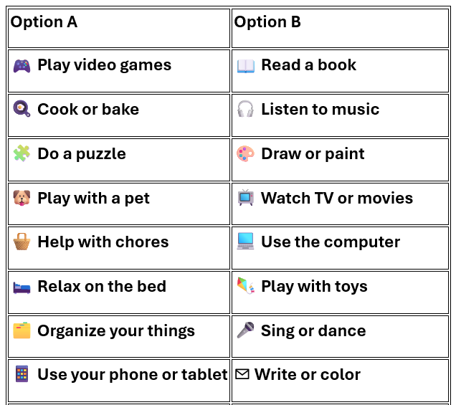
Figure 1. A home leisure preference comparison table using content generated with ChatGPT.
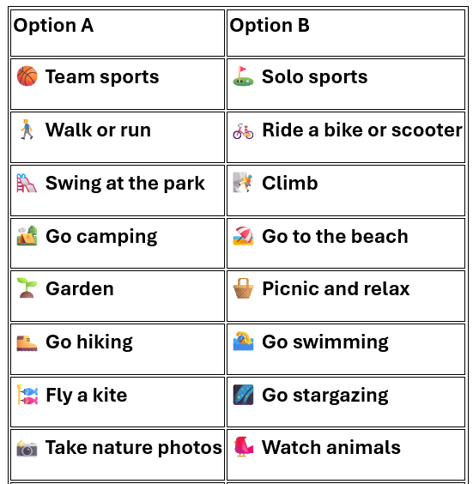
Figure 2. An outside leisure preference comparison table using content generated with ChatGPT.
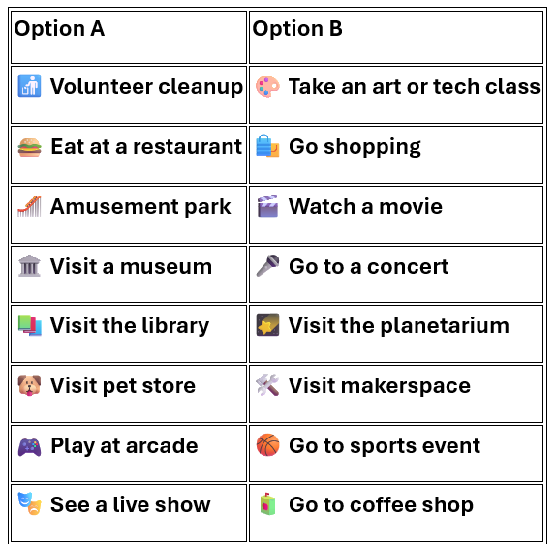
Figure 3. A community leisure preference comparison table using content generated with ChatGPT.
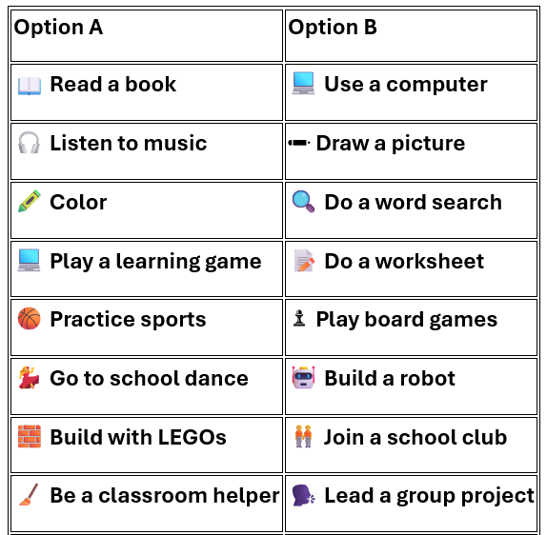
Figure 4. A school leisure preference comparison table using content generated with ChatGPT.

2. InVideo AI – Context and Introduction Videos
InVideo AI was used to develop four short, narrated videos aligned with the leisure interest assessment, with one video created for each context: home, outdoor, community, and school. Each video was generated individually using targeted prompts specifying a brief duration (approximately 30–45 seconds), a slow pacing, and the use of simple, direct language. The scripts described examples of leisure activities and modeled how individuals make different leisure choices across settings. For example, the home video stated, “At home, people enjoy relaxing, playing games, cooking, or spending time with family,” while the community video explained, “In your community, you might visit a park, store, or library. Everyone likes different things—what do you enjoy doing?” Following generation, all videos were reviewed and edited prior to use. Revisions included replacing selected stock footage with alternative media from the InVideo AI library and refining narration using the script-editing function to reduce linguistic complexity, shorten sentence length, and improve clarity. Collectively, the videos provided background knowledge, primed understanding, and modeled diverse examples of leisure participation in an accessible format.
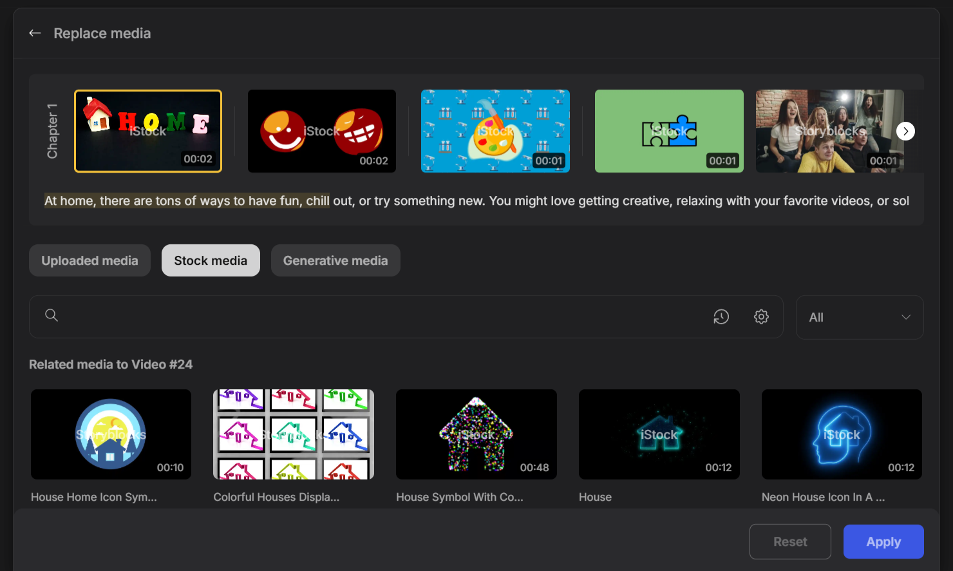
Figure 5. The InVideo AI media editing interface showing the actual video refinement workflow.
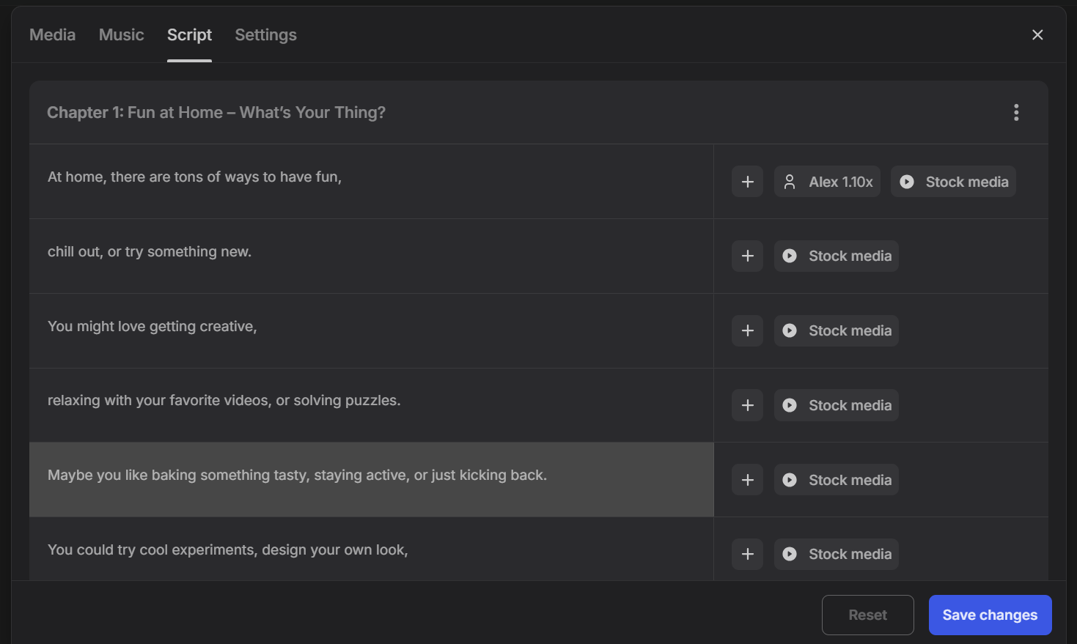
Figure 6. The InVideo AI media editing interface showing the actual video refinement workflow for video narration.

3. Sora – Animated GIF Development
Sora was used to generate animated GIFs that depicted movement or actions to enhance comprehension through motion cues. Example dialogue commands included: “Create a simple looping animation of a teens playing basketball at outdoor community court” (see Figure 7).
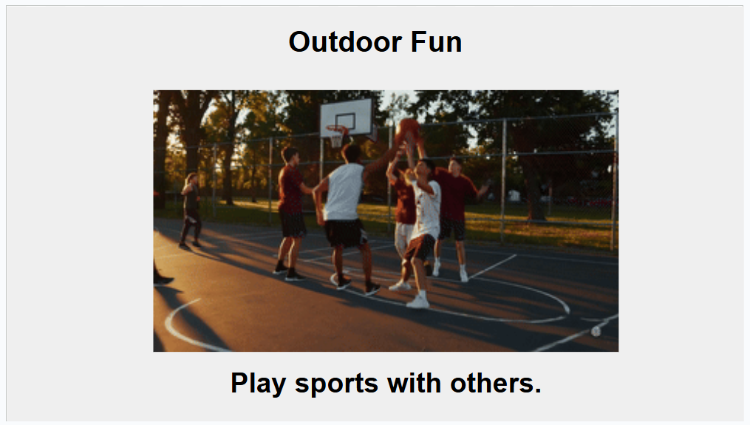
Figure 7. Example of an outdoor leisure preference GIF image created with Sora.
Two animated GIFs were created per setting, home, outdoor, community, and school, to illustrate actions such as doing crafts, watching TV, walking, exercising, playing mini golf, visiting a carnival fair, playing music in class, and playing sports, reinforcing engagement and visual understanding.

4. DALL·E and Gemini: Visual Development and Refinement
AI-generated visuals were developed and refined through an iterative design process using DALL·E and Gemini embedded within Google Slides. Initial images were generated using DALL·E with prompts designed to produce age-appropriate, engaging visuals aligned to student leisure contexts. These images varied in style from simplified illustrations to more photorealistic representations, depending on the context and instructional intent, as shown in screenshots of the Google Slides assessment featuring AI-developed and refined visuals (see Figures 8–11).
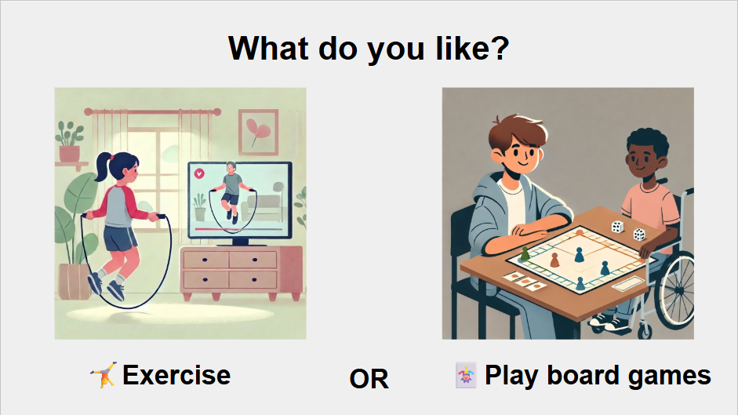
Figure 8. A home leisure preference slide.
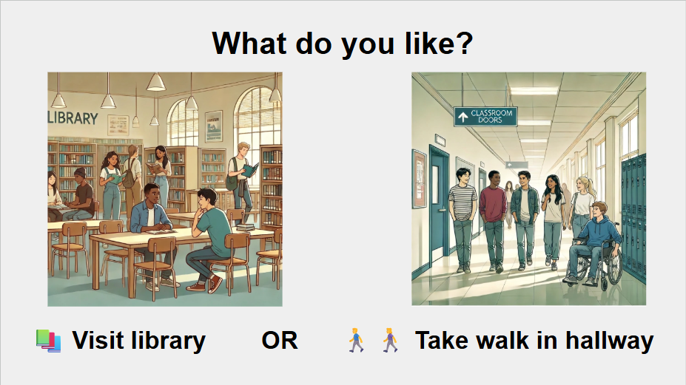
Figure 9. A school leisure preference slide.
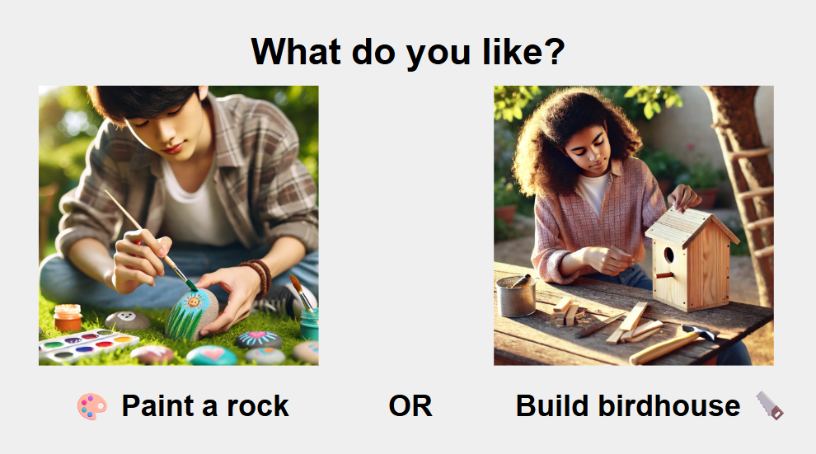
Figure 10. An outdoor leisure preference slide.
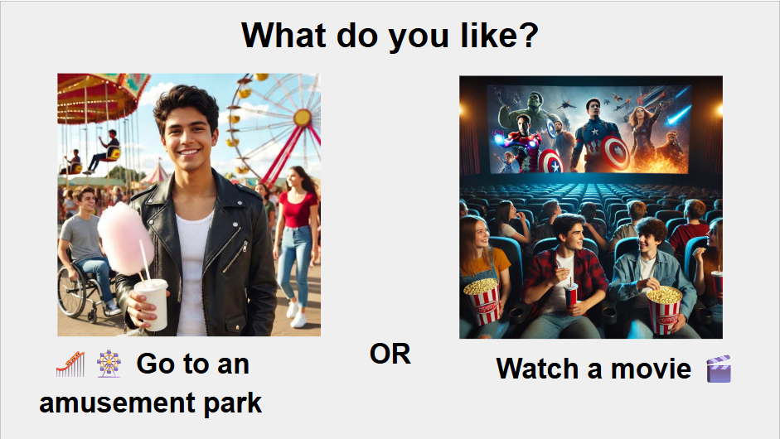
Figure 11. A community leisure preference slide.
Images were then copied and pasted into Google Slides, where they were resized, organized, and paired with text to create structured assessment slides. This environment supported ongoing iterative refinement, allowing adjustments to layout, visual clarity, and alignment with instructional goals.
To enhance representation and accessibility, images were further refined using Gemini’s embedded editing tools within Google Slides. This secondary refinement process focused on improving cultural and racial representation, integrating visible indicators of disability (e.g., mobility aids), and increasing contextual relevance for middle school students. Edits were applied iteratively to ensure visuals were inclusive, realistic when needed, and free from unnecessary visual complexity that could distract from task demands.
Across iterations, design decisions balance realism and simplicity. Photorealistic images were used when familiarity and environmental recognition were important, while simplified or illustrative images were used to reduce visual load and direct attention to key actions or features. Variations in composition (e.g., closer perspectives) were also used to increase salience and student engagement.
This multi-step workflow resulted in a cohesive set of visuals that support accessibility, representation, and student connection to leisure activities. The process can be replicated by educators using similar AI tools in combination with iterative design and accessibility-focused principles.

Implementation and facilitation
The multimedia leisure preference assessment was implemented across four instructional sessions aligned to ecological contexts: Home, School, Outside, and Community. Each session lasted approximately 20 minutes, including brief setup (e.g., connecting the laptop and distributing printed assessment forms) and approximately 15 minutes of structured instructional activity with pacing, prompting, and waiting time to support student regulation and engagement.
Implementation was supported by a team consisting of the classroom teacher, two instructional assistants, an interpreter, and the researcher, working with eight students. Each session began with a brief introduction to the target context using simple, direct language (e.g., “Today we are going to look at things you like to do at home”), followed by a short (30–45 second) AI-generated video to model leisure activities and prime students for choice-making. Animated GIFs were also used to reinforce key concepts and support comprehension.
Instruction was intentionally facilitated through small-group and individualized support. The assessment slides were not projected during responding; instead, students attended to their paper-based assessment while staff provided in-the-moment support at their seats. This design reduced cognitive load by minimizing split attention between visual displays and response formats, consistent with principles of multimedia learning (Mayer, 2009).
For each item, staff delivered a standardized prompt (e.g., “What do you like?”), named each option, and supported students in identifying a selection. Students engaged one at a time and responded using pointing, verbalizations, gestures, or by marking choices on the assessment form. Staff supported participation by re-reading prompts, restating choices, and guiding responses as needed, while maintaining a neutral tone that emphasized exploration rather than correctness. Support was gradually faded across sessions as students became familiar with the routine.
Student selections were documented after each session using a structured response form, allowing efficient identification of preference patterns across contexts to inform transition and recreation planning.

Student Instructional Sequence
Each item followed a consistent response routine. Students visually attended to two options, considered the prompt, and indicated a preference using available communication methods. Teachers provided wait time and repeated prompts as needed to support processing. This routine was repeated across paired comparisons within each session, providing a predictable structure to support engagement and decision-making.

Practice and assessment
The activity functioned as both instructional practice and formative assessment. Through repeated exposure to the structured choice format, students practiced visual discrimination, expressive choice-making, and self-advocacy within predictable routines. Repetition across sessions supported familiarity with task expectations while allowing teachers to observe consistency and change in preferences over time.
Assessment occurred during structured instructional sessions, with student responses recorded on paper-based forms. Student selections were documented after each session using a structured response form, allowing identification of patterns within and across ecological contexts. Teachers adjusted pacing, prompts, and wait time to accommodate variability in attention, regulation, and expressive language. No additional testing sessions were required.
Teacher implementation guide
This activity is designed to support leisure-related choice-making through structured, paired visual options and supported student responding. Prior to implementation, teachers should review the multimedia leisure preference materials (e.g., slides, videos, and assessment forms) to become familiar with the structure and flow of the activity. While the assessment can be adapted for different schedules, the described implementation occurred across four sessions (approximately 20 minutes each), with one ecological context addressed per session (Home, School, Outside, and Community). Each session begins with a brief introduction to the target context using simple, direct language, followed by short videos or animated GIFs to model leisure activities and provide visual context. These visuals are used to build understanding and support connections to real-life activities prior to student responding.
Student responses are completed using printed, two-sided assessment forms rather than projected slides. Instruction is facilitated through small-group and individualized support, with teachers and instructional staff seated alongside students. This approach reduces the need for students to shift attention between a projected display and a separate response format, supporting sustained attention and accessibility. For each item, staff present a standardized prompt (e.g., “What do you like?”), name each option, and support students in identifying a preferred choice. Students may respond by pointing, gesturing, verbalizing, or marking their selection on the assessment form. Staff may repeat prompts, clarify language, or provide visual and gestural supports as needed. A neutral tone is maintained to avoid influencing student selections, and emphasis is placed on student exploration and expression rather than correctness.
Pacing is flexible to support student regulation and engagement. Teachers provide wait time for processing and may incorporate brief pauses or breaks between items as needed. Support is gradually reduced as students become more familiar with the routine and expectations. Student responses are recorded on the assessment forms during each session. Following the session, educators transfer and organize responses using a structured record form to identify patterns of interest within and across ecological contexts. These results can be used to inform instructional planning, transition goals, and communication with families to support leisure participation across settings.
To support successful implementation, teachers may simplify language, reduce visual complexity, or limit the number of items presented based on student needs. Previewing a small number of items or incorporating movement or sensory breaks may further support engagement and participation.

Critical Reflection
The multimedia leisure preference activity was implemented across four sessions with middle school students with developmental disabilities. Students consistently attended to the multimedia visuals, responded to preference prompts, and demonstrated sustained engagement with the structured choice-making format. Delivering the activity in short, approximately 20-minute segments supported attention and processing, and extended wait time was beneficial for several students as they considered and communicated selections.
The instructional experience met its intended purpose of teaching and practicing leisure-related choice-making. Students indicated preferences using multiple response modalities (e.g., pointing, gestures, verbal responses, or marking). Repeated opportunities to choose between two clearly defined options supported consistent expression of individual preferences. For one to two students, selections appeared to favor the first option more frequently, with occasional shifts to the second option. This pattern may reflect variable attention, uncertainty about available choices, or emerging preference for alternate options. Importantly, these variations did not diminish the instructional value of the activity, as the primary goal was to provide repeated, supported opportunities to practice making choices. Continued implementation over time may help clarify stable preferences while further strengthening students’ choice-making skills.
Multimedia components were intentionally designed using concise, explicit scripting and carefully selected stock video and animated imagery to support comprehension and engagement. However, practical constraints were evident. Available stock footage in InVideo AI has limited precision in representing some leisure activities. The impact of short introductory videos as a priming strategy in this assessment was not directly evaluated. Similarly, GIFs and static visuals were used to support understanding; however, the influence of image quality, realism, and specific visual features on student comprehension and responding was not directly evaluated. These considerations highlight the importance of continued refinement in multimedia design for instructional accessibility.
The consistent two-option choice format provided clear structure and supported accessible decision-making for students with diverse communication needs. At the same time, future iterations may explore the instructional value of presenting three or more options to increase discrimination demands, promote more nuanced preference expression, and support emerging critical thinking within supported choice contexts. Refinement of individual choice items may also yield more differentiated or context-specific response patterns across repeated administrations. Future implementations may also include increased variation in choice formats and further refinement of visual representations to better capture nuanced student preferences.
Overall, the activity integrated naturally within ongoing instruction focused on self-expression and decision-making. Future classroom use should continue to examine how structured multimedia choice formats influence the accuracy, consistency, and generalization of student choice-making across settings and time. Future research may also explore the systematic fading of direct teacher support following initial instruction, including shifting from individualized facilitation to more whole-group presentation with targeted prompting as needed. This approach may support increased independence, sustained attention, and continued development of choice-making skills in less supported contexts, with the broader goal of strengthening students’ ability to communicate meaningful preferences in authentic daily settings.
Reflecting on the technical workflow, the initial decision to utilize ChatGPT and DALL-E served as a foundational design choice for this project's rapid prototyping phase. However, as generative technology has rapidly expanded, tools like Gemini offer embedded AI image generation and edit features directly within assembly environments like Google Slides. This evolution suggests that future multimedia assessment development could be explored within a single, consolidated platform, potentially removing the need to navigate multiple disparate AI tools. Such integration would further streamline the instructional design process, significantly reducing the time required for educators to develop highly customized and accessible learning materials.

References
Association for Educational Communications and Technology. (2020). AECT standards for professional education programs (5th ed.). AECT. https://aect.org/
Bronfenbrenner, U. (1994). Ecological models of
human development. International Encyclopedia of Education, 3, 37–43.
CAST. (2018). The UDL guidelines. Retrieved June 9, 2026 from https://udlguidelines.cast.org/
Council for Exceptional Children. (n.d.). Advanced special education preparation standards. Council for Exceptional Children. https://exceptional children.org/standards/advanced-special-education-preparation-standards
DeLeon, I. G., & Iwata, B. A. (1996). Evaluation of a multiple-stimulus presentation format for assessing reinforcer preferences. Journal of Applied Behavior Analysis, 29(4), 519–533. https://doi.org/10.1901/jaba.1996.29-519
Fisher, W. W., Piazza, C. C., Bowman, L. G., Hagopian, L. P., Owens, J. C., & Slevin, I. (1992). A comparison of two approaches for identifying reinforcers for persons with severe and profound disabilities. Journal of Applied Behavior Analysis, 25(2), 491–498. https://doi.org/10.1901/ jaba.1992.25-491
InVideo AI. (2026). InVideo AI [AI video generation platform]. InVideo. https://invideo.io/ai-tools/
Litman, A., Sauerwald, N., Green Snyder, L., Foss-Feig, J., Park, C. Y., Hao, Y., Dinstein, I., Theesfeld, C. L., & Troyanskaya, O. G. (2025). Decomposition of phenotypic heterogeneity in autism reveals underlying genetic programs. Nature genetics, 57(7), 1611–1619. https://doi.org/10.1038/ s41588-025-02224-z
Mayer, R. E. (2009). Multimedia learning (2nd ed.). Cambridge University Press.
OpenAI ChatGPT. (2026). ChatGPT [Large language model]. OpenAI. https://chatgpt.com
OpenAI Sora. (2026). Sora [AI video generation model]. OpenAI. https://openai.com/sora
Tripp, S. D., & Bichelmeyer, B. (1990). Rapid prototyping: An alternative instructional design strategy. Educational Technology Research and Development, 38(1), 31–44. https://doi.org/ 10.1007/BF02298246
Wehmeyer, M. L. (2005). Self-determination and individuals with severe disabilities: Re-examining meanings and misinterpretations. Research and Practice for Persons with Severe Disabilities, 30(3), 113–120. https://doi.org/10.2511/ rpsd.30.3.113

About the Author
Charles Thull is a Middle School Resource Employment and Transition Representative in Fairfax County Public Schools, where he supports transition planning and post-secondary readiness for students with disabilities. He is a Ph.D. candidate in Instructional Design and Technology at Old Dominion University and holds an M.S. Ed. in Special Education. His work focuses on transition planning, career development, and the design of technology-supported instructional tools to promote independence and self-determination. He also develops transition assessments, curriculum, and teacher training materials, and provides professional learning and family-facing resources to support effective implementation of transition services. He has over a decade of experience in special education across transition programs and school-based services. He can be contacted at charlesthull@gmail.com.
Sharing & Modification Permissions
Unless otherwise noted, this article and its resources are published under a Creative Commons Attribution-NonCommercial-ShareAlike 4.0 International license:

You can freely share the article and its resources if you indicate the original authors, identify the Creative Commons license, and use them non-commercially.
You may also make and share modifications by:
- Identifying the original authors.
- Using the resources non-commercially.
- Licensing modifications under the CC BY-NC-SA 4.0 license (and including a link to it).
- Indicating what modifications were made.

Charles Thull, PhD, is affiliated with Old Dominion University. His work focuses on transition planning, accessible instructional design, career readiness, and self-advocacy instruction for students with disabilities.

