AI as a Lesson-Planning Partner in
Preservice Teachers’ Mixed-Reality Rehearsal
  - Nelson Cubas and Susie L. Gronseth, University of Houston

Overview
This lesson helps undergraduate preservice teachers (PSTs) use artificial intelligence (AI) ethically and strategically during lesson preparation. PSTs engage in a structured cycle of lesson internalization, optional AI-supported planning, peer feedback, and mixed-reality teaching rehearsal. PSTs analyze provided digital citizenship lessons, complete a guided internalization worksheet, and decide when and how AI tools can support brainstorming, perspective-taking, organization, and instructional clarity. PSTs reflect on AI use and non-use through low-stakes planning and simulation observation tasks to build awareness of appropriate purposes, limitations, and ethical considerations when integrating AI into instructional planning.
Topics: AI Prompting For Teachers, Classroom Management, Ethical AI Use, Instructional Strategies, Lesson Internalization, Mixed-Reality Simulations
Time: 2–3 class sessions (120-180 minutes total)

Materials
- Lesson Internalization Lecture Slides
- Mursion Activity Lecture Slides
- Microteaching Rehearsal Lecture Slides
- Lesson Internalization Activity Worksheet
- Lesson Internalization Activity Example
- Critical Friends for Lesson Internalization Activity
- Integrating Peer Feedback Activity
- Thought Partner Activity
- Four ISTE digital citizenship lessons (ISTE, n.d.)
- Generative AI assistant (ChatGPT, Gemini, etc.)
- Mursion mixed-reality simulation platform
- Zoom link for Mursion session
- Padlet simulation observations discussion board

Context-at-a-Glance
Setting
Undergraduate educational technology course at a large, urban, Hispanic-serving institution in the southern United States.
Modality
Face-to-face instruction with synchronous mixed-reality simulation delivered via Zoom. Simulation may be replaced with microteaching rehearsal.
Class Structure
Lesson internalization and AI modeling occur during a single class, followed by an independent rehearsal period and a mixed-reality experience.
Organizational Norms
The program emphasizes practice-based teacher education, district-aligned lesson preparation routines, reflective teaching, and responsible technology integration.
Learner Characteristics
PSTs in the Grades 6–12 certification program. Most have limited teaching experience and a strong interest in instructional technology.
Instructor Characteristics
The instructors are a doctoral teaching fellow and an instructional technology faculty member experienced in facilitating mixed-reality learning experiences and using AI in lesson planning.
Development Rationale
To equip PSTs with strategies for internalizing provided curriculum materials while discerning appropriate uses of AI in lesson planning.
Design Framework
Practice-based instructional sequence emphasizing rehearsal, feedback, and reflection before enactment.

Setup
Prior to implementation, the instructor reviews the three digital citizenship lessons available for student selection and prepares an instructor-modeled lesson internalization example using a fourth lesson. The instructor also reviews Mursion avatar profiles to anticipate instructional and behavioral dynamics and sets up the Padlet discussion boards in advance of the simulation. This instructional preparation requires approximately 60–90 minutes prior to the week of implementation.
Implementation occurs across two, one-hour and 45-minute class sessions. The first session introduces lesson internalization, provides instructor modeling, and orchestrates peer and optional AI mediation.
The second session centers on mixed-reality teaching rehearsal using Mursion and structured peer observation using Padlet. Instructor preparation involves logistical and technical setup, including launching the Mursion environment, setting up Zoom projection, and testing audiovisual functionality. Instructors should allocate approximately 20-30 minutes of pre-class setup for these tasks.

Standards
This lesson supports the International Society for Technology in Education (ISTE, 2016; 2017) standards for students and educators. Specifically:
- ISTE (2016) Student Standards:
  - 1.3 Knowledge Construction
  - 1.6 Creative Communicator
- ISTE (2017) Educator Standards
  - 2.5 Designer
  - 2.6 Facilitator

Context and Setting
This learning representation was implemented in an undergraduate educational technology course designed to prepare secondary preservice teachers (PSTs) for teaching in digitally mediated classrooms. The course emphasized practice-based teacher preparation and supported PSTs in developing instructional readiness when working with pre-designed or district-aligned curriculum materials. As teachers are increasingly expected to enact district provided curricula, lesson preparation involves internalizing instructional moves, anticipating student thinking, and preparing for enactment decisions rather than authoring lessons from scratch (Narayanan et al., 2024).
In this course, we frame lesson internalization as a professional planning routine through which teachers interpret curriculum materials to anticipate instructional flow, student responses, and potential points of difficulty prior to teaching. In this regard, lesson internalization emphasizes interpretive judgement, adaptability, and anticipatory thinking that support instructional decision-making during enactment. This framing aligns with research on practice-based teacher education, which highlights the importance of preparing teachers to reason through the instructional complexity before entering a live classroom setting (Grossman et al., 2009).
The course incorporates mixed-reality simulation through the Mursion platform. Mursion (n.d.) combines artificial intelligence with a live simulation specialist to create real-time interactions with avatar students. The simulations enable PSTs to rehearse instructional moves in low-stakes environments. Prior research demonstrates that mixed-reality simulations can support teacher learning by approximating classroom complexity and providing opportunities to rehearse instructional strategies, classroom management, and student engagement while retaining space for experimentation and reflection (Dalinger et al., 2020; Dieker et al., 2023; Runge et al., 2025). Thus, we selected Mursion for use in this lesson to support short lesson enactments focused on practicing lesson openers and early engagement routines.
Generative artificial intelligence (AI) tools were available as optional support during lesson preparation. Though AI use in teacher education coursework is an emerging area, recent research suggests that AI tools have potential use as cognitive planning scaffolds for brainstorming, organization, and anticipatory thinking; however, authors caution that these tools should be used selectively and critically rather than as a substitute for critical judgement (Lu et al, 2025; Nguyen & Barbieri, 2025). Furthermore, research highlights that PSTs’ decisions to adopt, limit, or avoid AI use are shaped by ethical considerations, professional identity, and instructional context (Cooper et al., 2025; Wen & Wen 2025). Therefore, we position AI use in this course as a professional judgment exercise within lesson preparation that maintains that preservice teachers retain responsibility for justifying their instructional reasoning and decision-making.

Learning Representation

Learning Objectives
By the end of the lesson, PSTs will be able to:
- Identify and refine key components of a pre-designed lesson through guided lesson internalization.
- Anticipate student thinking, questions, and engagement challenges prior to lesson enactment.
- Integrate constructive peer and optional AI feedback into lesson planning decisions.
- Explain how collaborative and AI-supported planning influences instructional confidence and readiness for teaching practice.

Grading
All lesson activities are structured as low-stakes course assignments to prioritize rehearsal, professional reasoning, and instructional practice rather than performance-based evaluation. The completion of the lesson internalization worksheets in the first session is assessed as a low-stakes assignment. At this early stage of the lesson, grading of the worksheet is based on completion of and engagement with the planning process rather than the quality of instructional decisions. PSTs’ participation in mixed-reality teaching and associated post-teaching reflective writing on a Padlet digital board are also assessed as a low-stakes assignment to promote emphasis on participation and reflective engagement during rehearsal.

Session 1: Lesson internalization
The lesson begins with PSTs selecting one of several pre-designed digital citizenship lesson plans for learners in the middle grades. These lessons are framed as district-provided instructional materials
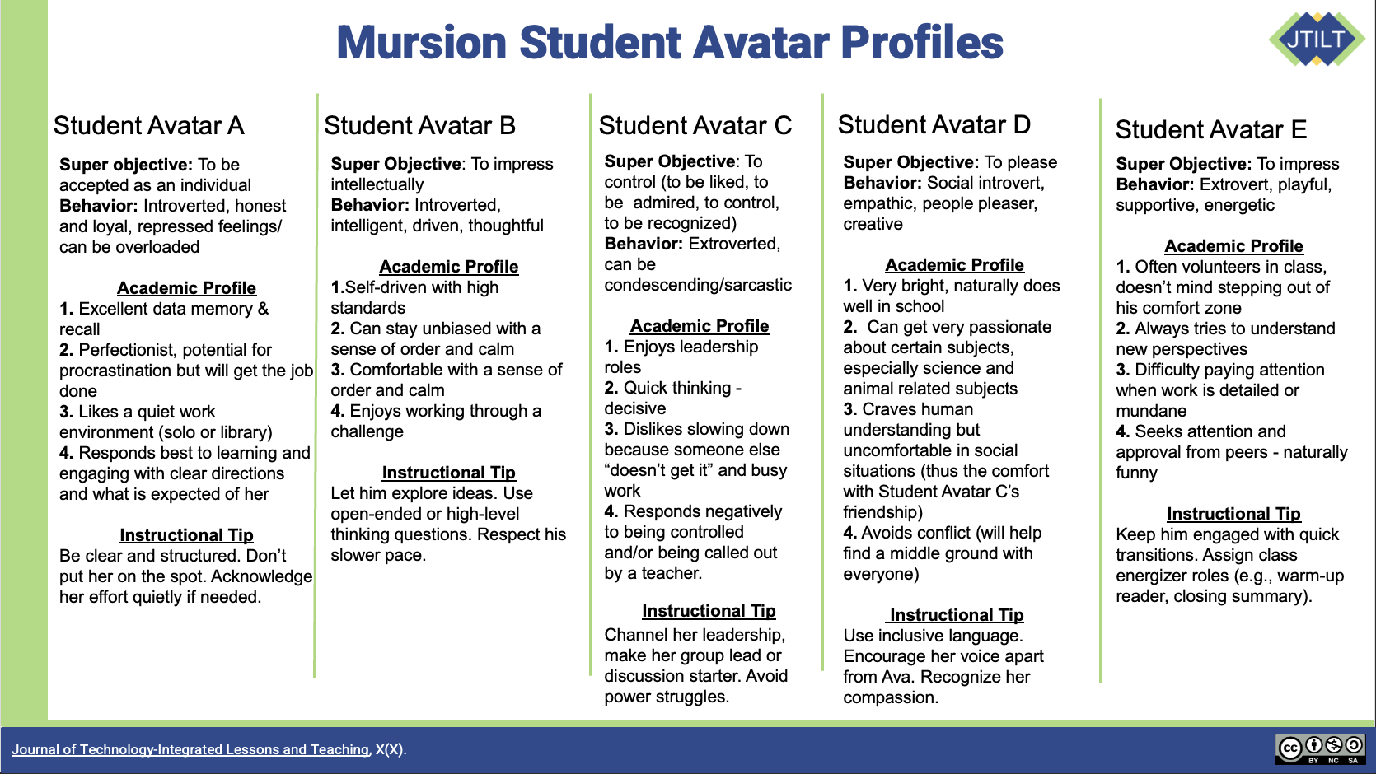
Figure 1. Mursion student profiles for PSTs, based on Mursion (2022).
that must be enacted within a constrained instructional context. PSTs are situated in a scenario in which they teach a short homeroom lesson where they have limited instructional time and, therefore, need efficient lesson openers and engagement strategies. This homeroom experience is later simulated using Mursion. PSTs are given student profiles (see Figure 1) to prepare for this scenario.
The PSTs then complete a guided Lesson Internalization worksheet (see Figure 2) designed to prompt anticipatory instructional thinking to support preparation for teaching practice in Mursion or another microteaching setting. Prompts guide PSTs to articulate lesson objectives in student-friendly language, identify central concepts, consider how to activate students’ prior knowledge, anticipate potential student questions or misconceptions, plan possible lesson openers, prepare responses for off-task behavior, and identify diverse learner supports.
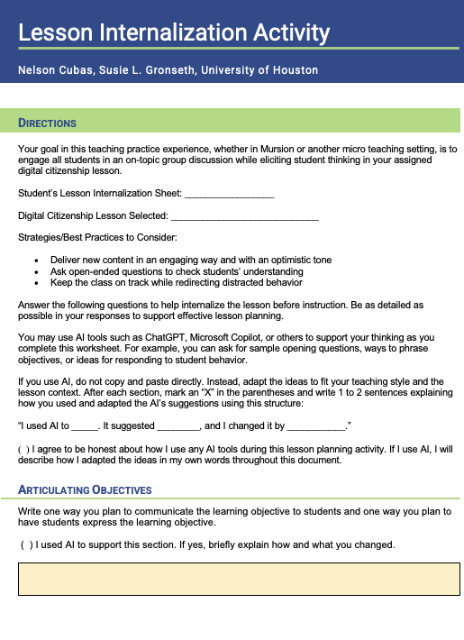
Figure 2. Lesson internalization worksheet sample.
PSTs are instructed that they may use AI tools such as ChatGPT and Microsoft Copilot to ask for help with internalizing the lesson. The instructor teaches them how to download the ISTE digital citizenship lesson (ISTE, n.d.) as a PDF and upload it to the chatbot to request feedback regarding the specific lesson. The instructor mentions that PSTs can use AI to ask for help in any of the sections in the worksheet by writing tasks such as “help me come up with two questions that middle grade students would ask in this lesson plan,” or “what are some important concepts that students would need to already know prior to being presented this lesson?”
PSTs are then asked to document whether AI tools were used for individual worksheet sections and explain how AI-generated suggestions were used and adapted in their own words. They are instructed to follow the template “I used AI to ____. It suggested _____, and I changed it by _____.” PSTs are encouraged to make deliberate decisions about when AI meaningfully supports instructional reasoning and when it does not.

Instructor Modeling and Guide Work
The instructor models the lesson internalization process using another example lesson to establish expectations and norms. Sample instructional decisions are discussed in each worksheet section, illustrating how planning decisions can be connected to anticipated student responses and lesson flow. Ethical and strategic AI use is modeled during this walkthrough. The instructor demonstrates how AI tools may be used to support brainstorming or perspective-taking while explicitly narrating moments where AI-generated suggestions are revised or rejected. For example, the instructor highlights instances in which AI responses lack depth or overstep professional norms, such as proposing language inappropriate for teachers to use or offering guidance related to parent–child negotiations. In these cases, the instructor explains why such suggestions require thoughtful adaptation or should be declined. PSTs are explicitly instructed not to directly copy or paste AI-generated language into their worksheets but to use the AI-generated suggestions in ways that help them think through their instructional planning decisions. They are reminded that they remain responsible for all instructional decisions and original wording.

Peer and AI Feedback
Following the completion of the initial lesson internalization worksheet, PSTs engage in a structured sequence of peer and AI feedback to help deepen their instructional reasoning. PSTs first exchange their completed lesson internalization worksheets with an assigned peer (referred to as their “critical friend”), and the partners provide targeted and constructive feedback on the PSTs’ written lesson internalization responses using a guided Critical Friends for Lesson Internalization Activity worksheet (see Figure 3).
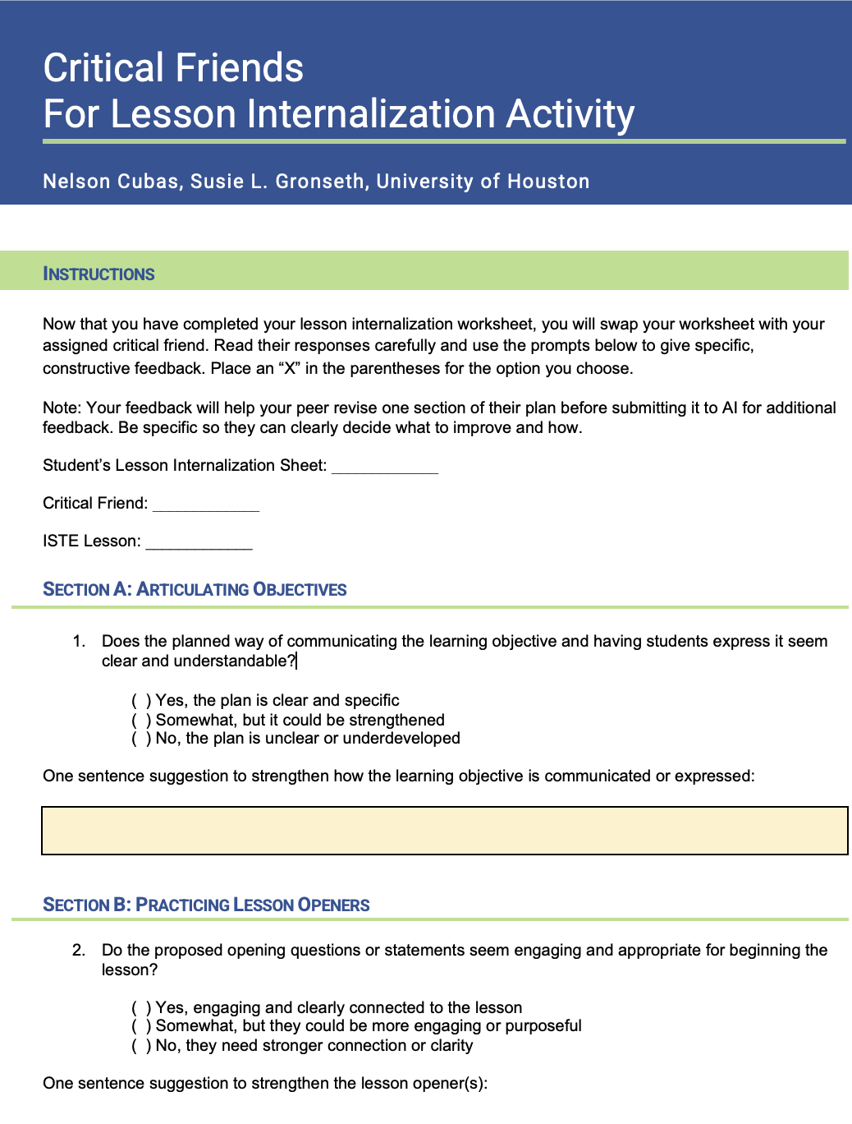
Figure 3. Critical friends for lesson internalization activity worksheet.
The feedback prompts focus on strengthening anticipatory instructional thinking in each worksheet section rather than evaluating lesson quality. PSTs are asked to provide specific and actionable suggestions in one or more areas related to lesson objectives, openers, main concepts, activation of prior knowledge, anticipated student questions, support for diverse learners, or classroom management strategies.
After completing the critical friend's activity, PSTs complete an Integrating Peer Feedback into Lesson Internalization Activity worksheet (see Figure 4), whereby they select one section of their lesson internalization worksheet to revise based on their critical friend’s feedback. They are instructed to document the original version of the selected section, summarize their peers' feedback for improvements, and briefly explain what they changed and why as they rewrite the section in their own words to reflect instructional improvements. This step aims to reinforce the expectation that feedback should inform their instructional reasoning rather than be applied uncritically.
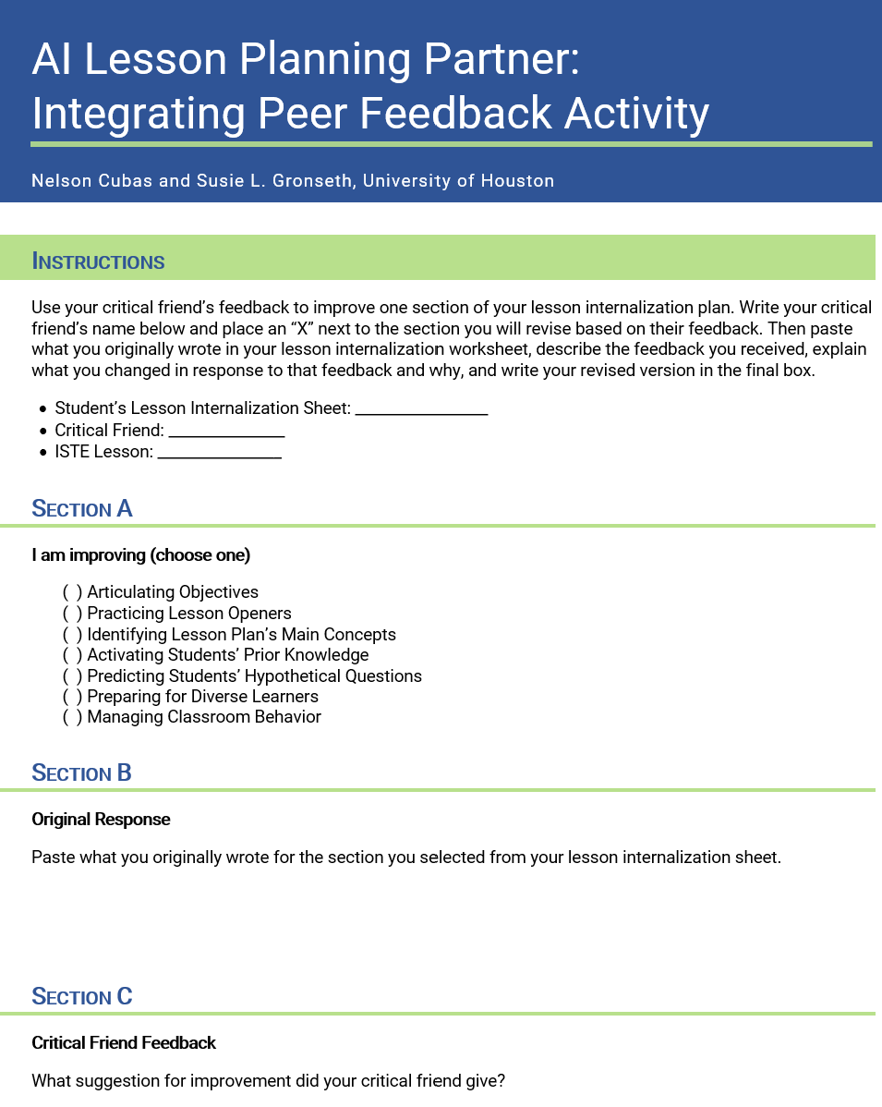
Figure 4. Integrating peer feedback into lesson internalization activity.
Following this revision, PSTs use AI to obtain additional insights. Using a structured AI as a Lesson Planning Thought Partner Activity worksheet (see Figure 5), they select the same section from the peer review to request feedback through an AI chat, such as Microsoft Copilot, ChatGPT, Gemini, Claude, etc. On the worksheet, they document their AI prompt, the full AI response, and their decision to adapt, partially adapt, or decline the suggestion, along with a brief explanation. PSTs then revise their lesson internalization worksheet accordingly and submit the completed lesson materials for class credit. Instructors may also choose to collect both original and revised versions of the lesson internalization activity worksheet to make changes across the feedback process more visible.
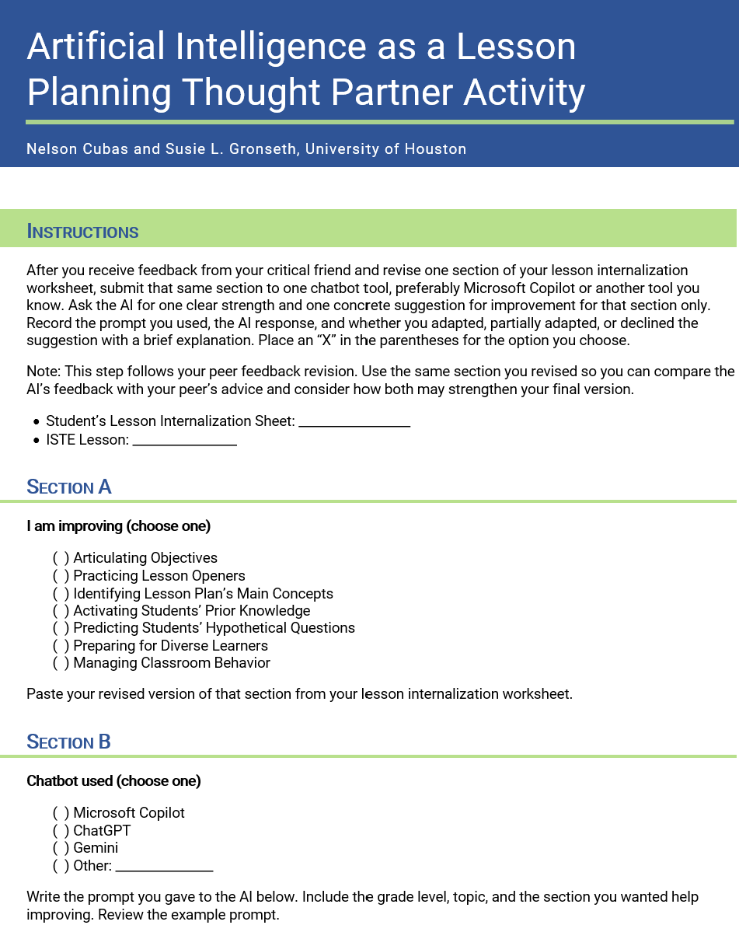
Figure 5. AI as a lesson planning thought partner activity.

Independent Rehearsal Preparation
Following the class session, PSTs retain their revised lesson internalization planning materials to use for independent rehearsal in preparation for the upcoming teaching practice experience, such as a mixed-reality simulation or peer microteaching rehearsal. During this time, PSTs are coached to continue to refine and practice for that experience using the materials as flexible planning references. They mentally rehearse lesson openers, anticipate student responses, and refine instructional transitions.
As they review their materials, PSTs are prompted to reflect on how their planning decisions may unfold when they try them out in the simulation. PSTs are invited to revisit their use of AI as well to explore additional engagement strategies or clarify anticipated student questions. They are also told they can choose to intentionally avoid additional AI use. Both approaches are framed as valid and productive towards instructional readiness.

Session 2: Mixed-Reality Rehearsal
In the second session, PSTs engage in a mixed-reality teaching rehearsal using Mursion. Each PST has the opportunity to deliver their lesson opener and initial instructional moves from their selected digital citizenship lesson. Teaching segments are intentionally limited to approximately five to six minutes to emphasize rehearsal of instructional decision-making in the opening portion rather than teaching the full lesson.
While each PST teaches, their peers observe the interaction between the PST and the avatar students. Peers are assigned rotating observer roles using a shared Padlet discussion board to structure observation and promote analytic noticing. Padlet (https://padlet.com/) is a collaborative digital bulletin board that allows participants to post brief written responses in real time, enabling multiple observers to document instructional observations during each enactment (see Figure 6).
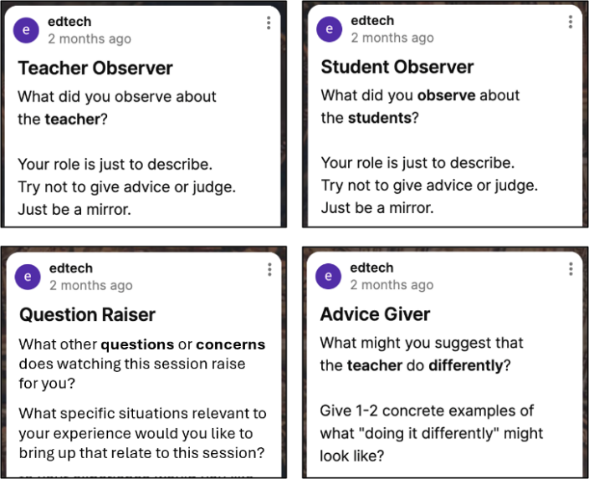
Figure 6. Peer observation roles in Padlet.
During each simulation, one group of peers focuses on describing the teacher’s instructional moves, another attends to student responses and engagement, a third identifies questions or tensions raised by the interaction, and a fourth offers concrete suggestions for how instructional moves might be adjusted. After each PST completes their simulation, observers rotate roles so that all students engage with multiple analytic perspectives across enactments. This rotation supports distributed attention and prevents any single enactment from being reduced to evaluative feedback alone. PSTs take screenshots of their completed posts and compile them onto Google Docs or Microsoft Word documents to showcase their participation in peer feedback during the simulations.

Debrief and Guided Reflection
Finally, the class engages in a structured whole-group debrief to support collective sensemaking and reflective analysis of the simulation experience. The instructor facilitates a guided reflection that draws on both PSTs’ teaching experiences and the Padlet observation posts.
Debrief prompts focus on planning and instructional responsiveness, including questions about how PSTs felt in their anticipation of student questions or comments, how they responded when unexpected interactions occurred, how classroom dialogue unfolded, and which teaching or learning moments were most salient during the simulations. These prompts are designed to help PSTs connect lesson internalization decisions to how they enact instructional practices and in-the-moment pedagogical reasoning. Padlet entries are revisited during the debrief to surface patterns across observations, highlight shared challenges, and identify instructional strategies that support student engagement and classroom management.

Critical Reflection
The lesson was initially developed and piloted in Spring 2025 in two in-person sections of the educational technology course. It was subsequently refined and implemented again in two Fall 2025 course sections. A total of 81 PSTs participated in the lesson activities across these four course sections. Institutional Review Board (IRB) approval was obtained prior to post-semester analysis of student worksheets.
We reflected on multiple data sources generated through the learning representation, including the Lesson Internalization Activity worksheet, Critical Friends for Lesson Internalization Activity worksheet, Integrating Peer Feedback into Lesson Internalization Activity worksheet, and AI as a Lesson Planning Thought Partner Activity worksheet. We also relied on data from Padlet observation posts completed during the mixed-reality simulations, instructor field notes, and student reflections. These artifacts provided insight into how PSTs reasoned through their lesson preparations, engaged with peer and AI feedback, navigated decisions about when and how AI supported their instructional thinking, and perceived value in the activities.
Across the implementations, more than 50% of PSTs agreed or strongly agreed with the statement, “The structure of the lesson internalization sheet helped me stay on track during the Mursion session.” In the final course reflections, many PSTs identified the lesson internalization and mixed reality rehearsal sequence as one of the most meaningful components of the course. For example, one PST remarked, “The Mursion activity was phenomenal and very fun... I had a blast taking the skills I learned in my student observations this semester and using them in this activity.” Another student mentioned, “Another assignment that was really fun was when we had to do the interactive simulation with the middle schoolers. I was really nervous to participate, but it gave me a feel for what it could really look like when I am in the classroom. I feel as if I had a good experience and even saw what I need to improve on.”
A smaller subset of PSTs reported experiencing moments of difficulty during the simulation, especially when responding to unexpected student behaviors. Some also struggled with maintaining lesson pacing or adapting when classroom dialogue diverged from the anticipated responses. These remarks suggest that although the worksheets supported lesson planning, the simulation exposed the PSTs to the kinds of instructional decisions and uncertainties they must learn to navigate during early teaching practice.
Together, these data sources indicate that the lesson supported PSTs in developing instructional preparedness and reflective awareness of their planning and enactment process. It served to foreground lesson internalization as a professional planning practice and to position AI as an optional support for instructional reasoning rather than a prescriptive solution. The structured prompts encouraged PSTs to surface assumptions about student understanding, anticipate potential misconceptions, and consider how instructional choices might unfold during mixed-reality enactment. The sequencing emphasizes anticipatory thinking, rehearsal, and comparison across feedback sources to help PSTs make deliberate decisions about instructional preparation prior to enactment.
The low-stakes assignments in the lesson, including the lesson internalization worksheet and the mixed-reality teaching practice, positioned lesson preparation as a rehearsal opportunity meant to foster confidence and growth. In this way, lesson preparation, feedback, and simulation-based rehearsal served as formative experiences embedded within the course rather than as high-stakes assessment tasks. This design supports experimentation, ethical decision-making, and reflective practice without discouraging risk-taking through potential performance pressure.
The first session class period allowed sufficient time for the PSTs to complete the internalization worksheet, exchange feedback, revise one selected section, and, if desired, consult an AI tool for an additional comparison. This pacing structure was intentionally designed to prevent cognitive overload and procedural rushing while preserving space for deliberation, revision, and instructional reasoning.
The AI-generated feedback activity was intentionally sequenced after peer feedback and applied to the same section students had already revised based on their peer’s suggestion, so that the human-mediated instructional reasoning remained the primary source of revision. AI was viewed as one perspective among several rather than as an authoritative source. This sequencing foregrounds deliberation and comparison across feedback sources and supports PSTs in examining how peer and AI input differentially inform instructional clarity, student perspective-taking, and professional judgement.
Padlet responses were completed in real time and emphasized description, interpretation, and questioning rather than judgment. This structure encourages PSTs to connect their lesson internalization decisions to observable teaching practice, student behavior, and instructional contingencies. After the simulation rehearsal, Padlet entries supported whole-group discussion on alignment between planned instructional moves and enacted practice, as well as areas where instructional reasoning may need revision.
The debrief centered on instructional reasoning, decision-making processes, and the relationship between planning, enactment, and adaptation. Together, the lesson internalization activities, feedback structures, simulation rehearsal, and guided reflection led PSTs in lesson preparation as a dynamic, adaptive professional practice rather than a static document task. This design reframes planning as a form of instructional rehearsal that supports anticipatory thinking, pedagogical judgement, and professional sensemaking prior to classroom enactment.

Instructional Design Reflections
PSTs engaged in the lesson in ways that suggested that the lesson internalization activity functioned as more than a preparatory checklist; instead, it operated as a cognitive planning scaffold that supported anticipatory reasoning, instructional coherence, and professional sensemaking prior to enactment. Analysis of student worksheets, reflections and observational data indicated that PSTs increasingly treated lesson internalization as an interpretive process through which they reasoned about instructional flow, student thinking, and pedagogical decision-making.
The integration of peer feedback and optional AI comparison further supported PSTs in examining their instructional reasoning from multiple perspectives without positioning any single source as authoritative. An important takeaway is that AI’s role in the learning representation needed to remain bounded by design. Engaging with AI after initial planning and peer feedback encouraged PSTs to develop and articulate their own instructional intentions before consulting AI tools. This structure allowed PSTs to critically evaluate AI-generated suggestions and decide whether they meaningfully contributed to instructional clarity or student perspective-taking.
The mixed-reality rehearsal further transformed planning into enacted cognition by making the relationship between anticipatory reasoning and in-the-moment instructional action visible. Simulation-based teaching and structured observation supported analytic noticing of how internalization decisions shaped classroom interaction, student responses, and instructional contingencies. Planning, enactment, and reflection became cognitively linked rather than pedagogically separated. This process was done strategically to allow PSTs to experience preparation as an adaptive reasoning cycle. The learning representation thus frames instructional planning as a site of epistemic development where professional knowledge is constructed through sensemaking, evaluation, and adaptive decision-making.

Limitations & Future Refinements
The mixed-reality rehearsal focused on brief lesson openers rather than full lessons, which constrained opportunities to examine sustained instructional decision-making. AI use was optional, resulting in varied levels of engagement that limit direct comparison between AI-supported and non-AI-supported planning approaches. Additionally, the lesson involved a single simulation cycle, which restricted opportunities for iterative rehearsal and revision. Another limitation is that access to mixed reality platforms such as Mursion may not be available in all teacher preparation programs due to financial or technological constraints.
Future implementations can address limitations by incorporating multiple rehearsal cycles, expanding enactments beyond lesson openers, and designing structured opportunities for PSTs to compare planning decisions across repeated simulations. When mixed-reality platforms are not available, instructors can modify this lesson internalization activity by using peer microteaching rehearsals in which PSTs practice lesson openers for classmates who role-play student responses. To make this adaptation more feasible in teacher preparation settings with fewer technological resources, we also include lecture slides for a microteaching rehearsal format in addition to the Mursion-specific slides. The lesson internalization materials and rehearsal components may also be adapted for either individual or small-group implementation, depending on class size, available time, and instructional goals. These refinements aim to deepen PSTs’ understanding of lesson internalization and further support reflective, judgment-centered engagement with AI within professional instructional practices.

References
Cooper, G., Tang, K.-S., & Fitzgerald, A. (2025). Intersections of mind and machine: Navigating the nexus of artificial intelligence, science education, and the preparation of pre-service teachers. Journal of Science Education and Technology, 34(6), 1255–1259. https://doi.org/ 10.1007/s10956-025-10200-9
Dalinger, T., Thomas, K. B., Stansberry, S., & Xiu, Y. (2020). A mixed reality simulation offers strategic practice for pre-service teachers. Computers & Education, 144, 1-15. https://doi. org/10.1016/j.compedu.2019.103696
Dieker, L., Hughes, C., & Hynes, M. (2023). The past, the present, and the future of the evolution of mixed reality in teacher education. Education Sciences, 13(11), Article 1070. https://doi.org/ 10.3390/educsci13111070
Grossman, P., Hammerness, K., & McDonald, M. (2009). Redefining teaching, re-imagining teacher education. Teachers and Teaching, Theory and Practice, 15(2), 273–289. https://doi.org/10. 1080/13540600902875340
International Society for Technology in Education. (n.d.). Digital citizenship lessons. Retrieved June 16, 2026 from https://iste-ascd.org/digital-citizenship-lessons
International Society for Technology in Education. (2017). ISTE standards: For educators. https://www.iste.org/standards/iste-standards-for-teachers
International Society for Technology in Education. (2016). ISTE standards: For students. https://iste.org/standards/students
Lu, X., Zaitseva, A., & Troyan, F. J. (2025). AI literacy: A core practice in world language education. Foreign Language Annals, 59(1), 9-33. https://doi.org/10.1111/flan.70037
Mursion. (2022, December 5). Middle school reference materials [PowerPoint slides].
Narayanan, M., Shields, A. L., & Delhagen, T. J. (2024). Autonomy in the spaces: Teacher autonomy, scripted lessons, and the changing role of teachers. Journal of Curriculum Studies, 56(1), 17–34. https://doi.org/10.1080/00220272. 2023.2297229
Nguyen, N. N., & Barbieri, W. (2025). Mentorship in the age of generative AI: ChatGPT to support self-regulated learning of pre-service teachers before and during placements. Education Sciences, 15(6), Article 642. https://doi.org/10.3390/ educsci15060642
Runge, I., Hebibi, F., & Lazarides, R. (2025). Acceptance of pre-service teachers towards artificial intelligence (AI): The role of AI-related teacher training courses and AI-TPACK within the Technology Acceptance Model. Education Sciences, 15(2), 1-17. https://doi.org/10.3390/ educsci15020167
Wen, H., & Wen, W. (2025). “The brain’s behind the operation”: Using activity theory to investigate pre-service teachers’ processes of designing AI-assisted unit plan. Journal of Research in Childhood Education, 40(1), 90-107. https:// doi.org/10.1080/02568543.2025.2578528

Support Materials
Mursion. (n.d.). Solutions (Education section). https://www.mursion.com/solutions/education/

About the Authors
Nelson Cubas is a doctoral researcher in Curriculum and Instruction at the University of Houston with a focus on Learning, Design, and Technology. His research examines how mixed-reality simulations and AI-supported rehearsals can help future teachers connect lesson planning to real-time instructional decisions. He may be contacted at nwcubas@gmail.com.
Susie L. Gronseth is a Clinical Professor in the Learning, Design, and Technology program area in the College of Education at the University of Houston. She specializes in learning technologies, instructional design and evaluation, health sciences education, and the application of Universal Design for Learning (UDL) to address diverse learner needs in online, face-to-face, and blended contexts. She can be contacted at slgronseth@uh.edu.

Sharing & Modification Permissions
Unless otherwise noted, this article and its resources are published under a Creative Commons Attribution-NonCommercial-ShareAlike 4.0 International license:

You can freely share the article and its resources if you indicate the original authors, identify the Creative Commons license, and use them non-commercially.
You may also make and share modifications by:
- Identifying the original authors.
- Using the resources non-commercially.
- Licensing modifications under the CC BY-NC-SA 4.0 license (and including a link to it).
- Indicating what modifications were made.

