Exploring Biomes and Ecosystems
Using Artificial Intelligence Tools
  - Aishat O. Balogun¹ and Ajarat O. Balogun²,
¹Indiana University Bloomington, ²Bloomington High School North

Overview
This activity is part of a series of environmental science lessons designed for 11th–12th grade students that focuses on biomes, ecosystems, and human impacts on environmental systems. Serving as the culminating project, this activity builds on prior learning and requires students to demonstrate understanding through artificial intelligence tools. Students explore various biomes, identify ecosystems, research human impacts, and investigate strategies for sustainability. Throughout the unit, students use AI tools to create visual products and support content understanding. The activity concludes with student presentations.
Keywords: Artificial intelligence, Biomes, ecosystems, Human Impact, Sustainability
Time: 60 to 75 minutes. Multiple class sessions are required to complete all aspects of the activity.

Materials
- Computer with internet and Google drive access
- Learning Management System
- Cellphones or mobile devices
- Teacher and student accounts on https://www.magicschool.ai/
- Presentation

Setup
Set up teacher and student MagicSchool AI accounts and create the teacher MagicSchool AI room. Share the sign-up link with students prior to the activity. Review the AI tools students will use and ensure their easy access during the activity. Students will work in small groups so provide space for group discussions.

Context-at-a-Glance
Setting
Activity designed for 11th–12th grade students in a suburban public high school in the United States.
Modality
In person
Class Structure
The activity is part of a graded science course that meets for 75 minutes every other day using a block schedule throughout the school year.
Organizational Norms
The course is a yearlong elective science option offered by the school.
Learner Characteristics
Class enrollment typically ranges from 15 to 35 students, primarily juniors and seniors who have completed other science courses but require a third science credit to meet graduation requirements.
Instructor Characteristics
Instruction is led by two high school science teachers. One has experience teaching in higher education. The other instructor has taught in international and elementary school settings.
Development Rationale
This activity serves as the culminating project in a sequence of ecology-focused topics. Students review and apply key concepts using targeted artificial intelligence tools to create artifacts demonstrating their understanding.
Design Framework
This activity is guided by the Adaptive Learning 4A Model (De Leon & Santos, 2019), emphasizing knowledge acquisition, abstraction, and contextual application.

Context and Setting
This activity was developed as part of a five-week environmental science unit delivered in 60–75-minute block-scheduled classes during the introductory study of environmental science and ecosystems. The course is offered at a suburban public high school in the Midwestern United States and is available as both a general credit and Advanced Placement (AP) elective within the science department. It is primarily taken by 11th- and 12th-grade students seeking a third science credit to meet graduation requirements. The activity is adaptable for both course levels, with increased rigor and depth of analysis for AP students. Typical class sizes range from 15 to 35 students. Canvas is used as the learning management system, while Google Drive supports collaboration and content sharing.
This activity intentionally integrates MagicSchool AI, an education-focused artificial intelligence platform recently adopted by the school. AI is used to scaffold research, support visualization of complex ecological relationships, and assist students in synthesizing information across biomes and ecosystems. By generating and refining artifacts such as visuals and explanatory content, students engage in higher-order thinking processes, including analysis, evaluation, and application of ecological concepts. In this way, AI enhances learning by supporting sense-making, conceptual transfer, evidence-based reasoning, and student engagement.
The activity may be delivered synchronously or asynchronously using Canvas, with Microsoft Teams or Zoom facilitating online collaboration when needed. While some components are completed in class, others may be assigned outside of class to fit within the five-week unit timeline. Students work collaboratively to research, review, and apply ecological concepts, using AI tools to create artifacts that demonstrate their understanding. Collaboration is emphasized to promote shared learning and multiple perspectives, with Google Drive used to support idea exchange throughout the project.

Learning Representation
The introduction to environmental science and ecosystems unit spanned approximately five weeks and coincided with the school district’s adoption of MagicSchool AI, an education-focused artificial intelligence platform. This activity was intentionally designed as the culminating project for the unit, allowing students to consolidate their understanding of ecological concepts while simultaneously developing proficiency with AI-supported learning tools. Students were given one week to complete the project, culminating in class presentations of their final products.
The instructional design followed a learner-centered approach aligned with the Adaptive Learning 4A framework (De Leon & Santos, 2019). Students first engaged in anchoring activities through research to activate prior knowledge. During the abstraction phase, students learned how to use MagicSchool AI tools to synthesize new information and refine their understanding. In the application phase, students integrated ecological concepts and AI tools to create artifacts demonstrating their learning. This structure ensured clear alignment between lesson objectives (concept mastery and tool fluency), assessments (research, artifact creation, and presentation), and deliverables (AI-generated products and explanations), reinforcing both conceptual understanding and applied skills.
The Adaptive Learning 4A Model (De Leon & Santos, 2019) provides a strong pedagogical framework for this activity by structuring learning around knowledge acquisition, abstraction, and contextual application. During the acquisition phase, students build foundational understanding of biomes, ecosystems, and human impacts through guided research and curated resources. The abstraction phase is supported through the use of MagicSchool AI tools, which help students synthesize information, identify patterns across ecosystems, and translate complex ecological relationships into visual and conceptual representations.
Finally, contextual application occurs as students use AI-generated artifacts to apply their understanding to real-world environmental challenges, such as sustainability strategies and human-environment interactions. By aligning AI tool use with each stage of the 4A Model, the activity
ensures that the technology supports cognitive development and conceptual transfer rather than surface-level engagement, reinforcing deeper ecological understanding and adaptive learning.
This activity is an opportunity to create an “AI ready graduate” who is an “empowered learner” using AI tools to create media, learn new skills, synthesize information, think critically and reflect while envisioning new possibilities (ISTE, n.d.). Meanwhile the instructor acts as a facilitator and guide to manage the activity as students learn how to responsibly use these tools.

Teacher Preparation
Instructors are encouraged to review multiple online tutorials about how to maneuver the MaginSchool AI before the activity begins. The activities outlined here should be completed by the teacher ahead of time (before students start the activity). These include:
- Create the teacher MagicSchool AI room (see Figures 1-8). Note: Screenshots from MagicSchool AI (https://www.magicschool.ai) used for instructional demonstration purposes.
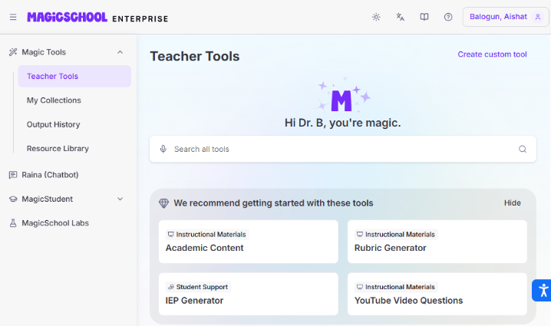
Figure 1: Image for teacher sign in page.
Remember to create rooms ahead of the activity so students can access the information and materials.
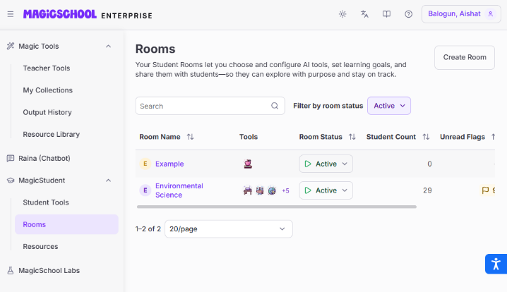
Figure 2: Create a room view from teacher dashboard.
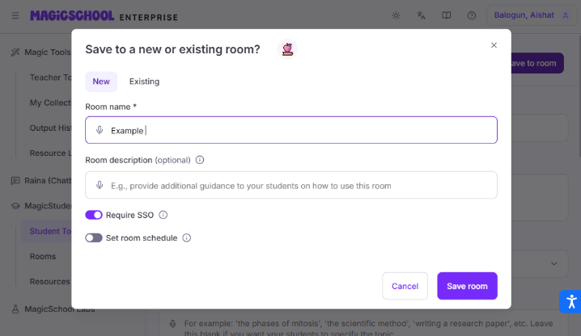
Figure 3: Save room view.
- Add tools you want students to access to the room you created. For this activity, the tools included a study bot, student support chatbot, AI tutor, text translator, image generator, text rewriter, text summarizer, text proofreader, and Raina (another chatbot and learning assistant) for students. Teachers should pick tools they feel their students will need for the specific activity they want to complete.
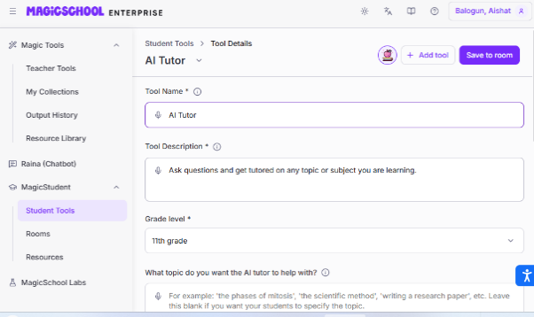
Figure 4: AI tool selection view.
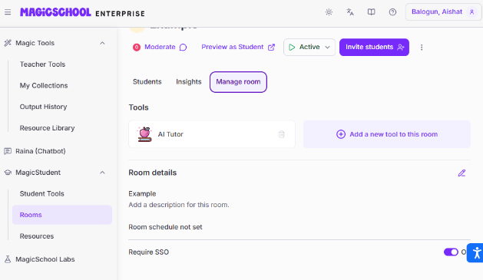
Figure 5: Example of AI tool selected view.
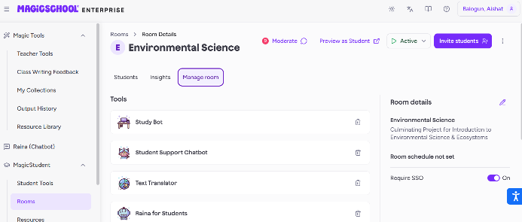
Figure 6: Manage room view to manage tools.
- Share the sign-up link with students.
Walk students through platform sign-in. Remember to share the link to join the room you have created.
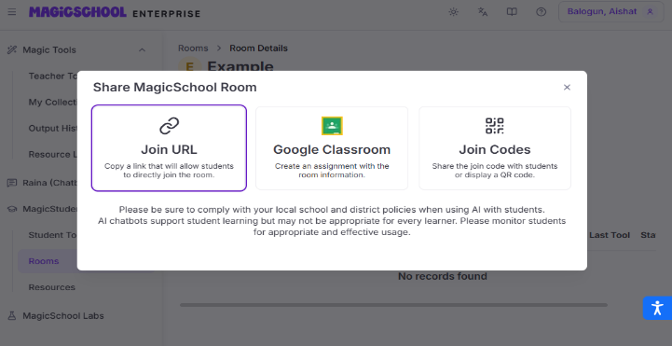
Figure 7: Option for student to sign in.
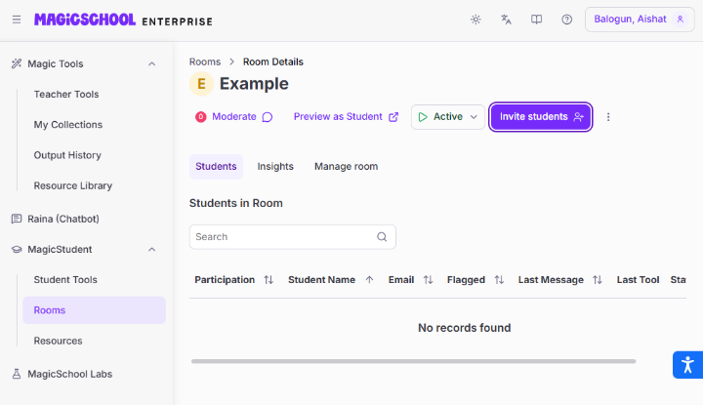
Figure 8: Invite students view.

Objectives
The following objectives guided this activity:
- Students will analyze how deforestation, urbanization, and industrialization impact biodiversity and ecosystem health.
- Students will identify renewable energy, conservation, and restoration technologies that help adapt environments to human needs.
- Students will propose strategies to sustain biodiversity considering ecological, social, and economic factors at various levels.

Anchor: Activate Prior Knowledge
The start of the activity entailed a review of ecosystem information especially focused on human impact on biodiversity and ecosystem sustainability. Using the Culminating project environmental science lecture PowerPoint, show slides 1 through 12.
Ask students questions to prompt their recall of information about the ecosystem. Some of the question prompts used are:
- What is a Biome?
- What is an ecosystem?
- Provide examples of ecosystems\

When examples of ecosystems are mentioned, ask questions specific to each ecosystem:
- What threats are specific to the ecosystem mentioned?
- What are the impacts of these threats to the ecosystem?

Abstraction: Apply new knowledge
After reviewing slides 1 through 12, open the website for MagicSchool AI and introduce the platform. Share slides 13 through 18 for students to sign in to the platform. You can share the link to the website directly via the Canvas LMS or a QR code so students can easily access the website.

Application
This is the section that provides specific information about the project. Share the information on slides 19 through 23 with students—specifically the project purpose, focus, and deliverables.
Review how technology can be integrated in the project and share the project assignment. Specify exactly what students are supposed to deliver at the conclusion of the project. This includes the following:
- A presentation about the selected ecosystem that covers all project objectives;
- A science fiction script about the selected ecosystem, addressing human impact and sustainability in the selected ecosystem;
- A visual poster about the selected ecosystem.

Critical Reflection
This was a very interesting and useful activity that provided an opportunity for students to use AI tools in the context of a unit. The students were able to review concepts while leveraging AI tools to demonstrate understanding of the concepts. By crafting artifacts, they were able to reflect on their grasp of the course content, which was one of the objectives of the activity.
The activity was very successful in getting the students to engage with new technology without making it an activity focused just on learning how to use AI tools. The students felt it made learning about the tools more fun since it was in the context of what they were working on. The AI tools appeared to provide students with more options to conclude a project.
Students were also glad that the tools they used (e.g., the text rewriter, text translator, and text summarizer) made it easier for them to express themselves. For instance, the text rewriter was very helpful in generating a movie script that the groups used to express what they felt about how to save or manage their selected ecosystems. It enabled students to be creative with the solutions they proposed for revitalizing destroyed ecosystems. Students also said the AI tools made the concepts they were learning more vivid. This made the activity come alive by including tools that enabled students to portray real life implications in various formats like posters and movie scripts.
From an instructor perspective the AI tools provided an opportunity for students to think critically, reflect on their work, review the strengths and weaknesses of various tools, and reinforce that AI tools are not replacements for their efforts. Rather, these tools are a means to improve efficiency.

Challenges
While the project was successful and students appreciated the opportunity to use AI tools that could portray their work and assist in generating the materials, there were a few challenges.
Making the students review the ecological concepts at the same time as completing the project was challenging for some of students. These students felt they were playing catch up and trying to grasp the information while learning new things. This overlapped structure disrupted to how they learned.
Adjustments had to be made that allowed students to become more familiar with the tools before using them for the activity. This made the project period last longer than what we had anticipated (hence the note at the beginning of this activity regarding time). Next time, we would spend more time during previous lessons to show examples of how to use the tools before letting students begin the project.

Personal Beliefs and Choices
Although the use of AI tools was a major component of this activity, some students shared their apathy or hesitation with these tools. Limiting students to AI tools made a few unhappy. These students felt they should not be required to use tools for the project that they did not agree with.
While we were surprised with these comments, we respected student choices and allowed flexibility in the use of AI tools to complete the project. For instance, one student refused to use AI tools for visual illustrations. However, the same student used another app to draw their visuals.

Copyright Concerns
One project submission that students completed was a movie script about the ecosystem. Students used the text rewriter tool to complete this aspect of the project. Since the tool rewrote existing information, most students used an existing movie synopsis as the prompt generator. The result was a script that closely resembles the existing movie. This could be regarded as plagiarism if shared outside the classroom. However, for this activity we asked students to share their original movie synopsis and discussed how far they could share the resulting material and how they should cite the source document.

Future Modifications
While the activity was considered a success, it is apparent that some modifications would make it better. These include:
- Providing more specific and targeted rubrics that emphasize copyright implications.
- Including a section that explicitly teaches students how to frame prompts used for the AI tools (thereby reducing the risk of copyright infringement when creating multimedia materials).
Instructors should also take into consideration the digital divide that may exist in the classroom between tech savvy students and reluctant users. The means making sure group dynamics are considered to ensure all groups have those who are active users of technology (creators, analyst) and passive users of technology (content consumer).

Conclusion
Overall, this activity was successful in meeting its objectives. The students were glad with their finished work and appreciated the opportunity to act as AI tool reviewers. Although some struggled initially, they adapted quickly to the use of these tools. The activity was a great way to review scientific concepts while learning and applying new skills.

References
Carreon, J., Baltazar, M., De Leon, V. P., Peñaredonda, M. R., & Santos, R. F. (2019). The use of 4A model instructional strategy to improve the reading skills of grade 7 students. Research Gate. https://doi.org/10.13140/RG.2.2.17674.11207
Magic School. (2025). MagicSchool.ai - AI for teachers - lesson planning and more! https://www.magicschool.ai/
International Society for Technology in Education. (n.d.). Generation AI: Transforming teaching and learning. https://www.iste.org/generationai
International Society for Technology in Education. (n.d.). ISTE standards for educators. https://iste.org/standards

About the Authors
Aishat Olere Balogun likes to read, travel, and create multiple opportunities for students to extend STEM outside the school/classroom curriculum. Her interests include science education; STEM; and the intersection of technology, learning, and its application to education. She is currently a 9th - 12th grade science teacher, an adjunct professor, and a Fulbright specialist.
Ajarat O Balogun has taught both elementary math and high school science for a couple of years in various countries. She loves to read, cook, travel and explore ways to improve her teaching across various contexts. She is currently exploring teaching science in the American high school system.

Sharing and Modification Permissions
Unless otherwise noted, this article and its resources are published under a Creative Commons Attribution-NonCommercial-ShareAlike 4.0 International license:

You can freely share the article and its resources if you indicate the original authors, identify the Creative Commons license, and use them non-commercially.
You may also make and share modifications by:
- Identifying the original authors.
- Using the resources non-commercially.
- Licensing modifications under the CC BY-NC-SA 4.0 license (and including a link to it).
- Indicating what modifications were made.

