AI Education for Young Children (PreK-2): Nurturing Curious and Creative Thinkers
  - Sohheon Yangª and Anne Winiger^{b}; ªIndiana University, ^{b}A Public Elementary School

Overview
This curriculum introduces PreK-2 students to Artificial Intelligence (AI) to foster curiosity, agency, and ethical awareness. Structured around the AI4K12 framework, the 12 themed lessons cover four phases: 1) digital technology, 2) representation and reasoning, 3) natural interaction and perception, and 4) ethics and societal impact. Individual activities are designed to span 20-30 minutes. Students engage with various web tools, drawing supplies, and screen-free robots. The curriculum cultivates curiosity and ethical awareness of AI. Student questions, discussions, and ideas evidence learning. Students also create their own AI. Assessment occurs through classroom observation, conversation, and student-made artifacts.
Topics: AI, symbolic representation, machine learning, ethics
Time: 20-30 minutes per activity; 10-11 hours total (which can be spread over multiple days).

Materials
- Websites: Book Creator, Magic School AI, Scroobly*, AutoDraw*, Quick, Draw!*, Animated Drawing*, and Teachable Machine*
- Non-digital tools: Tale-Bots and drawing supplies
- Video-editing tool: iMovie
- Storybooks: Artificial Intelligence for Kids by Dr. Dhoot*, and AI+Me Big idea 1-5 series by ReadyAI* (See the support materials)
- Presentation slides
- Computer equipment: Classroom touchscreen TV*, webcam*, and microphone
- Interview Questions and assessment rubric
* Required tools for this curriculum. Other tools can be swapped out with similar items.

Context-at-a-Glance
Setting
A Midwestern U.S. public kindergarten.
Modality
Face-to-face.
Class Structure
Team Teaching: A teacher led the co-designed lessons while a researcher assisted. The lessons include circle time, story time, whole-group or small-group discussions, and station or free play.
Organizational Norms
The curriculum meets Indiana academic standards.
Learner Characteristics
26 five-to-six-year-olds of undisclosed ethnicity. Though iPad-proficient and familiar with home devices like Alexa, they had no formal AI experience.
Instructor Characteristics
A teacher with 25 years of experience co-designed the curriculum with an AI education researcher with 4 years of kindergarten teaching experience. Instructors need to possess the technical fluency required for tool management and troubleshooting and/or a growth mindset to explore and master the various tools used in these lessons.
Development Rationale
Despite the benefits of AI curricula for children’s literacy and core competencies, a significant gap remains in curriculum design for early childhood education.
Design Framework
Co-design was employed to create a curriculum where a teacher and a researcher collaborate to design and evaluate (Roschelle & Penuel, 2006), while incorporating students’ voices into the curriculum.

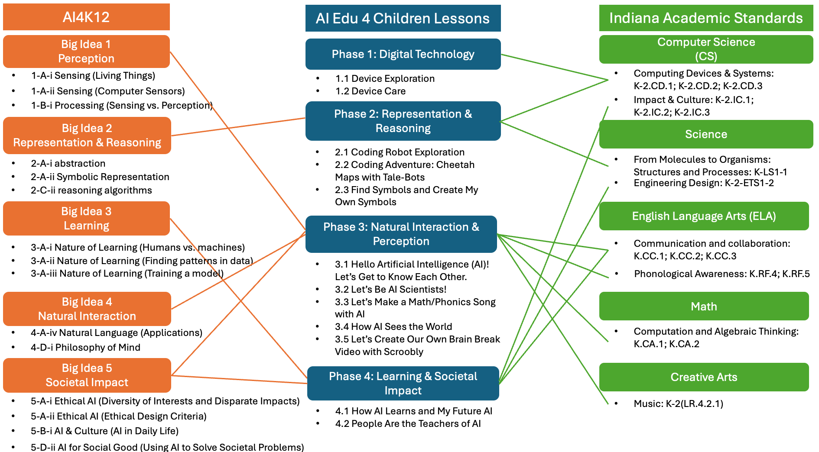
Figure 1. The AI Edu 4 Children Curriculum Framework.

Standards
The AI Edu 4 Children curriculum design was guided by the Artificial Intelligence for K-12 (AI4K12) initiative (2020). This framework outlines the Five Big Ideas: Perception, Representation and Reasoning, Learning, Natural Interaction, and Societal Impact (AI4K12.org, 2020a, 2020b, 2021, 2022a, 2022b). From these, we extracted the most relevant components for a student-tailored curriculum.
Also, the curriculum aligns with the Indiana Academic Standards for kindergartners (IDOE, 2023), specifically incorporating those identified as core standards by the elementary school. They include Indiana Early Learning Standards, English Language Arts (ELA), Math, Science, Social Studies, and Computer Science (CS). These lessons are designed to be adaptable across various educational contexts.
The curriculum has four phases: 1) digital technology, 2) representation and reasoning, 3) natural interaction and perception, and 4) learning and societal impact/ethics. Figure 1 illustrates how each phase aligns with the AI4K12 Big Ideas and Indiana Academic Standards. Phase 1 is foundational, bridging existing knowledge with AI learning.

Context and Setting
While AI is omnipresent in young children's lives, there is limited discussion regarding early childhood AI education. Several studies show that AI curricula can benefit not only students’ AI literacy (Lin & Van Brummelen, 2021; Williams, 2018) but also other competencies such as social-emotional skills, creativity, problem-solving, inquiry, and collaboration (Kewalramani et al., 2021; Su et al., 2023). However, a primary challenge remains the “lack of curriculum design” (Su et al., 2023, p. 10). Therefore, further research and design efforts are essential to create developmentally appropriate learning experiences for young children within AI education.
Co-design was employed to create a curriculum where a teacher and a researcher collaborate to design and evaluate (Roschelle & Penuel, 2006), while incorporating students’ voices. Specifically, the teacher’s expertise in the existing curriculum and her students' developmental stages was integrated with the researcher’s expertise in early childhood AI education to provide a developmentally appropriate learning experience.
The co-design process was initiated by the researcher, who was conducting an independent study on early childhood AI education. The researcher reached out to the teacher they had previously met at a technology-focused practitioner conference to gauge her interest in the co-design project, as shared needs and interests are essential. Although the teacher was new to AI, she was interested in the project and actively engaged with it.
For implementation, the teacher primarily delivered the co-designed lessons, while the researcher assisted and facilitated specific activities. The teacher has 25 years of experience in a U.S. kindergarten, which helped connect ideas into existing curriculum, her regular teaching practice, and her students’ developmental stages to improve feasibility of lessons. The researcher has 4 years of kindergarten experience in South Korea and has expertise in technology integration, which helped facilitating tools and ideas exploration. Both valued playfulness in early childhood education
Given this context, it is essential for instructors to have a growth mindset to learn new technologies. While it is ideal for the lead instructor to have an advanced level of technological fluency, they can also be supported by an assistant with stronger technical skills if they work collaboratively.
The learners consisted of 26 kindergartners aged five to six. They were proficient with iPads as the classroom provides 1:1 iPad support. While some students had previously encountered AI in their daily lives through Alexa or AI camera filters, they were not yet aware of the technology behind them. Additionally, the fact that some children used Snapchat or TikTok highlighted the importance of the subsequent lesson on privacy. This curriculum served as learners’ first formal introduction to AI education. Their typical day included ELA, math, brain breaks, recess, lunch, stations, and specials such as music or STEM.
The curriculum design was guided by four key principles aimed at fostering students’ curiosity and agency through AI education: 1) nurturing curious and creative thinkers, 2) promoting playfulness through hands-on activities, 3) centering children’s interests through a contextualized approach, and 4) emphasizing the human role in the AI era. These principles were co-constructed by the teacher and researcher as they articulated their pedagogical beliefs through an iterative co-design process grounded in cycles of experience and reflection. Furthermore, these principles demonstrated how the AI4K12 Five Big Ideas can be effectively integrated and tailored for early childhood classrooms. Rather than following a prescribed order, we synthesized the AI4K12 Five Big Ideas through an iterative co-design process. This allowed us to tailor the sequence based on our discussions to provide the most effective learning experience for the students.
First, the curriculum aimed to nurture curious and creative thinkers. The initial impetus for designing an AI curriculum for young children stemmed from a fundamental inquiry: What, why, and how of AI education in early childhood? From our first-hand experience in designing and implementing it, we have valued AI education as a way of nurturing curious and creative learners who develop their own learning agency, critical thinking, and creativity in this rapidly changing era, while recognizing that AI education can serve many different goals.
Second, the curriculum emphasized playfulness through hands-on activities. Play is central to early childhood education. Although the lesson plans include some structured activities, we infused playfulness into them by integrating hands-on experiences and connecting with children’s prior knowledge and interests. These include drawing, movement, and various hands-on digital technologies.
Third, incorporating children’s interests and a contextualized approach served as the primary drivers of the decision-making process. We incorporated children’s interests and voices into the lesson plans and considered the existing curriculum of the class by aligning with the Indiana Academic Standards and school culture. This principle serves as a foundation for curriculum design encompassing the Five Big Ideas of the AI4K12 framework. Regardless of which concept a teacher introduces first, it is essential to incorporate children's interests to enhance their learning experiences by establishing meaningful connections to their daily lives.
For example, in the lesson “People Are the Teachers of AI,” our students created a “Fish or Not Fish Sorting Game” using the Teachable Machine. This idea came from a student’s thought about a future AI that could identify fish, inspired by his own enjoyment fishing. We encourage teachers who read this document to reflect on their students’ interests and voices and to incorporate them into the curriculum to make it contextualized and meaningful.
Lastly, we emphasized the humans’ roles in the AI era. Rather than focusing on exact knowledge of AI in early childhood, we valued provoking students’ thoughts and attitudes about humans’ roles in the AI era: humans as thinkers and teachers in AI training and use, humans’ creativity, humans’ collaboration with AI, and humans’ validation of AI-provided information. These values are closely aligned with the "Learning" and "Societal Impact" dimensions of the AI4K12 framework, as they emphasize human agency and accountability. Ultimately, this ties to realizing our own value as human beings and helping children see themselves as amazing thinkers who are responsible for the creation and use of AI, now and in the future.
This AI Edu 4 Children curriculum aims to foster student agency, “the capacity to set a goal, reflect and act responsibly to effect change” (OECD, 2019, p. 2). This allows students to become active learners in their own learning by acting, shaping, and making decisions responsibly (OECD, 2019). We, as educators, need to see students as active learners, and this can thrive through AI education where students inquire, explore, try out, discuss, critically evaluate, and develop ethical awareness of AI with a curriculum that is relevant to their interests and lives.

Learning Representation
In the AI Edu 4 Children curriculum, each phase consists of several lessons focusing on similar themes. Each lesson includes various activities such as circle time, whole-group or small-group discussions, story time, and station or free play. These activities do not need to be conducted back-to-back; instead, they can be spread throughout the day or across multiple days depending on students’ attention spans and the broader class curriculum.
Also, all storybooks included in all the lessons can be adapted for different developmental levels. For example, a teacher might omit certain sections if the content appears too complex for the kindergarten level. Conversely, teachers can add more depth and interactive elements for older students.
There are four phases in this curriculum: 1) digital technology, 2) representation and reasoning, 3) natural interaction and perception, 4) learning and societal impact/ethics. The first two phases stemmed from students’ interests, which cover general digital technology and a screen-free coding robot. These served as prior experiences for further AI learning. Depending on teachers’ pedagogical knowledge and decisions, they could start from Phase 3 and 4 to focus more on AI learning.

Phase 1: Digital Technology

1. Device Exploration

A. Learning Objectives & Technology Integration
The lesson focuses on exploring digital devices that pique students' interests. Although not directly centered on AI education, it serves as a starting point for sparking curiosity about different types of digital technology and providing a foundational experience that builds a bridge toward AI competency. The learning objectives include:
- Children will be able to explore the device.
- Children will be able to ask questions about the device as a new topic.
- Children will be able to develop an attitude of caring for the device.
Technology Integration: Integrating technology requires different types of digital technology that can be provided in the classroom, such as cameras, microphones, voice recorders, etc.

B. Lesson Flow
The lesson is composed of circle time (15 minutes), vocabulary lesson (30 minutes), and station/free play (20 minutes per group). It uses presentation slides 2-14.
Circle Time: The teacher begins by asking, “Have you ever used a camera before? What can we do with a camera?” This inquiry stemmed from the students’ curiosity regarding the researcher’s recording equipment. By respecting their interests and treating them as active learners, we provided a learning space where they can freely explore various types of recording devices.
Station/Free Play: Students work in groups to explore different devices (see Figure 2). In this instance, the equipment included recording tools such as cameras, voice recorders, tripods, and camcorders. This can be adapted to include any technology in the classroom.
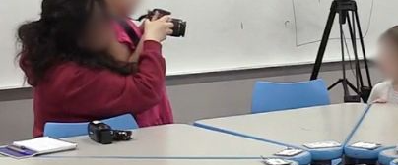
Figure 2. A group of students exploring a camera and taking pictures.
During this activity, the teacher emphasizes the importance of handling and caring for the devices properly.
Vocabulary Lesson: The teacher presents slides featuring images and names of various technologies, such as cameras, camcorders (video cameras), tripods, microphones, voice recorders, computers, laptops, phones, tablets, televisions, speakers, and robots. As the class reviews the slides, the teacher encourages students to share their prior experiences or ask questions about each type of digital technology.

C. Consideration
Troubleshooting and Classroom Management: Given that students may become overly excited when working with digital devices, teachers should provide clear guidance on proper device handling and maintenance. By observing student behaviors during initial interactions, teachers can tailor subsequent lessons to address specific device-care protocols more effectively.
Adaptation: This lesson stemmed from the students’ interest in recording devices. Depending on the interests of students in different contexts, teachers may initiate the curriculum using other digital technologies that resonate with their students. Alternatively, they may bypass this introductory phase and proceed directly to Phase 2 or 3, which aligns more closely with the AI4K12 framework.

2. Device Care

A. Learning Objectives & Technology Integration
The lesson focuses on developing and applying students’ knowledge and attitudes regarding the care of digital devices. As they begin to use these tools for learning, including AI-related technologies in the near future, it is essential that they understand how to handle them responsibly. The learning objectives include:
- Children will be able to develop a caring attitude toward the device.

B. Lesson Flow
The lesson is composed of circle time (15 minutes) and whole-group discussion (25 minutes). It uses presentation slides 15-23.
Circle Time: The teacher asks, "What are some things we use every day that we need to take care of?" Examples might include toys, books, and pets. This question connects to digital technology, allowing teacher to follow-up with “How do we take care of our devices?”
Whole-Group Discussion: A class goes over slides featuring how to take care of devices. The behaviors include:
- Clean Hands, Happy Devices: “Why should we have clean hands before touching a tablet or laptop?” (Keeps screens and buttons from getting sticky!)
- Gentle Hands, No Ouchies: “What happens if we drop a tablet or press too hard on a screen?” (Cracks, breaks, or stops working!)
- Charging is Important: “What happens if we forget to charge a device?” (It won’t work when we need it!)
- Safe Places Only: “Where should we put a tablet when we are not using it?” (On a table, not the floor or near water!)
- Ask Before Downloading or Clicking: “Should we press buttons or download things without asking a teacher or parent?” (No! Some things might not be safe.)

C. Consideration
Adaptation: The teacher can add a drawing or coloring activity to provoke students’ interest in different types of technology (see Figure 3). How to take care of devices can be emphasized throughout the course as it’s a fundamental attitude that students need to develop. In a later phase, this discussion will be expanded regarding privacy and ethical issues to protect myself and others while using devices.
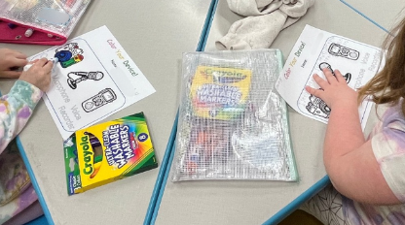
Figure 3. Students coloring different types of technology.

Phase 2: Representation & Reasoning

1. Coding Robot Exploration

A. Learning Objectives & Technology Integration
Building on the previous lessons of device exploration, the teacher introduces a screen-free coding robot. The lesson focuses on exploring the coding robot and gaining familiarity with it. The experience serves as a foundational entry point for symbolic representation as students explore symbols within the coding robot like different directional arrows. The learning objectives include:
- Children will be able to explore a tangible coding robot (non-AI) and get familiar with it.
- Children will be able to recognize and use symbols of the Tale-Bot (e.g., colors, arrows, loop, etc.)
- Children will be able to develop an attitude toward caring for the tangible coding robot.
The AI4K12 framework (AI4K12.org, 2021) includes:
- #2 Representation - Symbolic representation - 2-A-ii
  - Learning objective (LO): Give examples of symbols you encounter in daily life.
  - Enduring understanding (EU): Concepts can be represented using symbols in place of words.
Technology Integration: Integrating technology requires enough Tale-Bots to accommodate your student groups, plus drawing supplies and large paper for creating maps.

B. Lesson Flow
The lesson is composed of station/free play (25 minutes).
Station/Free Play: Students explore a Tale-Bot (see Figure 4), a screen-free coding robot, as individuals or in groups.
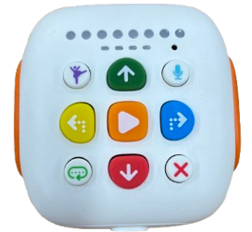
Figure 4. A Tale-Bot.

C. Consideration
Troubleshooting and Classroom Management: Given that students may become highly animated when interacting with a new robot, device-care protocols should be integrated throughout all lessons involving hands-on technology. Specifically, when using the Tale-Bot’s voice recording function, students may enjoy making loud or unconventional sounds. If this becomes a distraction, the teacher should clarify the purpose of the recording and guide students on how to produce high-quality audio that aligns with the lesson's goals.
Adaptation: Based on observation, the teacher can expand this exploration so students can be familiar and confident using the robots before moving on to the next lesson. The teacher can have students utilize existing maps or create maps to navigate with their Tale-Bots.

2. Coding Adventure: Cheetah Maps with Tale-Bots

A. Learning Objectives & Technology Integration
Now that students have developed a foundational understanding of the Tale-Bot’s functions, this lesson transitions into a deeper exploration of symbolic representation alongside creative expression. The lesson focuses on applying symbolic representation by drawing a map that represents only important pieces of information. The map-creation themes can be adapted to suit the specific interests and contexts of different classes. Also, this lesson fosters computational thinking by utilizing Tale-Bots to navigate the map. The learning objectives include:
- Children will be able to draw and construct an animal-themed map based on what they learned about animals (e.g., appearance, habitat, characteristics, diet).
- Children will be able to recognize and use Tale-Bot symbols (e.g., colors, arrows, loop).
- Children will be able to develop a sequence to go through the animal-themed map depending on instruction.
The AI4K12 framework (AI4K12.org, 2021) includes:
- #2 Representation - Abstraction - 2-A-i
  - LO: Construct a map of a home, school, or neighborhood.
  - EU: The map is not the territory. A map is a representation of a territory.
- #2 Representation - Symbolic representation - 2-A-ii
  - LO: Give examples of symbols you encounter in daily life.
  - EU: Concepts can be represented using symbols in place of words.
- #2 Reasoning - Reasoning algorithms - 2-C-ii
  - LO: Model the use of a classification or search algorithm to solve a problem.
  - EU: Reasoning algorithms are ways to solve reasoning problems.
Technology Integration: Integrating technology requires enough Tale-Bots to accommodate your student groups, plus drawing supplies and large paper for creating maps.

B. Lesson Flow
The lesson is composed of circle time (15 minutes), whole-group discussion (25 minutes), and station/free play (20 minutes per a group). It uses presentation slides 24-35.
Circle Time: The teacher opens with guiding questions: “What is a map? Have you seen one before? Why do people use them? If you could make a map, what kind would you create?” This discussion bridges students’ prior knowledge with the upcoming activities.
Whole-Group Discussion: The teacher presents slides introducing maps, explaining that “a map is a picture that shows where things are.” The activity moves from a broad to narrow focus: starting with a world map, then moving to a map of the United States, a state map, and finally a city or town map. Since the class was planning a field trip to the zoo, a zoo map was included at the end of this activity.
As the class explores these maps, the teacher asks students what they see to help them connect their observations to symbols. Afterward, the class creates their own map. For example, following a story about cheetahs, the students designed a cheetah-themed map, identifying important features like tear marks, tails, and spots to represent the animal.
Station/Free Play: Students explore their maps with Tale-Bots, either individually or in groups (see Figure 5). They program Tale-Bots to navigate from one area to another. This activity can be unstructured for free exploration or more guided, depending on the teacher's pedagogical intentions and the students' proficiency with the technology.
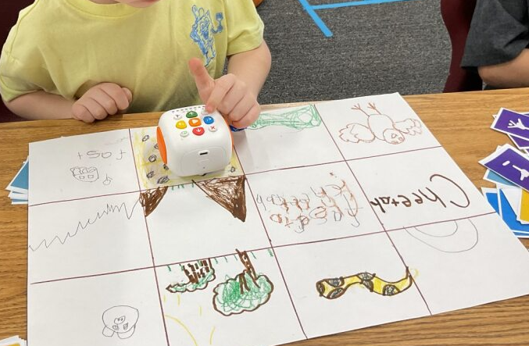
Figure 5. Students navigating their map with Tale-Bots.

C. Consideration
Adaptation: It is important to bring maps that are relevant to students’ lives. For example, we started from a world map and moved to their town and the zoo they planned to visit. Although this activity is not directly related to AI itself, it is a foundational activity that focuses on symbolic representation.
During the whole-group discussion, it is important to observe students’ understanding and reactions so the teacher can connect them to sequenced activities. For example, when we observed that students found symbols (e.g., a shopping cart as a symbol of a market; see Figure 6) in a town map, we connected this observation to the next activity focusing on understanding and creating symbols.
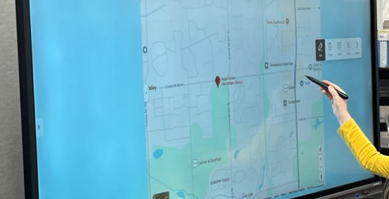
Figure 6. Student pointing to a symbol she found on the map.
Also, for map-making, the themes can be dependent on each class’s current curriculum. For example, we talked about animals before going to the zoo, so the theme of the maps was about cheetahs.

3. Find Symbols and Create My Own Symbol

A. Learning Objectives & Technology Integration
The lesson now establishes a closer connection to the students' daily lives by encouraging them to observe their surroundings and create their own meaningful artifacts. The lesson more closely relates to students’ lives by encouraging them to look around the world and create their own artifact. The lesson focuses on symbolic representation by finding examples of symbols in students' lives and creating their own symbol with abstraction skills, which is a brief connection with the symbolic representation of AI. The learning objectives include:
- Children will be able to identify symbols and their meanings in their daily lives.
- Children will be able to create their own symbols representing their own core characteristics.
The AI4K12 framework (AI4K12.org, 2021) includes:
- #2 Representation - Symbolic representation - 2-A-ii
  - LO: Give examples of symbols you encounter in daily life.
  - EU: Concepts can be represented using symbols in place of words.
Technology Integration: Drawing supplies for creating symbols are needed. To create a digital class book at the end, Book Creator can be utilized.

B. Lesson Flow
The lesson is composed of circle time (15 minutes), whole-group discussion (25 minutes), and station/free play (30 minutes). It uses presentation slides 36-43.
Circle time: The teacher begins by asking questions about the students’ experience with Tale-Bots, saying, “What did you like about the Tale-Bots, and what was difficult when you played with them?” Through this conversation, the teacher can connect student experiences with symbols. For example, some students may still be curious about what each button means or struggle to have Tale-Bots navigate maps as they intended. This difficulty may come from a lack of understanding of each symbol’s meaning, so the teacher can use the Tale-Bot experience to cover the topic of symbols (see Figure 7).
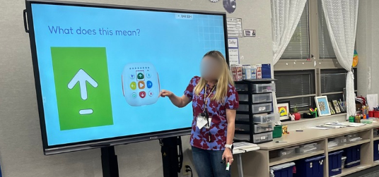
Figure 7. Teacher and students discussing Tale-Bot symbols.
Whole-Group Discussion: Reviewing the map activity from last session, the class goes over different symbols in their daily lives. The teacher can create slides with different symbols found in their community, such as restrooms, school symbols, stop signs, and markets (see Figure 8). The class is also asked to find symbols in the classroom. For example, one student brought up the numbering system in the class, matching each number with a certain student. Another student brought up a code on a smart TV that represented the teacher’s sign-in ID.
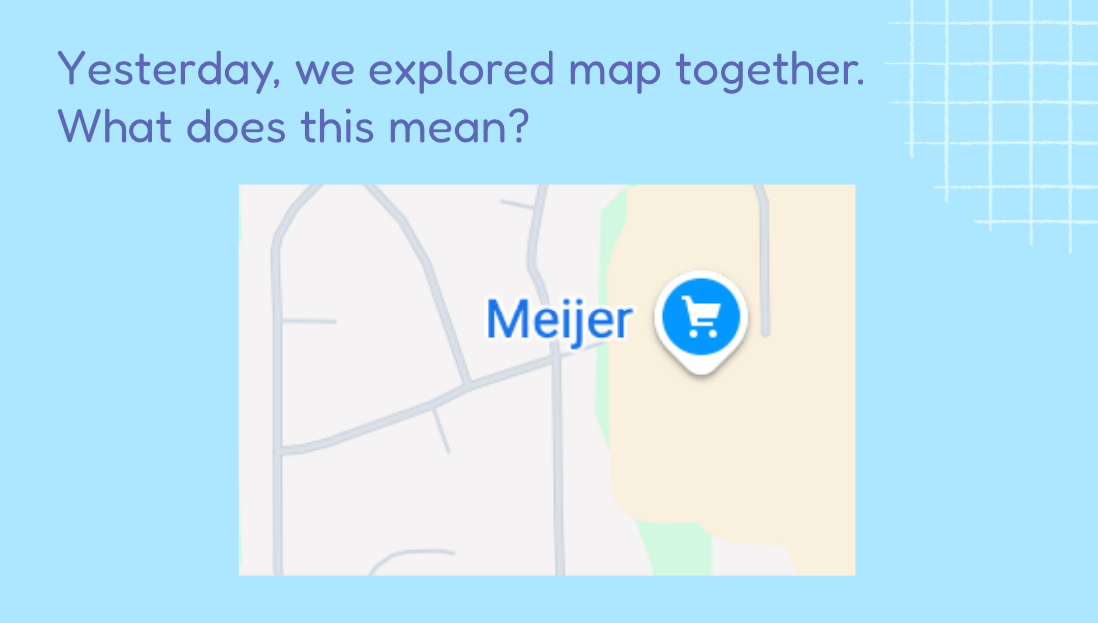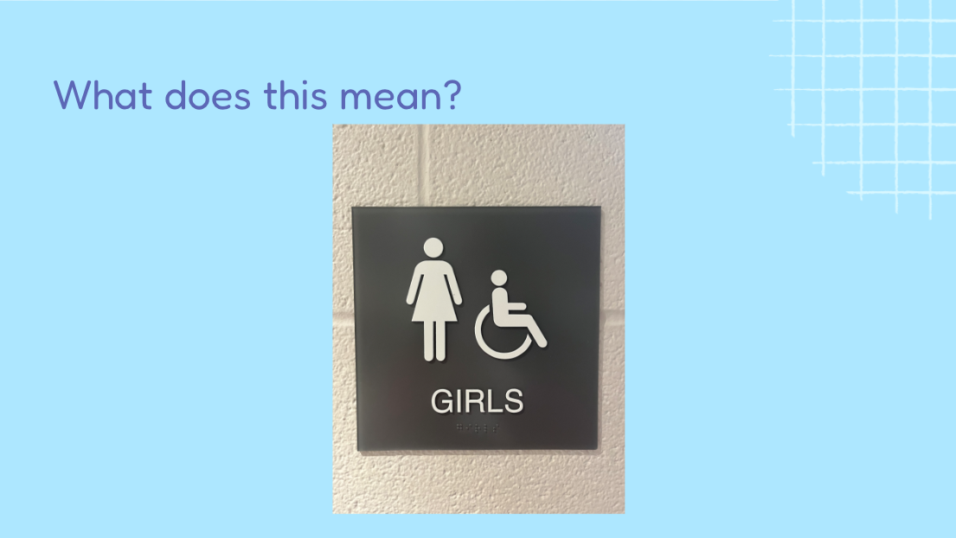
Figure 8. Slides about symbols around us.
Station/Free play: Students think about a core characteristic to represent themselves. Then, students freely draw their own symbols to represent that characteristic and describe the meanings. The teacher can turn these into a class book and read it together with the students.
For example, we used Book Creator for the class book (see Figure 9), printed it out, and read it together. The students engaged in figuring out which symbols belonged to whom by guessing the reasons. This serves as a bridge to how AI uses symbols to understand the world and perform tasks.
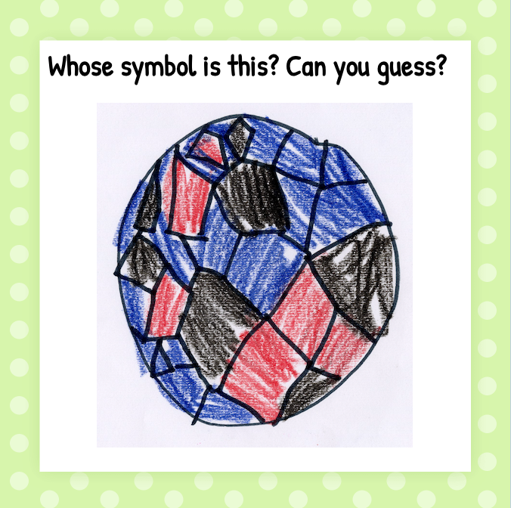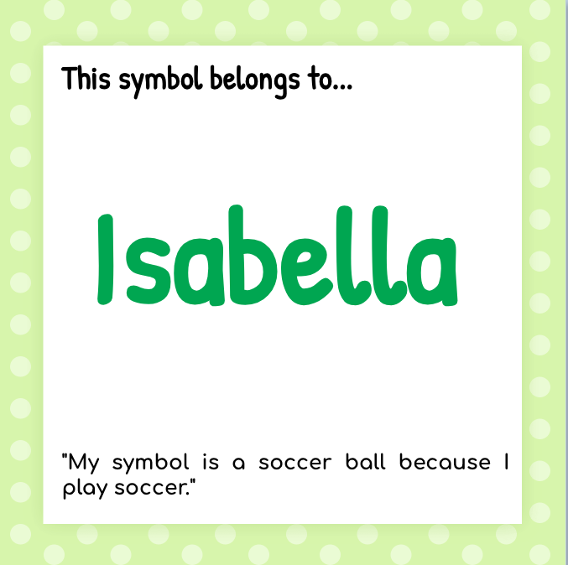
Figure 9. Classroom book with Book Creator: Isabella's symbol (pseudonym).

C. Consideration
Adaptation: It is important to encourage students’ symbolic representations by connecting them to their lives, such as symbols in the classroom, school, and community. Although this activity is not directly related to AI itself, the teacher can make a connection between symbolic representation and AI: Computers and robots don't have hearts or minds like we do. They do not understand things on their own. Instead, they follow special signals called symbols. A symbol is like a secret code that tells the computer exactly what to do based on our rules.

Phase 3: Natural Interaction & Perception

1. Hello, Artificial Intelligence (AI)! Let’s Get to Know Each Other

A. Learning Objectives & Technology Integration
Following the students' exploration of digital devices and Tale-Bots, teachers can extend their curiosity to the AI technologies already present in their environments. Their existing familiarity with technology provides a strong foundation for this expansion. This lesson introduces AI, tailored to the children’s level. The learning objectives include:
- Children will be able to recognize that AI is a kind of technology.
- Children will be able to describe what AI means.
- Children will develop their curiosity about AI.
The AI4K12 framework (AI4K12.org, 2022a, 2022b) includes:
- #4 Natural Interaction - Natural Language (Applications) - 4-A-iv
  - LO: Demonstrate the kinds of tasks an intelligent assistant can and cannot perform.
  - EU: Intelligent assistants (e.g., Siri, Alexa) are computers designed to respond to a limited set of requests. They cannot engage in a conversation like a human.
- #5 Societal Impact - AI & Culture (AI in Daily Life) - 5-B-i
  - LO: Identify devices in daily life that use AI technologies.
  - EU: AI technologies are part of any device that includes speech recognition or computer vision, such as smartphones, intelligent home assistants, and modern automobiles.
Technology Integration: The discussion requires real objects representing something natural and something artificial (e.g., a real flower and an artificial flower; see Figure 10) to help students understand what “artificial” means. For story time following the discussion, the teacher needs to prepare the picture book Artificial Intelligence for Kids by Dr. Dhoot, either as a paper copy or as slides. The order of these activities can be switched.
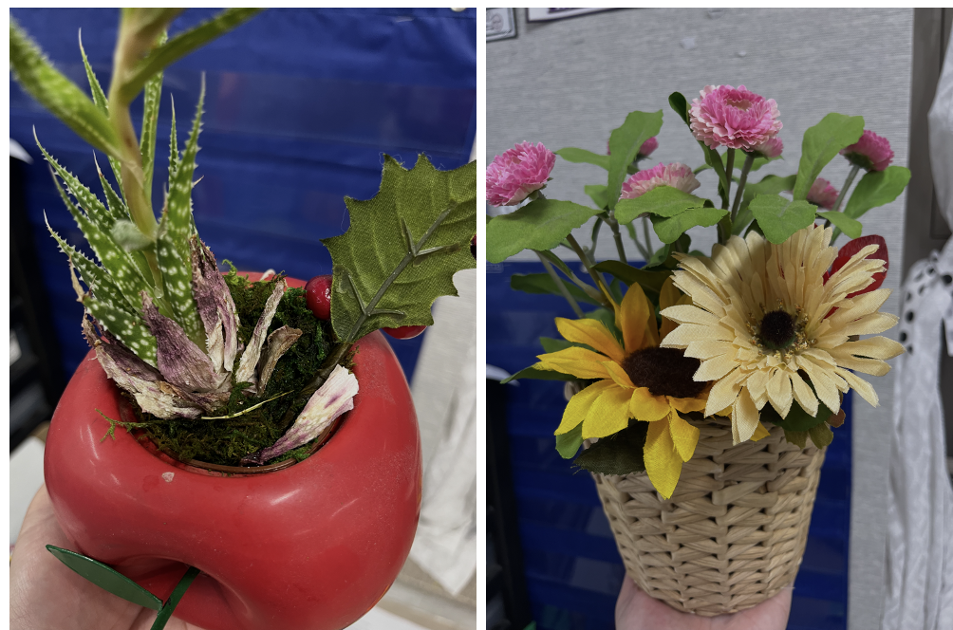
Figure 10. Natural flowers and artificial flowers in the classroom.

B. Lesson Flow
The lesson is composed of circle time (15 minutes), whole-group discussion (25 minutes), and story time (20 minutes). It uses presentation slides 44-54.
Circle time: The lesson starts with a circle time question, “Let’s think about how amazing our brains are! What do you love to do the most? What cool things can your brain help you do? What are you really good at?” The teacher then listens carefully to each student’s thoughts, encouraging them to reflect on their own abilities and skills as humans. This discussion serves as a starting point for identifying similarities and differences between humans and AI, ultimately helping students develop an understanding of how valuable they are as human beings.
Whole-Group Discussion: Next, the class moves to a discussion to introduce AI by connecting it to students’ interests and lives. They discuss what artificial intelligence means, beginning with a vocabulary lesson that explains “artificial” and “intelligence” separately. Comparing natural and artificial objects was an effective way to deepen students’ understanding of the concept of “artificial.” Bringing artificial items such as plastic flowers or fruits that students can easily compare with natural ones can provide meaningful learning opportunities (see Figure 11).
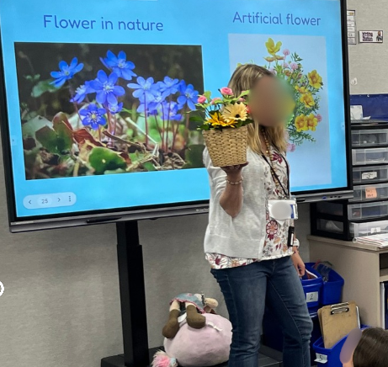
Figure 11. Teacher comparing real flowers and artificial flowers.
Story time: The teacher reads the picture book Artificial Intelligence for Kids (Tinker Toddlers) by Dr. Dhoot to the students and interacts with them during the reading. Leverage students’ ideas and curiosity while reading the book. For example, a child asked, “What if people make a cow?” when the picture book compared something natural (e.g., a cow) with something artificial made by people (e.g., a car). The teacher connected this question to a discussion about what makes a cow artificially intelligent. Next time, we showed a real-life video of an AI robot cow to illustrate that this is happening in the world.

C. Consideration
Adaptation: This activity begins with student specific interests and/or prior experiences. In this case, it was connected to manually programming Tale-Bots and then exploring how they differ from AI. The discussion also included examples of AI in everyday life, such as Alexa, Snapchat’s AI filters, and social robots that students had mentioned previously. In other classes, teachers can start from different contexts; the key is to begin with your students’ concrete interests and/or experiences.
Assessment: Following the discussion, the teacher can utilize students’ artifacts to assess their understanding of AI. For example, students distinguished between what is artificial and what is natural and drew examples of each (see Figure 12).
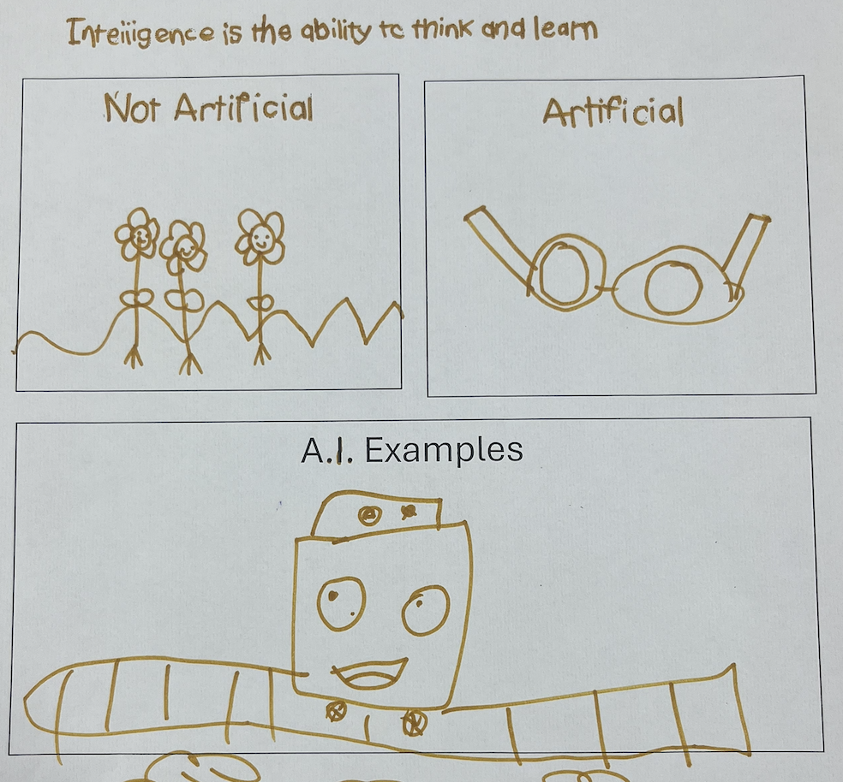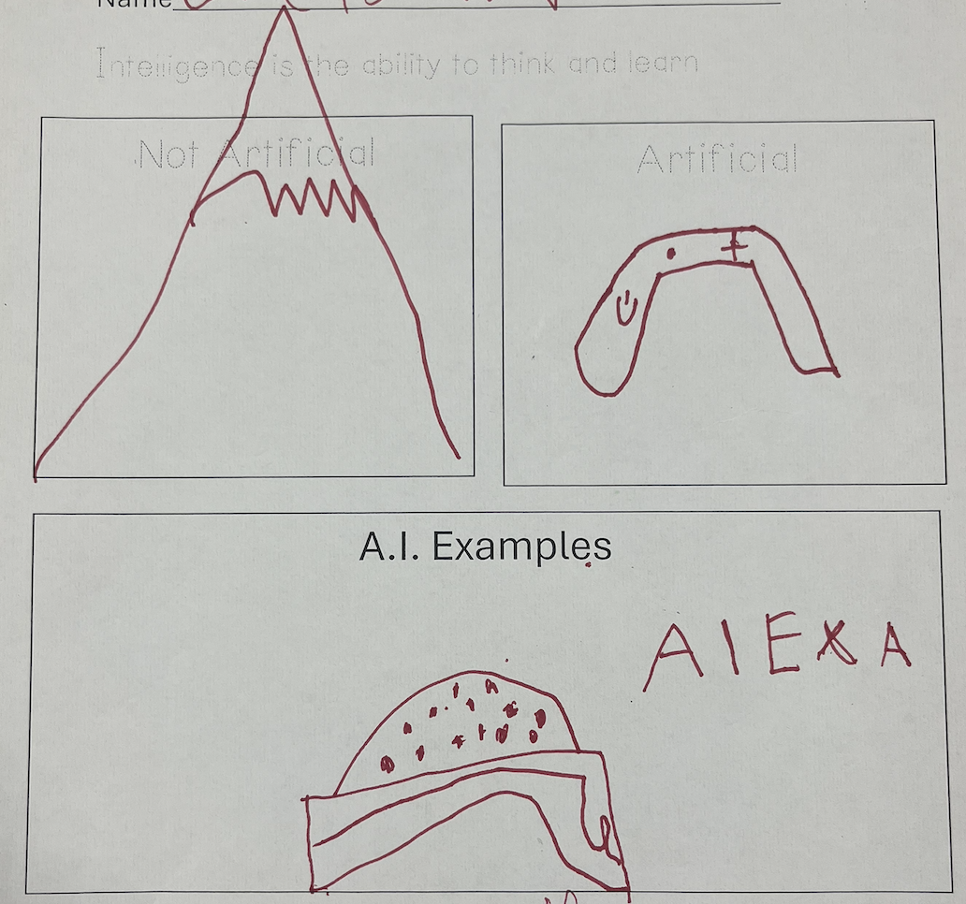
Figure 12. Students’ artifacts.

2. Let’s Be AI Scientists!

A. Learning Objectives & Technology Integration
Drawing from observations of students’ diverse inquiries regarding AI, the lesson focuses on exploring students’ own questions, seeking relevant information, and engaging in collaborative discussions to address questions. The learning objectives include:
- Children will be able to compare and contrast what humans and AI can do.
- Children will discuss how humans and AI are similar and how they are different.
- Children will develop their curiosity about AI.
The AI4K12 framework (AI4K12.org, 2022a) includes:
- #4 Natural Interaction - Natural Language (Applications) - 4-A-iv
  - LO: Demonstrate the kinds of tasks an intelligent assistant can and cannot perform.
  - EU: Intelligent assistants (e.g., Siri, Alexa) are computers designed to respond to a limited set of requests. They cannot engage in a conversation like a human.
- #4 Natural Interaction - Philosophy of Mind - 4-D-i
  - LO: Demonstrate some ways that Intelligent agents don't understand things the way people do.
  - EU: Artificial Intelligence devices are not people, they are computer programs designed by people.
Technology Integration: The small-group discussion requires the book Big Idea 4 – Human-AI Interaction: How We Work with AI by Ready AI, as well as large sheets of paper, pencils, pens, and erasers for creating a comparison chart of AI and humans.

B. Lesson Flow
The lesson is composed of small-group discussion (15 minutes), story time (15 minutes), and comparison drawing chart (30 minutes). It uses presentation slides 55-56.
Small-Group Discussion: The teacher briefly discusses students’ previous questions and what scientists do. For example, students’ questions might include, “What is AI?” or “How can it move?” Other questions could be, “How can we make Alexa?” or “Can I talk with AI?” Then, the teacher connects students’ questions to a discussion about what humans and AI can and cannot do. The teacher could say, “Last time, a few of you said, ‘Can AI have a conversation? I want AI to learn how to talk like we do!’”; “Let’s think about what you can do first. What do you do well? What do you like to do?”; “Do you think AI can do this too? Why or why not? How could it do this?’”
Story Time: Following the discussion, the teacher reads the book Big Idea 4 – Human-AI Interaction: How We Work with AI by Ready AI to the students to facilitate and expand the small-group discussion. Through the book, students can source relevant information to address their questions regarding the capabilities and limitations of AI.
Comparison Drawing Chart: Students draw what humans can do and what AI can do. The activity can be extended to include other factors, such as what humans find difficult to do and what AI cannot do. Considering students’ developmental levels, drawings with letters are encouraged if they can write.

C. Consideration
Troubleshooting and Classroom Management: Since this is a student-led research process facilitated by the teacher, it requires sufficient time for exploration. This process can be extended over multiple days and enhanced through home-to-school connections, such as asking students to bring a relevant book or to research information with their caregivers.
Adaptation: Based on students’ own questions, their interactions, and the information they find with the teacher, the outputs can be varied and contextual. Creating a comparison drawing chart can also be done using digital media such as Book Creator, Google Slides, Padlet, or other collaborative workspaces if students are comfortable using them.

3. Let’s Make a Song with AI

A. Learning Objectives & Technology Integration
To deepen the exploration of AI's potential, this lesson introduces generative AI through a song-making activity. This approach was intentionally aligned with the teacher's instructional strategies of using songs in Math and ELA blocks, ensuring the AI experience remained pedagogically relevant. The lesson focuses on human-AI collaboration in creating a song related to what students have learned. The learning objectives include:
- Children will be able to discover what AI can do in song making.
- Children will be able to identify the roles of AI and humans in song making.
- Children will be able to evaluate the AI-generated song.
- Children will collaborate with AI to create a song.
The AI4K12 framework (AI4K12.org, 2022a) includes:
- #4 Natural Interaction - Natural Language (Applications) - 4-A-iv
  - LO: Demonstrate the kinds of tasks an intelligent assistant can and cannot perform.
  - EU: Intelligent assistants (e.g., Siri, Alexa) are computers designed to respond to a limited set of requests. They cannot engage in a conversation like a human.
Technology Integration: The whole-group discussion requires a song generator in Magic School AI as a generative AI (GAI) tool. It was chosen over other commercial GAIs, such as ChatGPT or Gemini, due to age restrictions and privacy concerns. The teacher acts as a mediator, facilitating the process and providing input to the GAI based on students’ text-based interactions.

B. Lesson Flow
The lesson is composed of circle time (15 minutes) and whole-group discussion (30 minutes). It uses presentation slide 57.
Circle time: The lesson starts with the question, “What’s your favorite song?” to spark students’ interest in songs. The teacher can use this information to select a melody for the song-generation activity. They also discuss the similarities and differences between songs and spoken language, and how we create songs, as a starting point for this lesson.
Whole-Group Discussion (Song Generation): The teacher reminds students about the meaning of AI and talks about their experience of creating or/and singing a song. Then, they connect the discussion with AI (e.g., Say: AI can help make songs by using examples it has seen. It doesn’t feel or create like people do, but it can copy patterns it’s learned.)
Now, the teacher talks about humans’ role in song making and gather students’ thoughts about what words or sounds they want to include in a song. For example, in our case, students were learning about subtraction in a math block, and they brought up concepts that they’ve learned about subtraction such as “minus,” “take away, “equals.” Then the teacher input the words into Magic School AI and selected “Row, Row, Row Your Boat” for melody.
Once the class has Magic School AI create a song, they can sing along. In this way, they experience collaboration with AI through learning and play. An important teachable moment is validating the generated content to see if it makes sense to humans. When AI creates something incorrect, use this time to validate the content and discuss with students. The teacher can facilitate this process by emphasizing that AI has limitations, so people always need to double-check the information provided. (e.g., What’s your important job? Think first! Share your own ideas. Then check! Make sure the song makes sense and sounds right. Enjoy singing!)

C. Consideration
Troubleshooting and Classroom Management: It can be challenging to strictly differentiate the roles of the teacher, the students, and the AI, but if possible, discuss the similarities and differences in the roles each has played. For example:
- Students’ Job: Think, explore, and ask questions.
- Teacher’s Job: Help and guide children by asking questions and providing support.
- AI’s Job: Generate a song by learning from many examples.
Adaptation: This lesson can be adapted to different contexts when you want to use a song to support students’ learning on various topics, such as CVC words, subtraction, decomposition, butterflies, and more. It also requires enough time to discuss the roles of humans and AI. The discussion can take place in small groups for more in-depth exploration.
Several alternative platforms are available as additional options for implementation. School AI has a voice option, so young children can interact with it verbally under the teacher’s guidance. Suno AI generates its own melody with different moods based on a prompt, making it another option for use.

4.How AI Sees the World

A. Learning Objectives & Technology Integration
Building on their initial experiences with AI, this lesson focuses on perceptions and senses by identifying similarities and differences between humans and AI in terms of how they perceive the world through their senses. The learning objectives include:
- Children will be able to identify human senses and sensory organs.
- Children will be able to locate and identify sensors (camera, microphone) on computers, phones, robots, and other devices.
- Children will develop their curiosity about AI.
The AI4K12 framework (AI4K12.org, 2020a) includes:
- #1 Perception - Sensing (Living Things) - 1-A-i
  - LO: Identify human senses and sensory organs.
  - EU: People experience the world through sight, hearing, touch, taste, and smell.
- #1 Perception - Sensing (Computer Sensors) - 1-A-ii
  - LO: Locate and identify sensors (camera, microphone) on computers, phones, robots, and other devices.
  - EU: Computers "see" through video cameras and "hear" through microphones.
- #1 Perception - Processing (Sensing vs. Perception) - 1-B-i
  - LO: Give examples of intelligent vs. nonintelligent machines and discuss what makes a machine intelligent.
  - EU: Many machines use sensors, but not all use them intelligently. Non-intelligent machines are limited to simple sensing. Intelligent machines demonstrate perception.
Technology Integration: Story time requires the book Big Idea 1 – Perception: How AI Sees the World by ReadyAI. The whole-group discussion requires Scroobly, an AI-powered animation platform, and a webcam connected to a shared touchscreen.

B. Lesson Flow
The lesson is composed of circle time (15 minutes), story time (20 minutes), and whole-group discussion (15 minutes). It uses presentation slides 58-60.
Circle Time: The teacher facilitates circle time with a guided question: “What do you do with your five senses—eyes, nose, ears, tongue, and skin?” This interaction is designed to pique students' interest and increase their awareness of their five senses and their functions. This serves as a foundation to later connect human biology with AI technology: “Can you guess how AI sees the world? Today, we will learn more about how AI ‘sees’ the world, just as we do through our five senses.”
Story Time: The teacher reads the book Big Idea 1 – Perception: How AI Sees the World by ReadyAI to facilitate a discussion about the similarities and differences between human senses and AI sensing: Explore how our senses work and how computer sensors correspond to them (e.g., seeing – eyes and a camera; hearing – ears and a microphone; speaking – a mouth and a speaker). During this interaction, students can explore the classroom to identify physical sensors, such as cameras or microphones, where available.
Whole-Group Discussion: The teacher briefly introduces Scroobly and how it uses a camera sensor. They could say, “It uses a camera sensor to watch how we move, and it can help our character copy us. You can choose a character or even make your own! Today, we will play with Scroobly to create our own brain break video.” Students will briefly view the interface as a whole group and then engage in more in-depth interaction in small groups later.

C. Consideration
Adaptation: This lesson could begin by exploring the students' own bodies and the five senses, aligning with the standard curriculum often introduced at the start of a kindergarten semester. This self-knowledge then serves as a bridge to understanding AI through an exploration of their similarities and differences.

5. Let’s Create Our Own Brain Break Video with Scroobly

A. Learning Objectives & Technology Integration
Building on their initial exploration of sensors and Scroobly, this lesson incorporates an application and creation phase. The lesson focuses on creating something relevant to students, allowing them to exercise their creative muscles by collaborating with AI. The learning objectives include:
- Children will be able to utilize a camera sensor in AI-powered technology to express motions appropriately.
- Children will be able to create a video by expressing motions and singing a song, shifting their role from a consumer to a creator.
- Children will be able to collaborate with AI to create a video.
The AI4K12 framework (AI4K12.org, 2020a) includes:
- #1 Perception - Sensing (Living Things) - 1-A-i
  - LO: Identify human senses and sensory organs.
  - EU: People experience the world through sight, hearing, touch, taste, and smell.
- #1 Perception - Sensing (Computer Sensors) - 1-A-ii
  - LO: Locate and identify sensors (camera, microphone) on computers, phones, robots, and other devices.
  - EU: Computers "see" through video cameras and "hear" through microphones.
Technology Integration: Scroobly is a free, AI-powered website where students create animations using their body movements. In the classroom, it can be used with a webcam and projected onto a smart TV or accessed via devices like iPads and laptops.

B. Lesson Flow
The lesson is composed of whole/small-group discussion (20 minutes) and station/free play (15 minutes per group). It uses presentation slide 61.
This lesson builds on students’ interest in brain breaks, such as singing along to songs and moving together. Through this activity, students naturally observe how AI perceives the world through a camera sensor and learn how to collaborate with it.
Whole/Small-Group Discussion: The class creates a song. It can be written from scratch or based on an existing melody. In our case, we used the melody from "Go Bananas," as it is a student favorite. We adapted the lyrics to a car racing theme, based on a major racing event in the state.
At this stage, the teacher records the students’ singing. We recommend using a tablet to capture both audio (M4A) and video (MOV) files; this redundancy ensures maximum compatibility during editing and provides backup in case of file corruption.
Station/Free Play: Once students become familiar with their created song, each group creates a specific movement and records it using Scroobly based on their assigned lyric. For example, our groups (1–6) each performed a different action: "Start your engines," "Step on the gas," "Zoom down the track, "Turn the corner," "Hit the brakes," "Wave the flag.” (see Figure 13). With the melody from "Go Bananas," the song looks like this: "First you start, start, start your engine, yeah, you start, start, start your engine. Then you step, step, step on the gas, yeah, you step, step, step on the gas."
The teacher records students’ movements using Scroobly, which exports files in GIF format. If your video editing platform does not support GIFs, screen-record the playback of each student’s video; this ensures the file is saved in a format compatible with most editing software. In our case, we used iMovie on a Mac. The teacher’s final tasks involve: 1) importing all separate video clips, 2) compiling them into a sequence, 3) incorporating the song file, and 4) adding subtitles or other artifacts, such as students’ drawings (optional). After the editing is finished (at least a day later), the entire class views their custom-made brain break video.
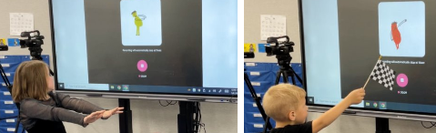
Figure 13. Students making movements using Scroobly.

C. Consideration
Troubleshooting and Classroom Management: To optimize Scroobly’s motion-capture capability, ensure only one person is in the scene at a time and use a clear background. If multiple people are present, the system may struggle to track a single subject, causing the capture to jump between individuals and hindering the quality of the recording. Additionally, because Scroobly may occasionally experience latency in syncing movements, the teacher can guide students to move more slowly than usual to ensure the AI tracks their motions accurately.
Adaptation: The main theme of the brain break video was inspired by students’ interest in the “Kindy 500,” a school-wide family activity. The theme can vary depending on the context, and students can contribute ideas for movements to express themselves and create the video.

Phase 4: Learning & Societal
Impact/Ethics

1. How AI Learns and My Future AI

A. Learning Objectives & Technology Integration
While Phases 1 through 3 focused on providing students with hands-on experience using various technologies and AI for creative expression, Phase 4 delves deeper into the mechanisms AI learning. This phase also examines the societal impact of AI on students’ lives and surroundings. The lesson introduces AI supervised learning in a child-friendly way and emphasizes that the human role is essential to the process. The learning objectives include:
- Children will be able to recognize that AI learns by looking at lots of examples.
- Children will be able to recognize that people give examples to AI.
- Children will be able to recognize that it is important for people to give many different kinds of examples (diverse examples).
- Children will be able to describe how people and computers learn differently.
The AI4K12 framework (AI4K12.org, 2020b, 2022b) includes:
- #3 Learning - Nature of Learning (Humans vs. machines) - 3-A-i
  - LO: Describe and provide examples of how people learn and how computers learn.
  - EU: Computers learn differently than people.
- #3 Learning - Nature of Learning (Finding patterns in data) - 3-A-ii
  - LO: Identify patterns in labeled data and determine the features that predict labels.
  - EU: Classes can be defined in terms of feature values. The relevant features can be inferred by examining labeled examples.
- #3 Learning - Nature of Learning (Training a model) - 3-A-iii
  - LO: Demonstrate how to train a computer to recognize something.
  - EU: Computers can learn from examples.
- #5 Societal Impact - AI for Social Good (Using AI to Solve Societal Problems) - 5-D-ii
  - LO: Describe how AI can be used to solve a societal problem.
  - EU: AI can be used to create a classifier that solves a problem important to society.
Technology Integration: For story time, the lesson utilizes Big Idea 3 – Machine Learning: How AI Learns by ReadyAI. Using a large smart TV for whole-group discussion, the class uses AutoDraw and Quick, Draw! to explore how AI learns from vast image datasets and predicts outcomes through pattern recognition. Finally, the teacher utilizes Animated Drawings to bring students’ drawings of future AI to life in a digital space.

B. Lesson Flow
The lesson is composed of circle time (15 minutes), story time (20 minutes), whole-group discussion (20 minutes), and station/free play (20 minutes). It uses presentation slides 62-69.
Circle Time: The teacher starts with a question, “How do you learn to do something new, like tying your shoes or drawing a cat? How do you think a computer learns?” This conversation encourages students to reflect on human learning and provides a bridge to discuss AI learning.
Story Time: The teacher goes over a storybook, Big Idea 3 – Machine Learning: How AI Learns by ReadyAI. Students see how AI learns by using many images of Cream (a dog).
Whole-Group Discussion: The teacher talks about pattern recognition. For the AutoDraw activity, students come up front and draw something they want while others try to guess it. They naturally compare human guesses and AI guesses. If AI guesses wrong, there is a teachable moment and discussion about why AI guessed incorrectly. The teacher could say, “Let’s guess how and why the AI made a prediction based on what I was drawing. We’ll talk about how AI can be fun, but sometimes it gets things wrong or doesn’t understand what we mean. It’s important to always check what AI made!” (see Figure 14).
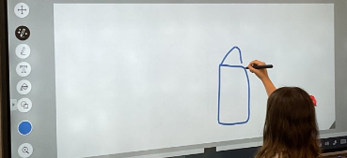
Figure 14. A student drawing a house using AutoDraw.
Then, as a class move on to the Quick, Draw! Activity. Students will be able to visually see that a bunch of images are needed for AI to learn, such as apples, angels, clocks, and more (see Figure 15). The teacher could say, “We’ll look at how many pictures the AI needs to learn from. That helps it get better at guessing! We’ll also talk about how it’s important to give the AI enough, good-quality examples (e.g., lots of different kinds of pictures).”
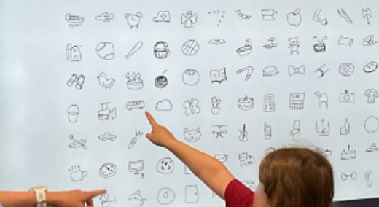
Figure 15. A Student Picking Up a Sample Drawing to See Other Examples on Quick, Draw!
At the end of the activity, the teacher asks the students for their ideas about future AI. To allow them to share and visualize their thoughts, they can draw their own designs during free play or station time. The teacher prompts them: “What differences do you want our AI machine to be able to recognize? What will your future AI look like? We will draw our designs today and create a real AI machine tomorrow!”
Station/Free Play: Students draw their own future/helpful AI. (see Figure 16). If the teacher focuses on the societal impact of their AI, this connects to the AI4K12 framework: “Describe how AI can be used to solve a societal problem.”
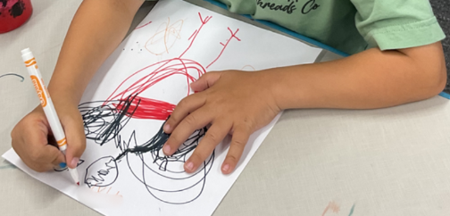
Figure 16. A student drawing an AI chicken robot that can classify good eggs and bad eggs.

C. Consideration
Classroom Management and Assessment: While designing their Future AI, some students may create drawings unrelated to AI's functional features. In such cases, the teacher should scaffold their learning by reinforcing concepts like classification or perception. Observing how students incorporate these features serves as an authentic assessment of their understanding of AI’s mechanisms and its impact on human life.
Adaptation: Drawing my own future AI activity can be implemented at the end of the entire series of activities to help students reflect on what they have explored and learned. Their drawings can serve as an assessment to gauge their understanding of AI. Also, their drawings can be animated and brought to life using Animated Drawings. For example, in our case, there was a dance party day where teachers created videos of their future AI moving and dancing using Animated Drawings (see Figure 17).
The teacher saves each video by selecting specific movements from the Animated Drawings library and exporting them as MP4 files via the share function. Using video editing software (e.g., iMovie), the teacher follows a process similar to the one used in the Scroobly activity. The final post-production tasks involve: 1) importing the separate video clips, 2) compiling them into a sequence, 3) incorporating the audio file (optional), and 4) adding subtitles (optional).
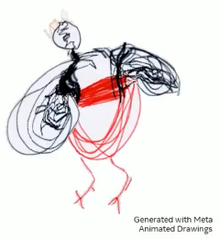
Figure 17. Animated drawing of an AI chicken robot dancing.

2. People Are the Teachers of AI

A. Learning Objectives & Technology Integration
As a final project, students develop a functional machine learning model through a child-friendly approach, collaborating as a whole class or in small groups. The lesson focuses on cultivating ethical awareness of AI by exploring its societal impact and the role humans play in its development and use. The learning objectives include:
- Children will be able to recognize that AI learns from data and patterns but does not know everything.
- Children will be able to recognize that AI has strengths and limitations.
- Children will be able to identify the human role in teaching AI through the process of data training using Teachable Machine.
- Children will be able to discuss the societal impact of AI on various aspects of human life.
- Children will be able to recognize the importance of protecting their personal information.
The AI4K12 framework (AI4K12.org, 2020b, 2022b) includes:
- #3 Learning - Nature of Learning (Training a model) - 3-A-iii
  - LO: Demonstrate how to train a computer to recognize something.
  - EU: Computers can learn from examples.
- #5 Societal Impact - Ethical AI (Diversity of Interests and Disparate Impacts) - 5-A-i
  - LO: Evaluate the ways a decision impacts people differently.
  - EU: Computers can sometimes make a decision that works for most people but harms or disadvantages other people.
- #5 Societal Impact - Ethical AI (Ethical Design Criteria) - 5-A-ii
  - LO: Discuss the characteristics of systems that are fair and unfair and the impact on people when a system is not fair.
  - EU: AI systems should be designed to benefit people. Creators of these systems should make sure that their systems treat everyone fairly.
Technology Integration: For story time, Big Idea 5 - Societal Impact: How AI Can Change the World by ReadyAI is required. Additionally, Teachable Machine is primarily used to demonstrate how AI learns, specifically highlighting the importance of validation through real-time training and testing with a Smart TV and webcam.

B. Lesson Flow
The lesson consists of circle time (15 minutes), story time (20 minutes), a whole-group discussion using Teachable Machine (25 minutes), and a whole-group discussion regarding privacy (20 minutes). It uses presentation slides 70-73.
Circle Time: The teacher starts with the question: “Can you think of a time when AI technology could help us, and a time when we should do something ourselves?” This serves to provoke a discussion on AI’s societal impact later in the lesson.
Story Time: The teacher reads a storybook titled “Big Idea 5 - Societal Impact: How AI Can Change the World” by ReadyAI. The teacher can incorporate supplemental materials that align with or expand upon the story, such as a video of a self-driving car or other real-life examples of AI.
Whole-Group Discussion using Teachable Machine: This activity comes from students’ ideas about their own future AI. The teacher reminds students, saying, “Yesterday, you shared what you wanted to teach our AI machine. Today, we’re going to help it learn by making categories based on your ideas!”
The teacher and a few students demonstrate how to train a Teachable Machine using 2-3 categories inspired by students’ suggestions. Students test the AI model and discuss whether it has been trained well. A teacher explains: “AI doesn’t really know what something is. It just learns by seeing lots of examples and looking for patterns!” If time is allowed and students would like to try a new thing, utilize voice/movement categorizer as well.
For example, we designed a Teachable Machine activity where students can train the model to distinguish between "fish" and "not fish" using printed images. This idea originated from a student who enjoyed fishing and wanted to create an AI fishing robot:
- Step 1: Students input training data into the machine (see Figure 18).
  - Fish: printed images of different types of fish.
  - Not fish: printed images of trash, non-fish, etc.
- Step 2: Students hit the “training” and wait for it to be completed.
- Step 3: Students test the machine with testing data
- Testing data should be different than the training data (see Figure 19).
- Teacher: Prepare some images of toy fish intentionally to get a teachable moment of AI limitations.
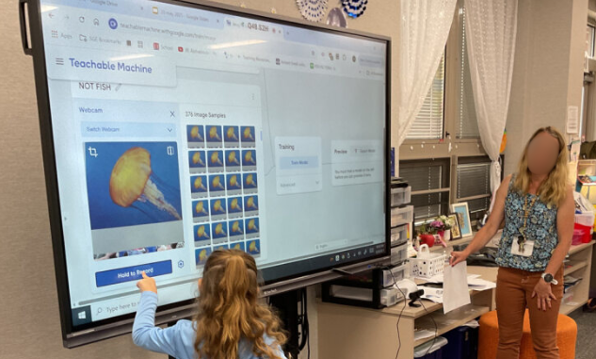
Figure 18. A student training a machine learning model using Teachable Machine.
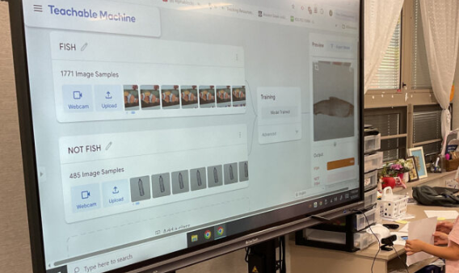
Figure 19. A student testing a machine learning model using Teachable Machine.
In this way, students experience how AI works. Also, they can identify AI’s limitation and the importance of human validation processes with the teachable moment when the machine incorrectly recognizes a toy fish as a real fish.
Whole-Group Discussion regarding Privacy: The emphasis is on protecting yourself and others regarding privacy and AI use. The teacher discusses how AI sometimes uses people’s pictures, voices, and videos to learn. Since they are kindergartners, the materials include icons and images to represent safe sharing, such as no name, no face, and no location, asking, “What should we not share online or with smart computers?

C. Consideration
Troubleshooting and Classroom Management: For the setup, it is recommended to prepare two distinct sets of printed images for training data and test data to facilitate hands-on learning. During implementation, position the webcam at the students' eye level or lower so they can easily hold the printed materials for capture. When a student holds the training button, the teacher may need to assist in maintaining the press long enough to ensure an equal amount of data (e.g., 100 shots) is collected for each category, maintaining data consistency.
Adaptation: What students create with Teachable Machine can vary based on what they drew in a “My Future AI” activity. The teacher then needs to consider how to make these ideas feasible as an in-class activity.
The teachable moment of validation is crucial because it provides a first-hand experience for students to see the limitations of AI, such as when the machine incorrectly recognizes a toy fish as a real fish. Through this, students can see why it is important for us to double-check the information provided by AI. To facilitate this, the teacher can intentionally include specific images designed to confuse the model.
To create a smooth learning experience, using printed images for a whole-group discussion worked better than using digital images. Students can participate in the training and testing process by holding the printed images and hitting the designated buttons. For older students, the teacher could provide the opportunity for them to create their own models using digital images.
Lastly, throughout the curriculum, data privacy can be emphasized not only in relation to AI, but also as part of digital citizenship. In this curriculum, it was used to wrap up the journey at the end, specifically in slides 74–78.

Assessment Plan
Our approach to assessment was holistic and qualitative, utilizing diverse methods including observation, artifacts (drawings), and interviews (conversations) rather than structured tests. First, for observation, the teacher and researcher utilized field notes and video recordings for research purposes. However, for feasibility in class, teachers can use the provided rubric/checklist for observations.
Second, student artifacts were utilized to gauge their conceptual understanding; representative examples are included in the "Learning Representation" section. Below are potential strategies for utilizing these artifacts as assessments:
- Phase 1 (Digital Technology)
  - Student drawings of their favorite technologies and illustrations of proper device care.
- Phase 2 (Representation & Reasoning)
  - Student-created maps utilizing symbols.
  - Personalized symbols designed by students to represent themselves.
- Phase 3 (Natural Interaction & Perception)
  - Student drawings that distinguish between artificial and natural entities, including AI examples.
- Phase 4 (Learning & Societal Impact)
  - Student drawings of their own Future AI.
Lastly, semi-structured interview questions (verbal assessment) were utilized by the researcher to understand students’ learning experience. Some examples of these questions are provided, which teachers may adapt to suit their specific classroom contexts.

Critical Reflection

Reflection on Curriculum
First, the curriculum highlighted students' agency as they took ownership of their learning. For example, they brought up their own questions about AI, shared their ideas about future AI, discussed whether something is AI or not, and created their own machine learning models. This provides a new opportunity for educators and students, showing that AI education can develop core competencies. For young children especially, it is vital to build a foundation for these competencies.
Second, the curriculum was effective because it connected with students’ lives and interests. For example, many activities started from students’ questions about AI, their responses to certain activities, and their daily lives. Starting from students’ interests brings relevant experiences to them, allowing for meaningful discussion among students and teachers.
Third, the curriculum highlighted ethical considerations around AI, and students demonstrated their ability to discuss them and develop their ethical awareness. For example, students were able to discuss the societal impact of AI on human lives, such as self-driving cars, data privacy, and limitations like misinformation. This curriculum shows that highlighting the human role in AI for young children is feasible and developmentally appropriate.
Fourth, collaborative work between teachers, researchers, and students can leverage the best learning experiences for everyone. A community-based approach to collaboration benefits stakeholders by allowing them to exchange expertise from their respective fields. This also ties back to listening to students’ voices by seeing them as active learners.
Fifth, an area for improvement is ensuring enough time for discussion. During implementation, time was occasionally limited due to other structured events and activities within the kindergarten. It would be beneficial for students to have ample time to address their questions and interests regarding the topics.
Lastly, this curriculum did not include much about GAI. In this curriculum, GAI was utilized by the teacher to discuss the roles of AI versus humans during a song-making activity with Magic School AI. There are numerous ethical considerations in GAI, and determining how to introduce these topics in early childhood contexts will be a significant area for future curriculum design research.

Implementation Tips
First, regarding the timeframe, the curriculum was implemented over nine days between March and May 2025 due to scheduling conflicts between the researcher and the classroom. The total duration may be shorter in other settings. Throughout this period, a cycle of concrete experience and reflection allowed the teacher and researcher to refine subsequent lessons. Specific pedagogical adjustments are detailed in the “Consideration” sections under each activity.
Second, regarding underperformed activities, "Let's Be AI Scientists!" was difficult to execute in 15-minute station rotations, as its core component requires deep research. Students need more time to discuss and investigate their questions about AI. Also, "Let's Make a Song with AI" struggled to convey GAI concepts to students within a short window. We concluded that more time is needed to clarify the distinct roles of the teacher, the students, and the GAI in the creative process.
Third, regarding student misconceptions and cognitive overload, students sometimes confused general technology with AI. This is understandable, as devices like iPads or smartphones serve general functions while also hosting AI like Siri. However, interviews showed that many students could describe AI in their own words. We did not view this as negative, as we focused more on students’ increased interest, curiosity, and critical thinking as a foundation rather than the exact accuracy of the knowledge itself. Also, since this curriculum was spread out over two months, we did not observe signs of cognitive overload among the students, and we ensured recess and lunch were included as break times. There was one case where a student did not want to participate in the Scroobly activity because he thought it was weird, and a few students did not want to share their thoughts during circle time. Their choices not to participate were respected.
Fourth, this curriculum heavily uses internet-based tools due to the nature of AI that is accessible to us. Thus, it is important to check the stability of internet access before activities. If the internet does not work, teachers can focus more on picture books, discussions, and students’ own creations rather than tool use. While unplugged activities are a valuable alternative, they are not covered in this version and remain a goal for future work.
Fifth, for accessibility, teachers must verify that school networks do not block tools like AutoDraw, Quick Draw!, or Teachable Machine. Coordination with IT departments is recommended. Furthermore, ensure all devices and Tale-Bots are fully charged. For better accessibility for students, teacher support is important to guide them on how to use the tools while they are learning by doing.
Sixth, for better instructional flow, a team-teaching model (main teacher and assistant) works best. For example, during the Scroobly activity, the main teacher can facilitate the discussion while the assistant handles the recording. If a second teacher is unavailable, high-performing students can assist.
Lastly, the most important tip is to start with your observations of students’ interests and connections to your teaching practice. You do not need to implement everything in this curriculum. AI education is not far from you, and when you look more deeply at your own students and teaching practices, you can find opportunities to integrate AI education into your curriculum.

References
AI4K12 Initiative. (2020). Five big ideas in AI. AI4K12.org. https://ai4k12.org/
AI4K12.org. (2020a, May 28). Draft big idea 1 – progression chart. Retrieved April 29, 2026 from https://ai4k12.org/wp-content/uploads/2021/01/AI4K12-Big-Idea-1-Progression-Chart-Working-Draft-of-Big-Idea-1-v.5.28.2020.pdf
AI4K12.org. (2021, June 28). Draft big idea 2 – progression chart. Retrieved April 29, 2026 from https://ai4k12.org/wp-content/uploads/2022/03/AI4K12-Big-Idea-2-Progression-Chart-Working-Draft-of-Big-Idea-2-v.06.28.2021_v3.pdf
AI4K12.org. (2020b, November 19). Draft big idea 3 – progression chart. Retrieved April 29, 2026 from https://ai4k12.org/wp-content/uploads/2021/01/AI4K12-Big-Idea-3-Progression-Chart-Working-Draft-of-Big-Idea-3-v.11.19.2020.pdf
AI4K12.org. (2022a, March 14). Draft Big Idea 4 – progression chart. Retrieved April 29, 2026 from https://ai4k12.org/wp-content/uploads/2022/12/AI4K12-Big-Idea-4-Progression-Chart-Working-Draft-v.3.14.2022_2.pdf
AI4K12.org. (2022b, December 22). Draft Big Idea 5 – progression chart. Retrieved April 29, 2026 from https://ai4k12.org/wp-content/uploads/2022/12/AI4K12-Big-Idea-5-Progression-Chart-Working-Draft_v.0.1_12.22.2022.pdf
IDOE. (2023). Indiana early learning standards. Indiana Department of Education. https://media.doe. in.gov/news/2023-early-learning-standards-final-5-25-23.pdf
Kewalramani, S., Kidman, G., & Palaiologou, I. (2021). Using artificial intelligence (AI)-interfaced robotic toys in early childhood settings: A case for children’s inquiry literacy. European Early Childhood Education Research Journal, 29(5), 652–668. https://doi.org/10.1080/1350293X. 2021.1968458
Lin, P., & Van Brummelen, J. (2021). Engaging teachers to co-design integrated AI curriculum for K-12 classrooms. In Y. Kitamura & A. Quigley (Eds.), Proceedings of the 2021 CHI Conference on Human Factors in Computing Systems (CHI '21, Article 239, pp. 1–12). Association for Computing Machinery. https://doi.org/10.1145/3411764.3445377
OECD. (2019). OECD Future of Education and Skills 2030 Conceptual Learning Framework: Student Agency For 2030. OECD Publishing. https://www.oecd.org/content/dam/oecd/en/about/projects/edu/education-2040/concept-notes/ Student_Agency_for_2030_concept_note.pdf
Roschelle, J., & Penuel, W. R. (2006, June). Co-design of innovations with teachers: Definition and dynamics. In S. Barab, K. Hay, & D. Hickey (Eds.), Proceedings of the 7th International Conference of the Learning Sciences (ICLS '06) (pp. 606–612). International Society of the Learning Sciences. https://dl.acm.org/doi/10.5555/ 1150034.1150122
Su, J., Ng, D. T. K., & Chu, S. K. W. (2023). Artificial intelligence (AI) literacy in early childhood education: The challenges and opportunities. Computers and Education: Artificial Intelligence, 4, 100124. https://doi.org/10.1016/j.caeai.2023.100124
Williams, R. (2018). PopBots: Leveraging social robots to aid preschool children's artificial intelligence education [Doctoral dissertation, Massachusetts Institute of Technology]. MIT DSpace. https://hdl.handle.net/1721.1/122894

Support Materials

Picture Books
- Children’s books: Tinker Toddlers
  - Artificial Intelligence for Kids
- Children’s books: AI and Me
  - Perception: How AI Sees the World
  - Representation & Reasoning: How AI Makes Choices
  - Machine Learning: How AI Learns
  - Human-AI Interaction: How We Work with AI
  - Societal Impact: How AI Can Change the World

About the Authors
Sohheon Yang is a Ph.D. candidate at Indiana University specializing in Instructional Systems Technology. Her teaching practice focuses on early childhood and teacher education, with a particular emphasis on technology integration. Recently, she has facilitated numerous workshops for pre- and in-service teachers on AI education. Her teaching and research aim to foster student/teacher agency.
Anne Winiger is an experienced kindergarten teacher in the Midwestern U.S. with more than 25 years of classroom experience. She possesses expertise across all early learning standards, including English Language Arts, literacy, mathematics, science, and social studies. She values developing students’ foundational skills through a playful and ethical learning process.

Sharing & Modification Permissions
Unless otherwise noted, this article and its resources are published under a Creative Commons Attribution-NonCommercial-ShareAlike 4.0 International license:

You can freely share the article and its resources if you indicate the original authors, identify the Creative Commons license, and use them non-commercially.
You may also make and share modifications by:
- Identifying the original authors.
- Using the resources non-commercially.
- Licensing modifications under the CC BY-NC-SA 4.0 license (and including a link to it).
- Indicating what modifications were made.

