Scenario Cards for Discussion
  - Sara G. McNeil, University of Houston

Instructions for Instructors: These scenario cards can be used for individual reflection, pair discussions, small group analysis, or whole-class discussion. Each scenario is designed to surface ethical considerations related to one or more AI personas. There are no single "right" answers—the goal is to practice applying the ethical framework.

Scenario 1: The Literature Review Dilemma

Persona Focus: Research Assistant
 | The Situation  Marcus is a third-year doctoral student in sociology working on his dissertation about food insecurity in urban communities. He has identified 47 relevant articles for his literature review, but he is overwhelmed by the volume. His advisor expects him to submit Chapter 2 (Literature Review) in six weeks.  Marcus uploads all 47 articles to Claude and asks them to:  Summarize each article's main findings  - Identify common themes across all articles  - Suggest an organizational structure for the literature review  - Create an annotated bibliography with all sources  Claude produces a comprehensive 15-page document with themes, summaries, and a suggested outline. Marcus reviews AI’s output, makes minor edits to improve the flow, and adds his own introduction and conclusion paragraphs. He submits the chapter to his advisor.

Discussion Questions
- Which AI persona is Marcus primarily using?
- What ethical blind spots might Marcus be missing? Consider: synthesis trap, citation integrity, knowledge gaps
- Apply the four red flag questions:
  - Could Marcus explain this chapter to his advisor right now without the AI document?
  - Would he be comfortable defending the organization of his literature review during his dissertation defense?
  - Is Marcus using AI to learn faster or avoid learning?
  - Could someone reproduce Marcus's work based on his documentation?
- What should Marcus have done differently?
- How should Marcus document this AI use?
- Does he need to tell his advisor?
- Should this be mentioned in the dissertation?
- What should he record in his AI assistance log?
- What would make this scenario more ethical?

Teaching Notes
Key Issues to Highlight:
- Marcus never read the original 47 articles—he only read AI's summaries.
- He's relying on AI's interpretation of the field rather than developing his own understanding.
- He can't speak knowledgeably about individual studies or make connections that AI didn't identify.
- His advisor expects Marcus to have deep engagement with the literature, not surface-level familiarity.
Better Approach:
- Use AI summaries to prioritize which articles to read first.
- Read all 47 articles himself, taking his own notes.
- Use AI to suggest organizational frameworks, then verify against his own reading.
- Test himself: Can he discuss each article's methodology, limitations, and contribution without AI?
Documentation: Marcus should log this into the AI Assistance Log Template:
Used AI to generate preliminary themes from 47 article abstracts.
Verified themes by reading all articles in full.
Modified AI's suggested organization by [specific changes].
Final chapter organization reflects my synthesis after reading all sources.

Scenario 2: The Polished Prose Problem

Persona Focus: Writing Coach
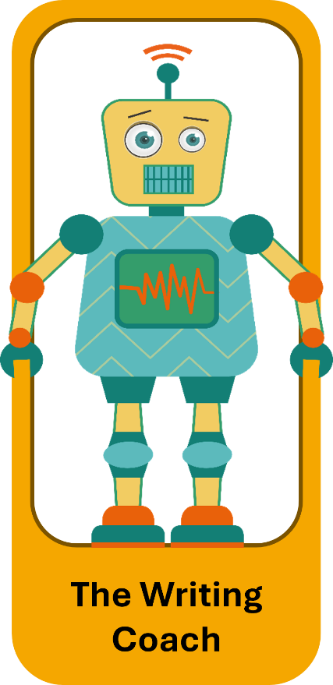 | The Situation  Jennifer is writing the findings chapter of her dissertation. She's a strong researcher but struggles with academic writing—English is her second language, and she finds it difficult to express complex ideas clearly. Her first draft is full of awkward phrasing, unclear transitions, and grammatical errors.  Jennifer copies her entire 35-page findings chapter into ChatGPT and asks it to:  Fix all grammatical errors.  Improve sentence structure and flow.  Make it sound more "academic and scholarly."  Reorganize paragraphs for better logical progression.  ChatGPT returns a beautifully written chapter. The prose is smooth, sophisticated, and professional. Jennifer reads through it, makes a few minor tweaks, and submits it to her advisor.
Her advisor is impressed with the writing quality but comments, "This is well-written, but I'm having trouble following your analytical reasoning. Can you explain why you organized the findings this way?"
Jennifer struggles to answer. She's not entirely sure why the paragraphs are ordered as they are now.

Discussion Questions
- Which AI persona is Jennifer primarily using?
- What are the ethical concerns here? Consider: voice authenticity, intellectual honesty, and committee expectations
- What's the difference between:
  - AI fixing grammatical errors?
  - AI improving sentence structure?
  - AI reorganizing Jennifer's arguments?
- Where should Jennifer draw the line?
- Apply the red flag questions:
  - Can Jennifer explain her chapter organization without looking at AI's version?
  - Is she learning to write academically or learning to prompt AI to write for her?
- What problems might this create later?
  - During dissertation defense?
  - When writing for publication?
  - In her future career?
- What would be a more ethical approach?

Teaching Notes
Key Issues to Highlight:
- There's a spectrum from "fixing grammar" (low concern) to "reorganizing arguments" (high concern).
- Jennifer's advisor can't provide appropriate feedback because the writing doesn't reflect Jennifer's actual thinking.
- Jennifer isn't developing her academic writing skills, she's outsourcing them.
- The smoothness of the prose masks conceptual confusion.
Better Approach:
- Use AI for mechanical issues: grammar, spelling, basic sentence clarity.
- Keep the argument structure and organization as her own.
- Save pre-AI version to compare: "Can I still recognize my thinking?"
- If AI suggests reorganization, understand WHY before accepting.
- Be transparent with her advisor: "I use AI for grammar help but not for argument development."
Nuanced Discussion: For multilingual students, AI can be a valuable equity tool—it helps level the playing field when English proficiency creates barriers. The key is to use it to express THEIR ideas more clearly, not to generate new ideas or organizational structures.
Documentation: Jennifer should mention to her advisor:

I used AI tools to help with grammar and sentence clarity since English is my second language.
My argument structure and analytical reasoning remain my own.
Would you like to see pre-edited versions?"

Scenario 3: The Statistical Shortcut

Persona Focus: Data Detective
 | The Situation  Keisha is analyzing survey data for her dissertation in educational psychology. She has responses from 300 teachers about their classroom practices. Her background in statistics is limited—she took one required stats course three years ago and barely passed.  Keisha uploads her dataset to Claude and describes her research questions. She asks: "What statistical analysis should I use for this data?" Claude recommends hierarchical linear modeling (HLM) because teachers are nested within schools. Claude explains the approach and generates R code to run the analysis.  Keisha copies the code, runs it, and gets output showing significant results. She copies the statistical findings into her results chapter, including the tables and interpretation Claude provided. She submits it to her advisor.  Her advisor asks: "Why did you choose HLM instead of a simpler regression model? What made you decide on this particular model specification?" Keisha admits she's not entirely sure since AI suggested it. Her advisor is concerned.

Discussion Questions
- Which AI persona is Keisha using?
- What are the major ethical problems? Consider: black box problem, methodological rigor, reproducibility
- What's the difference between:
  - Asking AI to explain a statistical concept?
  - Asking AI to recommend an analysis approach?
  - Having AI generate and run the analysis code?
  - Using AI's interpretation of results?
- Apply the red flag questions:
  - Can Keisha explain why HLM is appropriate without AI?
  - Can she defend this choice in her dissertation defense?
  - Can she interpret the results herself?
  - Can others reproduce her analysis?
- What are the consequences if Keisha proceeds this way?
  - During defense?
  - For publication?
  - For her career as a researcher?
- What should Keisha do now to address this situation?

Teaching Notes
Key Issues to Highlight:
- Keisha doesn't understand the analysis she's reporting.
- She can't defend methodological choices.
- She's violated a fundamental research principle: only use methods you understand.
- The analysis might be technically correct, but it is inappropriate for her specific research questions.
- AI doesn't know the methodological norms of her discipline.
Better Approach:
- Use AI to learn about HLM: "Explain hierarchical linear modeling to me."
- Study HLM through textbooks, tutorials, and consultation with her advisor.
- Verify AI's recommendation with her methodologist advisor.
- Write the code herself (with AI help for syntax) so she understands each step.
- Test herself: Can I explain, interpret results, and defend choices?
Critical Teaching Point: In her dissertation defense, committee members will ask:
- "Why this method?”
- “How did you handle [technical detail]?”
- “What do these parameters mean?" “
- AI can help her LEARN the method, but she must genuinely understand it.
Documentation: She should log this in the AI Assistance Log Template:
I consulted AI about appropriate analysis approaches.
AI suggested HLM.
I then: (1) studied HLM through [textbook], (2) consulted with [advisor], (3) verified HLM was appropriate because [specific reasons], (4) learned to interpret output, (5) ran analysis with code I understand.

Scenario 4: The Framework Finder

Persona Focus: Idea Generator
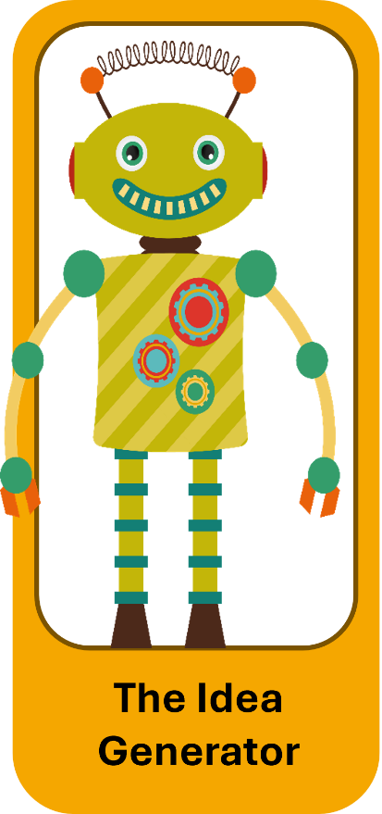 | The Situation  David is struggling to identify a theoretical framework for his dissertation on technology integration in middle schools. He's read widely but can't find a framework that perfectly fits his research questions. After weeks of frustration, he turns to AI.  David asks ChatGPT: "What theoretical framework would work for studying technology integration in middle schools, focusing on teacher beliefs and implementation practices?"  ChatGPT suggests using "TPACK" (Technological Pedagogical Content Knowledge) combined with "Diffusion of Innovations Theory." It explains how these frameworks complement each other and provides a detailed synthesis showing how they relate to David's research questions.  David is excited—this is exactly what he needed! He writes his theoretical framework section based on AI's explanation, cites the original sources for TPACK and Diffusion of Innovations, and moves forward with his proposal.  During his proposal defense, a committee member asks: "These frameworks have been criticized for [specific issues]. How do you address those limitations?" David had no idea there were criticisms—AI didn't mention them.

Discussion Questions
- Which AI persona is David using?
- What did David do right in this scenario?
- What ethical concerns remain? Consider: originality, feasibility, and field contribution
- Is the theoretical framework "his idea" or "AI's idea"?
- Does it matter?
- How is this different from a colleague suggesting a framework?
- What's missing from David's process?
- How should David proceed now?

Teaching Notes
Key Issues to Highlight:
- David didn't do his own homework to verify AI's suggestion.
- AI gave him a "good enough" answer, not necessarily the BEST answer.
- AI doesn't know recent criticisms, debates, or cutting-edge frameworks in his specific subfield.
- He's relying on AI's synthesis of frameworks without a deep understanding.
- What David Did Right:
  - He cited original sources (TPACK and Diffusion), not AI.
  - He used AI for brainstorming, not the final product.
  - He's building on established frameworks, not claiming AI's synthesis as his contribution.
Better Approach:
- Use AI's suggestion as a starting point.
- Do a thorough literature search on TPACK and Diffusion: Read original sources, critiques, and recent applications.
- Search for recent dissertations using these frameworks—what did they find?
- Discuss with advisor: "AI suggested this combination. What do you think?"
- Develop his OWN synthesis and rationale for why these frameworks fit.
Nuanced Discussion:
When is a framework "yours"? When you:
- Understand it deeply enough to explain and defend it
- Can identify its strengths and limitations
- Apply it thoughtfully to your specific context
- Synthesize multiple sources (not just AI's explanation)
Documentation: He should log this in the AI Assistance Log Template:

Through AI brainstorming, I identified a potential fit between TPACK and Diffusion of Innovations.
Conducted literature review on both frameworks, including [specific sources].
Consulted with advisor.
Chose this combination because [specific analytical reasoning].

Scenario 5: The Citation Machine

Persona Focus: Academic Concierge
 | The Situation  Rachel is finalizing her dissertation and needs to format 237 citations in APA 7th edition. She's exhausted from years of work and dreads the tedious process of citation formatting. She copies her reference list into ChatGPT and asks it to format everything in correct APA style.  ChatGPT returns a beautifully formatted reference list. Rachel does a spot check of 5-6 citations, and they look correct. She copies the entire list into her dissertation and moves on to other tasks.  During the final dissertation review, her committee chair finds several errors:  A DOI that doesn't exist (ChatGPT invented it)  An article publication year that's wrong (2019 instead of 2020)  An author's name is spelled incorrectly  A journal title that's slightly wrong ("Educational Research" instead of "Educational Researcher")  The chair questions whether Rachel actually read all her cited sources. Rachel realizes she needs to verify all 237 citations manually, which takes her an additional week.

Discussion Questions
- Which AI persona is Rachel using?
- What did Rachel do wrong?
- This seems like a low-stakes AI use (just formatting). Why did it create problems?
- Should Rachel have used AI at all for this task?
  - If yes, what should she have done differently?
  - If no, why not?
- What's the ethical principle here?
  - Consider: quality control, professional development, skills atrophy
- What are the broader implications of this error?
  - Beyond just fixing the citations
  - For Rachel's credibility
  - For her committee's trust

Teaching Notes
Key Issues to Highlight:
- AI "hallucinates" citations—this is a well-known problem.
- One citation error can make the committee question ALL citations.
- Small errors undermine the credibility of her entire dissertation.
- Rachel's shortcut created more work, not less.
The 70/30 Rule: This is a perfect example of when 70/30 applies:
- AI can help with 30% of routine formatting.
- Rachel should handle 70%—at minimum, thorough verification.
Verification is Non-Optional: Unlike other AI uses where judgment calls exist, citation verification is absolute:
- Check EVERY citation against the original source.
- Verify spelling of authors, publication years, titles, DOIs.
- No exceptions.
Better Approach:
- Use citation management software (Zotero, Mendeley) as primary tool.
- If using AI for formatting help, verify every single citation.
- Better yet: Learn the citation format and do it herself with software assistance.
- Time spent learning = skill for entire career.
Surprising Truth: Students often think citations are "just formatting"—not important enough to worry about. But citation errors:
- Signal lack of attention to detail
- Make committees question if you read the sources
- Can delay graduation
- Undermine professional credibility
Documentation: She should log this in the AI Assistance Log Template:

Used AI to check APA formatting of the reference list.
Verified every citation against the original source.
Corrected [X] errors AI made.

Scenario 6: The Comprehensive Case

Persona Focus: Multiple Personas
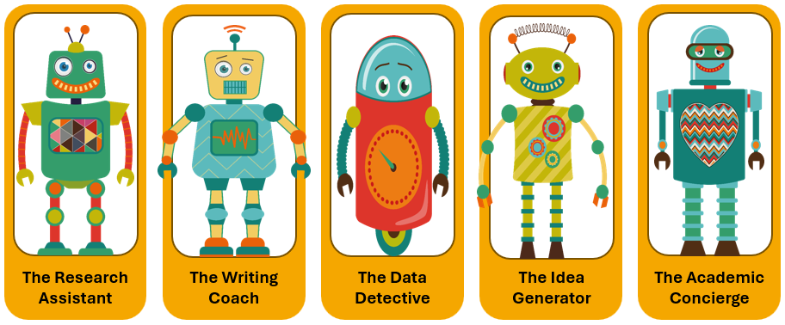
The Situation
Alex is an advanced doctoral student working on a mixed-methods dissertation about healthcare education. Over the past month, Alex has used AI in multiple ways:
Week 1: Used Claude to summarize 30 articles on clinical reasoning, identifying major themes (Research Assistant)
Week 2: Asked ChatGPT to help reorganize the methods chapter for better flow and suggest transitions between sections (Writing Coach)
Week 3: Used AI to suggest appropriate statistical analyses for quantitative survey data and help interpret some confusing results (Data Detective)
Week 4: Brainstormed with AI about theoretical frameworks that might explain unexpected qualitative findings (Idea Generator)
Throughout: Used Grammarly (AI-powered) for grammar and style suggestions, and ChatGPT to format citations (Academic Concierge)
Alex has documented none of this. The advisor asks: "Have you been using AI tools in your work?" Alex panics, unsure how to answer honestly without jeopardizing the dissertation.

Discussion Questions
- Identify all five AI personas in Alex's work. Which uses seem most/least problematic?
- Create a ranking: Which of Alex's AI uses require the MOST documentation/transparency? Which requires the LEAST?
- What should Alex say to the advisor right now?
- For each type of AI use, determine:
  - Does it need to be mentioned to the advisor?
  - Does it need to be documented in the dissertation?
  - What verification steps should Alex have taken?
- Is there a cumulative ethical concern?
  - If each individual AI use might be acceptable, does the total amount change the ethical calculus?
  - At what point does AI assistance become AI dependence?
- Moving forward: What system should Alex implement?

Teaching Notes
Key Issues to Highlight:
- Real doctoral work involves multiple types of AI use.
- The cumulative effect matters. Lots of small AI assists can add up to significant dependence.
- The absence of documentation creates a crisis when the question comes up.
- Different types of AI use have different ethical implications.
- Transparency BEFORE problems arise is always better than explaining AFTER.
Ranking Exercise (by level of concern):
Highest Concern (Must discuss with advisor):
- Statistical analysis interpretation (Data Detective)
- Methods chapter reorganization (Writing Coach)
- Theoretical framework brainstorming (Idea Generator)
Medium Concern (Should document, may discuss): 4. Literature review theme identification (Research Assistant)
Lower Concern (Document but perhaps don't need to highlight): 5. Grammar/style assistance (Grammarly) 6. Citation formatting (with verification)
What Alex Should Say: "I have used AI tools in several ways during my dissertation work. I'd like to walk through each use with you to ensure I'm approaching this appropriately. I want to be completely transparent about my process."
Then share specific examples, along with documentation of the verification steps.
Better Approach:
- Implement the Daily AI Ethics Checklist from the start.
- Keep the AI Assistance Log for all substantive uses.
- Have proactive conversations with his advisor about AI use.
- Develop clear personal guidelines about which AI uses require advisor notification.
Critical Teaching Point: The problem isn't that Alex used AI—it's that Alex has no documentation, no clear ethical framework, and no transparency with the advisor. This creates vulnerability and undermines trust.
Recovery Plan:
- Document all AI uses retroactively (as best as memory allows).
- For each use, note: what you asked, what AI provided, what verification you did, and what you ultimately used.
- Schedule a meeting with his advisor for an honest conversation.
- Implement systematic documentation from now on.
- If the methodology chapter needs revision to acknowledge AI assistance, do it.

GENERAL FACILITATION TIPS

For Individual Reflection:  - Give students 5 minutes to read the scenario and answer questions privately  - Then discuss as a whole group | For Pair Discussions:  - Pairs discuss for 5-7 minutes  - Each pair shares one insight with the large group | For Small Group Analysis:  - Groups of 3-4 get different scenarios  - Each group presents their scenario and analysis (2-3 minutes)  - Class discusses commonalities across scenarios

Discussion Prompts
- "What would you do in this situation?"
- "Where exactly did the person go wrong?"
- "How could this have been done ethically?"
- "What documentation would be appropriate?"

After Each Scenario
- Connect back to the personas framework.
- Apply the four red flag questions:
  - If my advisor asked me to explain this right now, could I?
  - Would I be comfortable defending this choice in my defense?
  - Am I using AI to learn faster or to avoid learning?
  - Could someone reproduce my work based on my documentation?"
- Identify what verification steps were missing.
- Discuss appropriate documentation.

