AI Personas Quick References Guide
  - Sara G. McNeil, University of Houston

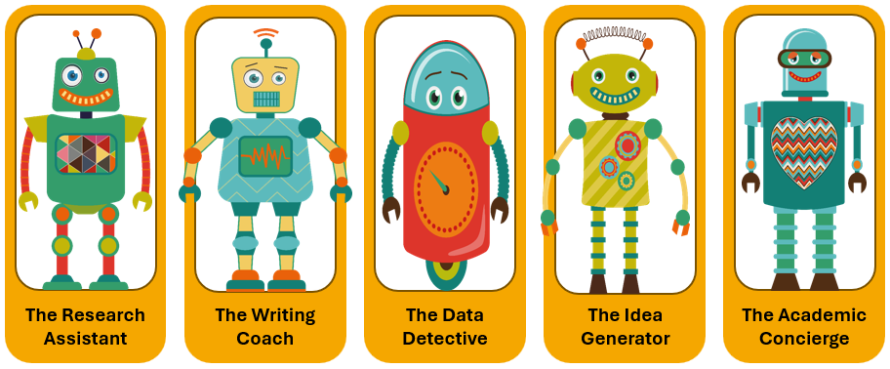
These five personas represent the most common ways graduate students use generative AI in their research and writing. Each persona offers specific benefits but also carries distinct ethical risks that students often overlook. Before using AI, identify which persona best matches your intended use. Then, carefully consider the ethical blind spots associated with that persona and apply the recommended strategies to address those risks.
Remember: the goal is not to avoid AI entirely, but to use it intentionally in ways that enhance rather than replace your learning and scholarly development.
When in doubt, ask yourself the four red flag questions:
- Can I explain this to my advisor right now?
- Would I be comfortable defending this in my defense?
- Am I learning faster, or am I avoiding learning?
- Could someone reproduce my work based on my documentation?
These personas provide a practical framework for making ethical decisions about AI use in your everyday research practice.

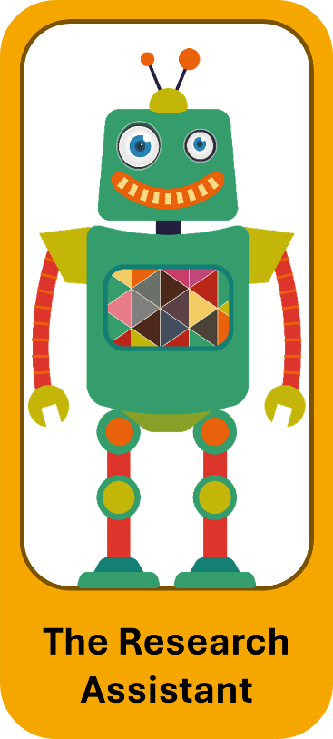 | The Research Assistant  What It Does: Summarizes articles, identifies themes, suggests search terms, creates bibliographies, and maps connections  Why It's Tempting: Cuts literature review time from weeks to days, finds connections across sources  Ethical Blind Spots:  Synthesis Trap: Consuming AI's interpretation, not understanding the field  Citation Integrity: Missing original sources or key articles  Knowledge Gaps: Missing methodological details AI filtered out  How to Use Responsibly:  - Read original sources (use AI as a starting point, not an endpoint).  - Cite original authors, not AI summaries.  - Test your understanding: Can you explain it without AI?  - Document your process clearly.
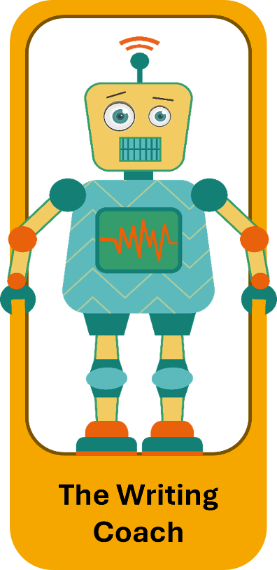 |  | The Writing Coach  What It Does: Improves sentence structure, suggests transitions, helps with academic tone, reorganizes arguments, and overcomes writer's block  Why It's Tempting: Fixes awkward phrases instantly, makes you sound more academic, breaks through writer's block  Ethical Blind Spots:  Voice Authenticity: When does your writing become AI's writing?  Intellectual Honesty: Are you developing YOUR voice or mimicking AI's?  Committee Expectations: Advisors need to see your thinking, even the messy parts.  How to Use Responsibly:  - Set boundaries: mechanics - yes, argument development – no.  - Keep your voice: Save pre-AI versions.  - Be transparent with your advisor.  - Document AI assistance in your log.

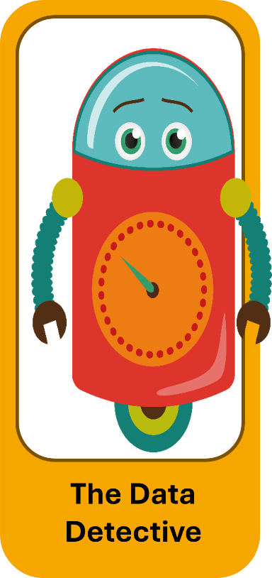 |  | The Data Detective  What It Does: Suggests statistical approaches, identifies patterns, explains complex analyses, generates code, catches errors  Why It's Tempting: Explains stats in plain English, makes advanced methods accessible, speeds up workflow  Ethical Blind Spots:  Black Box Problem: Can you defend it in your dissertation defense?  Methodological Rigor: AI suggests "good enough," not "most appropriate."  Reproducibility: Can others replicate without your AI prompts?  How to Use Responsibly:  - Never use methods you can't explain.  - Verify with the methodologist and discipline standards.  - Document prompts, reasoning, and verification steps.  - Test yourself: Can you explain, interpret, and defend?
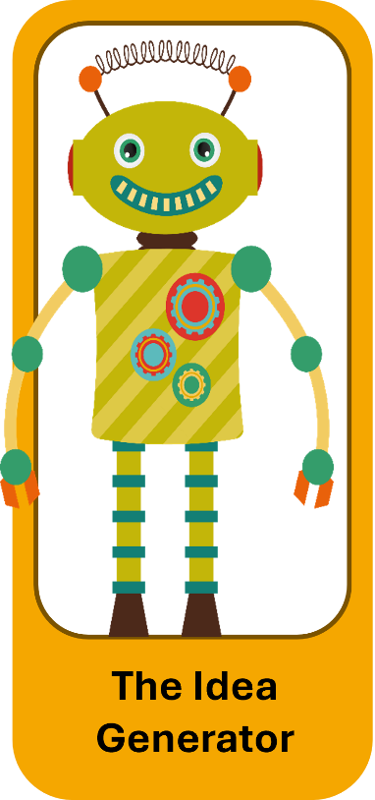 |  | The Idea Generator  What It Does: Brainstorms research questions, suggests theoretical frameworks, proposes novel connections, and offers interdisciplinary perspectives  Why It's Tempting: Unlimited 24/7 brainstorming partner, suggests creative ideas, breaks through mental blocks  Ethical Blind Spots:  Originality Questions: Is this your insight, AI's, or from the interaction?  Feasibility Reality: AI doesn't know your resources, timeline, or constraints.  Field Contribution: AI might suggest "novel" ideas already explored.  How to Use Responsibly:  - Treat AI ideas as raw material needing your expertise.  - Reality-test with advisor and peers who know your constraints.  - Do thorough literature searches on AI suggestions.  - Attribute clearly in your documentation.
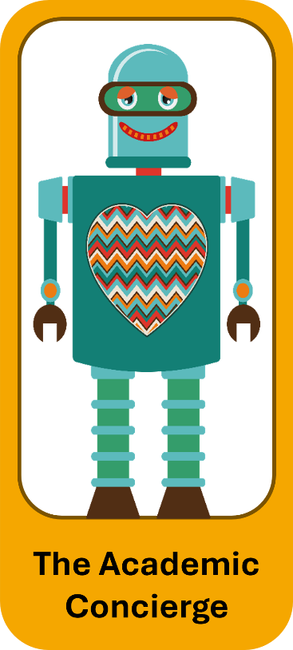 | The Academic Concierge  What It Does: Formats citations, grammar checks, manages administrative writing, tracks deadlines, and creates templates  Why It's Temping: Reduces formatting stress, ensures professional presentation, and frees mental energy  Ethical Blind Spots:  Skills Atrophy: Are you losing important academic competencies?  Quality Control: AI "hallucinates" citations, invents DOIs, and gets dates wrong.  Professional Development: Learning these systems is part of training.  How to Use Responsibly:  - Maintain competency: Do tasks manually regularly.  - Always double-check, especially citations.  - Follow the 70/30 rule: You practice 70%, AI handles 30%.  - Use saved time to develop higher-level skills.

