Fostering Pre-service Teachers' AI
Literacy: Lessons to Build Knowledge
and Confidence
  - Sohheon Yang, Alyse Harris, and Leonardo Alba-Lopez, Indiana University Bloomington

Overview
"Teaching with Technology" is an undergraduate course for pre-service teachers (PSTs) across all education majors. This paper details our approach to fostering PSTs’ Artificial Intelligence (AI) literacy and confidence by introducing foundational concepts, applications, and ethics. The curriculum integrates interactive digital tools to foster PSTs' engagement and critical thinking regarding AI. PSTs investigate concepts such as machine learning, create custom models using Teachable Machine, explore tools for AI education, discuss ethics, and develop AI guidelines for their future classrooms. Through hands-on activities, discussions, and reflection, PSTs deepen their understanding and demonstrate competency. Desired outcomes include increased AI literacy and confidence. Assessment includes observation of in-class activities and reflections.
Topics: AI literacy, machine learning, AI application, AI ethics
Time: Three 75-minute sessions

Materials & Setup
- Open classroom space for students to move around in small groups of 3–4 students.
- Computer with internet and a webcam. (A microphone is optional for audio projects.)
- Learning management system
- Session 1 slides: AI and Machine Learning
- Session 2 slides: AI Literacy Packet
- Session 3 slides: AI Ethics and Guidelines
- Poster design program (e.g., Canva, Google Slides)
- Paper and markers or pencils (for physical poster)

Context-at-a-Glance
Setting
Technology Integration Course for PSTs
Modality
Face-to-face
Class Structure
Three 75-minute sessions across a 16-week course with seven sections, adapted by five instructors
Organizational Norms
This required course prepares PSTs for state computer science standards and technology-integrated instruction.
Learner Characteristics
An average of 24 mostly first-year PSTs. Generally new to AI, with various elementary, secondary, special education, and counseling focuses
Instructor Characteristics
Four doctoral students and one faculty member with diverse teaching backgrounds
Development Rationale
Despite growing research on AI literacy, effective teaching practices remain limited (Lee et al., 2021), posing pedagogical challenges for teachers and cognitive challenges for students (Micheuz, 2020). Consequently, targeted research and instructional strategies are essential to prepare PSTs to teach AI’s benefits and limitations effectively.
Design Framework
Experiential hands-on learning addresses (Kolb, 1984).

Standards
This instruction aligns with the ISTE standard for educators 2.6, Facilitator: “Educators facilitate learning with technology to support student achievement of the 2016 ISTE Standards for Students” (ISTE, 2024).

Context and Setting

Curriculum Design Rationale
Over recent years, AI technologies attracted sustained scholarly and public attention due to their expanding capabilities and applications across diverse sectors. These technologies have permeated our lives in numerous ways, supporting a wide range of tasks, from generating written content (Brown et al., 2020) and predicting climate patterns (Domingos, 2015) to supporting medical diagnostics (Holmes, 2019) and enabling chatbot-based and biometric services (Miao et al., 2021). It is not surprising that multiple fields have embraced this technology since it can make our lives easier and encourage economic growth (European Commission, 2020). Education is no exception to this trend.
AI technologies are not new in the field of education. AI-based educational tools can be traced back more than three decades (Du Boulay, 2016). Nevertheless, Artificial Intelligence in Education (AIED) has gone through several AI winters,” periods during which funding and development slowed considerably (Holmes, 2019). This has changed considerably over the last decades with the emergence of more sophisticated computers and big data (Gillani et al., 2023; Holmes, 2019), making AI literacy an essential set of competencies to acquire across any professional field.
According to Long and Magerko (2020), AI literacy is the set of skills necessary to critically evaluate, ethically use, and effectively communicate and collaborate with AI technologies. And although AI technologies are becoming embedded in everyday life and professional practice, society's understanding of these technologies is still limited. Recent studies have highlighted misconceptions and uncertainty surrounding what AI is and how it works (West, 2018).
Thus, the unknowns of AI underscore the need for instructional materials and programs designed to understand both the potential and the limitations of these technologies. In this regard, educators could play a key role as the integration of AI into teaching and learning has rapidly shifted from a speculative idea to more tangible possibilities, leading to transformation in learning settings (Busuttil & Calleja, 2025; Roll & Wylie, 2016).
Recent research has explored how to promote AI literacy in K-12 settings. Ho et al. (2019), for instance, explored the activities that benefit learners’ understanding of what AI is. They found that unplugged activities related to facial recognition and basic robotic exercises positively favor learners’ understanding of AI technology. Van Brummelen et al. (2021) examined how middle and high school students’ perceptions of Alexa change by programming their own agents in AI workshops. Findings showed strong correlations between students’ perceptions of Alexa’s friendliness and trustworthiness, and safeness and trustworthiness. In another study, Kim et al. (2022) explored middle school learners’ evolving perceptions of AI during a summer camp experience. They identified five common perceptions: AI as automation and robotics, AI as a universal solution, AI as inherently intelligent, AI as capable of using all data, and AI as unrelated to ethics. These findings highlight the importance of understanding students’ preconceptions when designing AI curricula for K–12 contexts.
Despite the growing body of research on AI literacy, evidence on effective AI teaching practices remains limited (Lee et al., 2021). Teaching and learning AI concepts still present pedagogical challenges for educators and cognitive challenges for students (Micheuz, 2020). Therefore, additional research and the development of targeted instructional activities and strategies are needed to better prepare both PSTs and in-service teachers to teach about AI technologies effectively.

Detailed Instructional Context
To address the pedagogical challenges that AI poses to educators, we designed a three-session AI module. This was integrated into a technology integration course offered to PSTs in the teacher preparation program at Indiana University Bloomington.
Offered during the fall and spring semesters, EDUC-W 200 enrolls up to 24 students across each of seven in-person sections. Most students are in-state, white, female freshmen. This mandatory course for all education majors allows for interaction with students of diverse backgrounds and varying technological skill levels. Indeed, responses to a technology skills survey based on the ISTE standards, which PSTs complete at the beginning of each semester, have yielded critical information regarding PSTs’ technology skills over the past three years. Results have shown us that there are fluctuating levels of technological competence, ranging from basic to intermediate levels. However, we have observed that there is a set of competences that are typically limited among PSTs, AI literacy. Hence, these findings along with the pedagogical challenges that AI technology poses to educators motivated us to design the three-session AI module.
The AI module was designed by three doctoral students of the program in instructional technology. Prior to their doctoral studies, they had accumulated extensive teaching experience across various educational levels, including early childhood, secondary, higher, and adult education. They developed AI literacy through specialized coursework, workshops, and research groups, gaining a foundational understanding of AI mechanisms, applications, and ethics. The team refined the content through weekly meetings and feedback from faculty experts in instructional technology. While main activities occur in class, the course also supports self-directed learning through tool exploration and post-class reflection exit tickets.
The course is organized into five overarching units: 1) foundations, 2) learning experience design, 3) technology integration for various contexts (e.g., assessment), 4) Computer Science (CS) and AI, and 5) data science and contemporary issues. This course, which is taught by five instructors in the instructional technology program (four doctoral students and one faculty member) with diverse teaching backgrounds, aims to equip PSTs with the knowledge, skills, and experiences needed to integrate technology effectively into learning environments. The three-session AI module, which is part of a larger unit focusing on CS, introduces PSTs to foundational concepts related to AI technology, AI in education, and AI ethics. The modules have gone through various design iterations based on our observations of how students respond to the activities and class dynamics, allowing us to adapt them to student needs and rapid changes of AI technology.
Additionally, through experiential learning, the module seeks to develop PSTs’ AI literacy, curiosity, but more importantly, their confidence and familiarity with AI for educational purposes. This is in alignment with the state requirements regarding the preparation of PSTs on CS and technology-integrated instruction.

Learning Representation

Session 1: machine learning with Teachable machine

Background and Introductory Activity (25 Minutes)
The first session focuses on an introduction to AI. This first main activity introduces PSTs to the concept of machine learning using Teachable Machine, a web-based tool created by Google that allows users to build simple machine learning models without needing prior programming knowledge (Google Creative Lab, n.d.).
Before the main activity, the session begins with an introductory activity called “What Uses AI?” developed by the AI Goes Rural research team at Indiana University Bloomington (AI Goes Rural, 2022). The activity includes slides titled “What uses AI?” followed by several examples such as Siri, Toaster, industrial robots, Netflix, and more (see Figure 1).
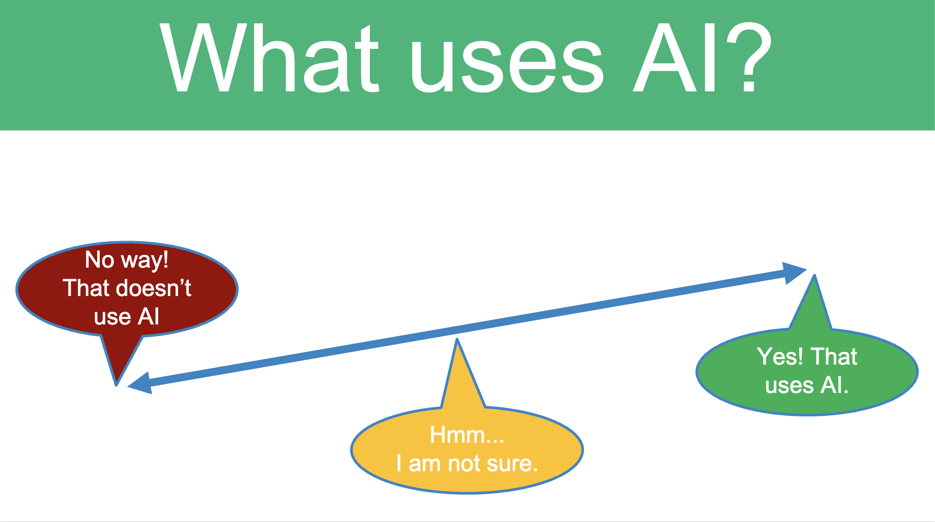
Figure 1. What Uses AI? Note. Adapted from “AI vs. Not AI” (pp. 6-17), by AI Goes Rural, 2022, Indiana University. Copyright [2026] by The Trustees of Indiana University.
PSTs move around the classroom based on their thoughts (e.g., front: “Yes! That uses AI,” middle: “Hmm... I’m not sure,” back: “No way! That doesn’t use AI.”). Alternatively, PSTs may use hand gestures from their seats to respond to the instructor's prompts. The main focus of the activity is not simply categorizing items as AI or not, but rather engaging in discussions about what makes something intelligent. For example, although a regular toaster does not use AI, you can ask PSTs, “If we make an AI toaster, what would make it intelligent?”
After the introductory activity, PSTs are introduced to the basic concepts of AI and the three main types of machine learning: supervised learning, unsupervised learning, and reinforcement learning. At this point, PSTs also learn that AI systems rely heavily on large volumes of data to identify patterns and that the quality of input data significantly affects the output and accuracy of AI models.

Main Activity (50 Minutes)
Once the instructor introduces the basic concepts of machine learning, they have PSTs move into hands-on exploration using Teachable Machine, focusing on supervised learning. This step serves as the concrete experience stage within the experiential learning cycle. For the first 15 minutes, the instructor demonstrates how to use Teachable Machine with a standard image model. A simple example includes creating a model that classifies happy and sad faces for a quick demonstration, using either a webcam or uploaded images.
- Step 1: Training Data—The instructor labels Class 1 and Class 2 based on the type of model they want to create. They should explain that this represents supervised learning, as labeled data is required to train the model. They should also note that additional classes can be added if necessary. For instance, they renamed Class 1 as “Happy Face” and Class 2 as “Sad Face,” (see Figure 2). They then used a webcam to record sample images of each expression. To build a robust model, they can record their own face as well as several PSTs' faces.
- Step 2: Model Training—After collecting training data, the instructor clicks “Train the model” to build the model.
- Step 3: Testing the Model—The instructor emphasizes that test data must be distinct from training data. This step offers an opportunity to discuss the limitations of AI, especially if the accuracy of the model is quite low, and to explore ethical considerations. PSTs consider why the model may have failed (e.g., insufficient or biased training data) and what can be done to improve it (e.g., collecting more diverse data). For example, in the “Happy Face vs. Sad Face” model, a teaching assistant and PSTs not involved in the initial training can be invited to test the model using their own expressions.
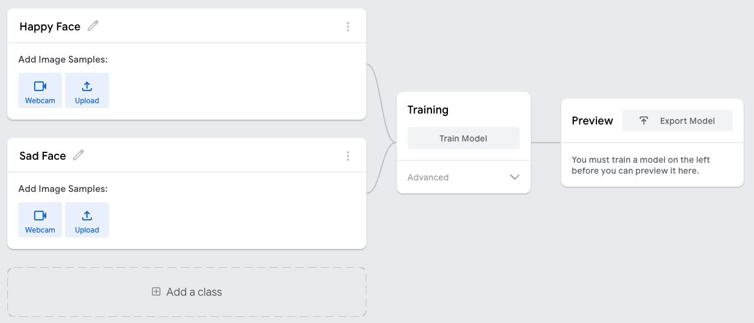
Figure 2. Teachable Machine Interface. Note. From “Teachable Machine,” by Google, n.d.
For the next 20 minutes, PSTs are encouraged to build their own machine learning models individually or in pairs. They are invited to experiment with different project types offered by Teachable Machine, such as image, audio, or pose recognition, and to brainstorm how these tools could be integrated into their future classrooms. While PSTs work on their projects, the instructor goes around to check in and provide personalized feedback. Laptops work best because they have built-in webcams and microphones. If PSTs cannot use laptops for any reason, the instructor should prepare a webcam and/or microphone connected to a desktop in the classroom.
In the final 15 minutes, PSTs share their projects with the class. This step serves as reflective observation of their own work and that of other PSTs, which allows them to further co-construct knowledge of machine learning. In their projects, they frequently used their own bodies (e.g., facial expressions, gestures, poses), nearby objects (e.g., tumblers, glasses), or internet images (e.g., animals) as input data. Figure 3 shows PSTs working on the audio project to build a machine learning model classifying high and low voices.
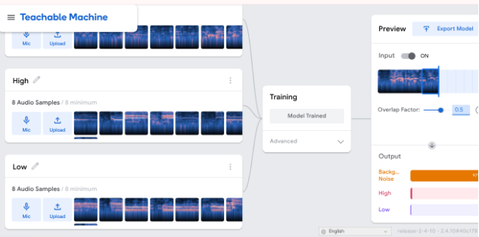
Figure 3. Audio Project Example: High and Low Voices
Figure 4 shows PSTs working on the pose project to build a machine learning model classifying peace signs as class 1 and heart signs as class 2. They also brainstormed ideas for integrating it into the classroom, such as creating different emotions and recognizing them for early elementary students.

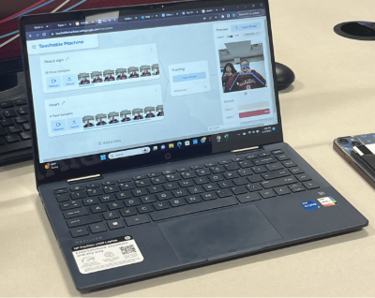
Figure 4. Pose project example: Peace signs and heart signs.

Adaptations and Extensions
The main activity can be flexibly adapted based on instructors’ goals, PSTs’ needs, or classroom contexts. Below are examples of how the activity might vary in implementation, content focus, or tool use.
First, instructors may pre-select and set up the training and testing datasets based on their instructional objectives. These preselected datasets can be printed out for use during instruction to ensure accessibility for all or saved in a shared cloud folder so that PSTs can download and use them for their projects. For example, to emphasize ethical considerations, instructors may use the "Introduction to Supervised Machine Learning and Algorithmic Bias" activity from the material “An Ethics of Artificial Intelligence Curriculum for Middle School Students” developed by the MIT Media Lab (2019), in which PSTs examine AI bias by training a model with cat and dog image data using Teachable Machine.
Second, instructors may connect this project with micro:bit for a tangible activity in a workshop called “Teaching and Learning about AI with Tangible Approaches,” which was developed by the AI Goes Rural research team (2025). This activity allows PSTs to develop their own machine learning model with Teachable Machine, then extract the model and connect it to a micro:bit so they can see how their machine learning model works with tangible outputs from the micro:bit, such as turning lights on and off using block-based coding.

Session 2: Tools for AI Literacy

Background and Introductory Activity (25 Minutes)
The second session focuses on how AI is taught and used in K-12 classrooms. The main activity allows PSTs to explore tools for AI literacy (hereafter referred to as the AI Literacy Packet) that can potentially be used in PK-12 education. The AI Literacy Packet includes a variety of web-based tools, such as AI curricula, generative AI applications, AI-powered tools, machine learning education tools, and educational AI assistants, which are further described in the next section.
Before the main activity, the session begins by introducing the concepts of learning about AI, learning with AI, and the broader idea of AI literacy, defined as “a set of competencies that enables individuals to critically evaluate AI technologies; communicate and collaborate effectively with AI; and use AI as a tool online, at home, and in the workplace” (Long & Magerko, 2020, p. 598).
Next, the Artificial Intelligence for K-12 initiative (AI4K12) is introduced. This initiative, jointly supported by the Association for the Advancement of Artificial Intelligence (AAAI) and the Computer Science Teachers Association (CSTA), serves as a national guideline for teaching AI in K-12 schools. AI4K12 outlines five Big Ideas in AI: “Perception, Representation & Reasoning, Learning, Natural Interaction, and Societal Impact” (AI4K12 Initiative, 2020). PSTs, working in small groups composed of peers from the same major, are encouraged to explore and analyze the AI4K12 guidelines in alignment with their targeted learners’ grade levels. Their discussion is guided by the following five questions (see Figure 5): (1) What do you notice? (2) Is there anything surprising? (3) Is there anything that concerns you? (4) Are there any guidelines that you value most? and (5) Do you have any ideas about how to integrate these guidelines into your future teaching practice?
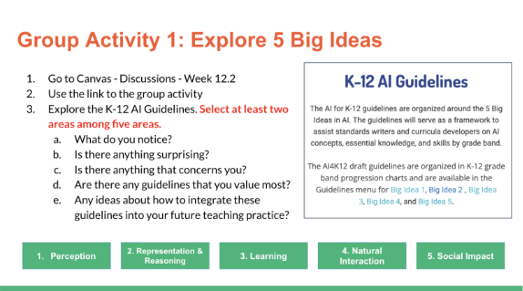
Figure 5. Instruction on exploring AI4K12 five big ideas.

Main Activity (50 Minutes)
After instructors introduce the AI4K12 guidelines, PSTs are encouraged to explore the AI Literacy Packet. This serves as the concrete experience of exploring digital tools for AI education. For this main activity, the instructor first creates a slide that includes hyperlinks to various tools. The slide is organized into five areas, as shown in Figure 6.
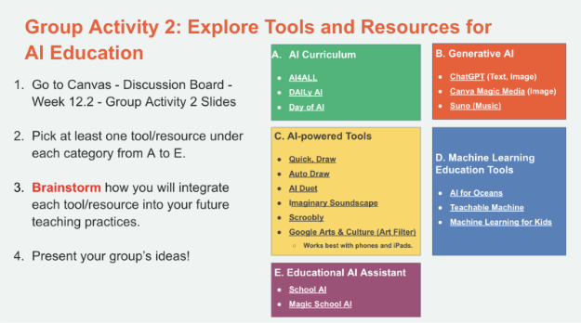
Figure 6. AI literacy packet.
First, the AI curriculum section includes examples of existing curricula developed by other institutions such as AI4ALL, DAILy AI, and Day of AI. Second, the generative AI section includes AI that allows users to generate text, images, or music, such as ChatGPT (text and image), Canva Magic Media (image), and Suno (music). Third, the AI-powered tools section comprises web-based tools that are powered by AI, enabling users to experiment with tools for diverse purposes, including drawing, music play, and artistic endeavors. They include Quick Draw, Auto Draw, Scroobly, and more. Fourth, the machine learning tools include web-based platforms where users can learn the concept of supervised learning without needing concrete skills in machine learning, such as Teachable Machine and AI for Oceans. Fifth, the educational AI assistant is an AI chatbot specifically tailored for educational settings, such as School AI and Magic School AI.
For the first 25 minutes, the instructor has PSTs, working in small groups, freely explore different tools in each section, and document their ideas about how to integrate these tools into PK-12 classrooms, considering the subject area, targeted learners, learning objectives, a brief description of an activity, and any additional comments, concerns, or questions. This small group leverages reflective dialogue and shared leadership by exchanging their curriculum ideas. During the activity, the instructor encourages them to actually try out the tools and discuss them. For the last 25 minutes, the instructor has PSTs come to the front to share their ideas and demonstrate the tools they chose to the entire class.
For example, PSTs suggested that Quick Draw could be used as a brain break for early elementary students, SchoolAI could be used as a bellringer, and Canva Magic Media could generate background images for stories that their students created in an ELA class. They also demonstrated critical thinking by questioning whether generative AI might replace students’ or teachers’ creativity. Furthermore, they noted that Teachable Machine may not always be accurate and might require re-training, and considering whether some tools are being used merely for fun rather than for educational purposes.

Adaptations and Extensions
This activity can be implemented using different approaches. First, the instructor can demonstrate selected tools before having PSTs explore them freely. In this case, the activity can be structured so that PSTs follow the instructor’s demonstration and then try the tools themselves.
Also, considering the limited time to cover all digital tools and discuss their integration into the curriculum in one session, the instructor should be flexible in managing it. The session could be spread over multiple days for in-depth discussion, or utilize flipped learning with pre-assigned readings (e.g., real-life examples of AI education with a specific tool) and hands-on experience outside of the classroom.
Lastly, the instructor can design this activity as either a group activity or an individual activity, depending on whether the focus is on group discussion or on individual autonomy in choosing tools.
Additionally, the instructor can use different platforms to provide the AI Literacy Packet. In the example above, we used Google Slides for PSTs to access and try out the tools. Other options include Padlet, and Microsoft Whiteboard (see Figure 7).
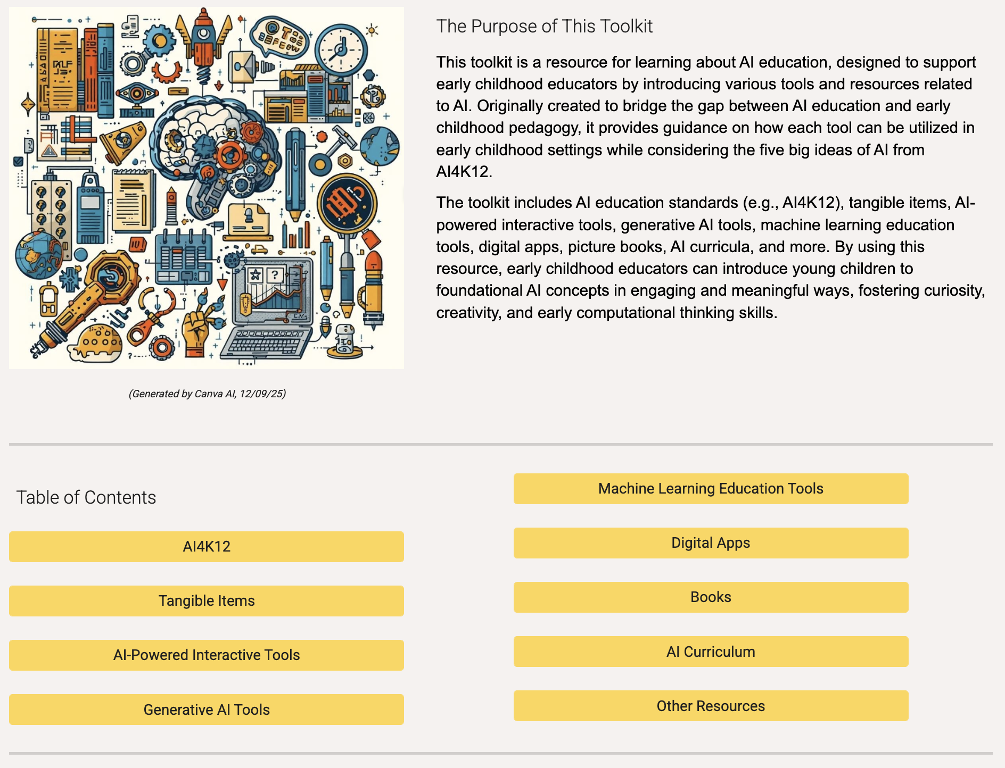
Figure 7. Google Sites for AI literacy packet developed by an instructor.

Session 3: Designing Your Classroom
Guideline Poster

Background and Introductory Activity (30 Minutes)
The third session focuses on AI ethics, including topics such as responsibility and ethical use, AI bias, and privacy. The main activity helps PSTs understand state-level guidelines on AI in education and apply that knowledge to their future classrooms using visualization tools such as Canva, Microsoft PowerPoint, or Google Slides.
Before the main activity, the session begins with a “Which side of the line are you on?” activity. The instructor displays a screen presenting various scenarios that require ethical consideration regarding the use of AI in education. Then, PSTs move to the front (ethical), back (unethical), or middle (unsure) of the classroom based on their judgment for each scenario and share their thoughts and rationale. Here is a descriptive list of the cases (see Figure 8):
- Student: writing a paper
- Student: generating ideas for assignment
- Student: critiquing/giving feedback on own assignment
- Teacher: giving feedback on a student’s assignment
- Teacher: grading students' work
- Teacher: creating a rubric or a test
- Teacher: creating entire lesson plan
- Student: responding to discussion post
- Teacher: responding to discussion post
- Teacher: writing reference letters for students
- Teacher: creating examples of an assignment
- Student: creating slides for a presentation
- Teacher: creating slides for a presentation
- Teacher/Student: generating art for a presentation:
- Teacher/Student using as a source in research
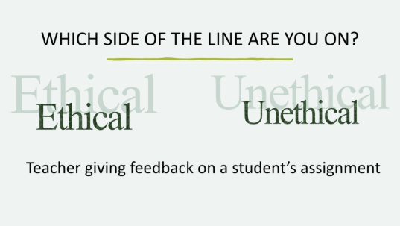
Figure 8. AI ethics: Which side of the line are you on?

Main Activity (45 Minutes)
Once PSTs look back on their own philosophy on ethical considerations around AI use in education, they move on to getting to know the state-level AI guidelines. In our case, the Indiana Department of Education (n.d.) provides AI guidelines on its website (https://www.in.gov/doe/educators/digital-learning). The materials are shared with PSTs in various ways, such as through a shared cloud folder or a learning management system (e.g., Canvas). Then, they are guided to design their own classroom AI guideline poster in small groups with peers from the same major. This activity incorporated situated learning, as PSTs developed their own AI guidelines within the specific context of their future classrooms. The instructor introduces various materials that could be used for PSTs to create visually appealing posters. For instance, many PSTs experimented with Canva, Google Slides, or Microsoft PowerPoint. The details of the instructions for designing your classroom AI guideline poster are shown in Figure 9.
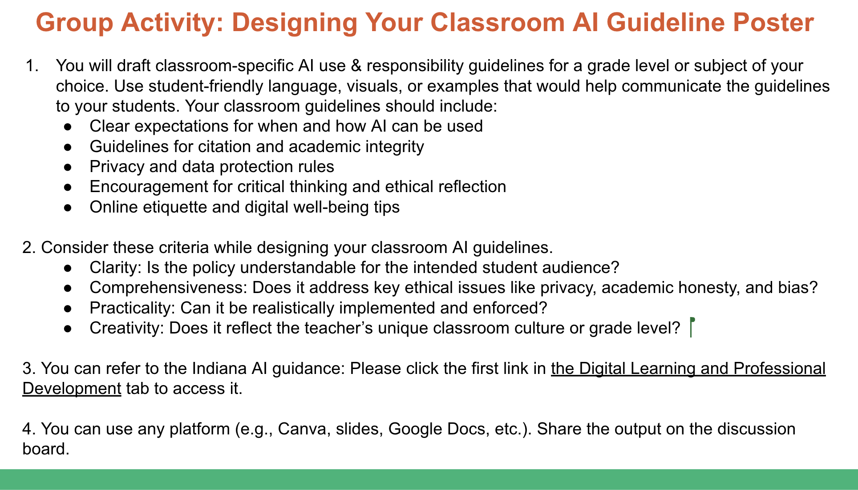
Figure 9. Instruction for designing your classroom AI guideline poster.
From a classroom observation, it was noted that PSTs attempted to apply their knowledge and express their beliefs about the use of AI in education when composing guidelines for their future classrooms. For example, some secondary education majors emphasized ethical and honest AI use by requiring their future students to share the prompt they used. They also emphasized, “AI is a tool, not a replacement" (see Figure 10).
Others, particularly elementary education majors, took a stricter stance, including guidelines such as “ChatGPT is not allowed unless specifically instructed” and “AI will not be used for research or writing activities” (see Figure 11). Their rationale was that younger students are still developing foundational thinking and writing skills.
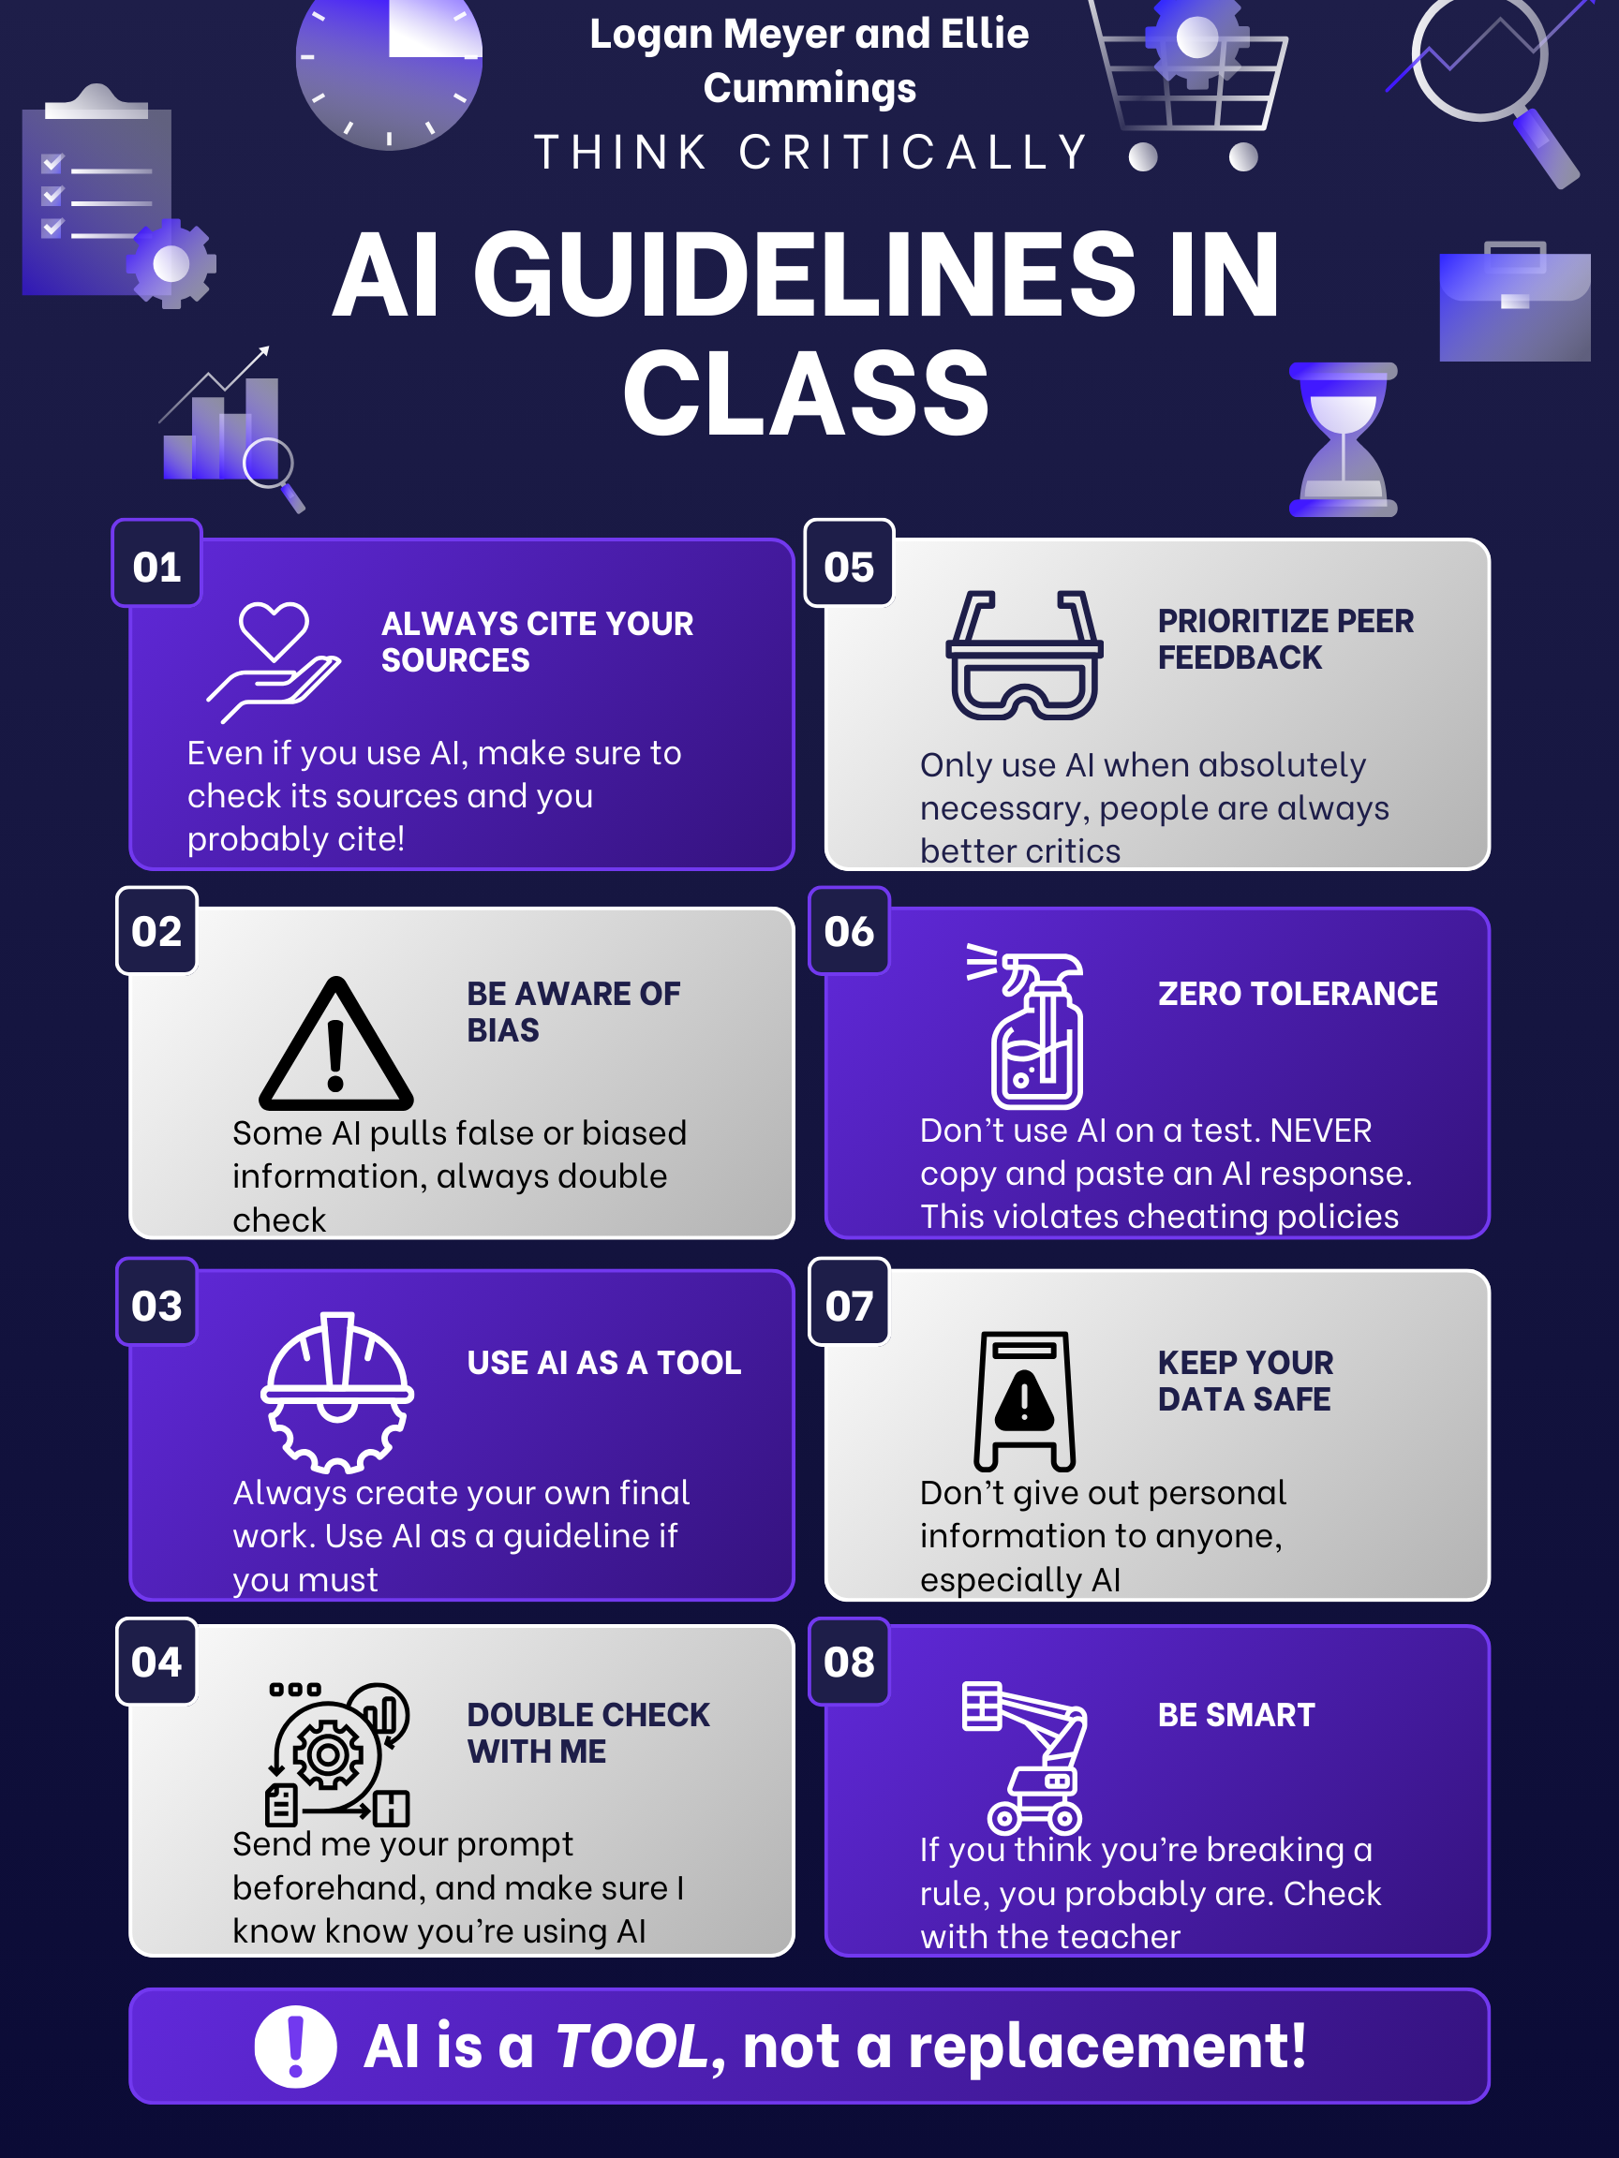
Figure 10. AI guideline from secondary major PSTs.
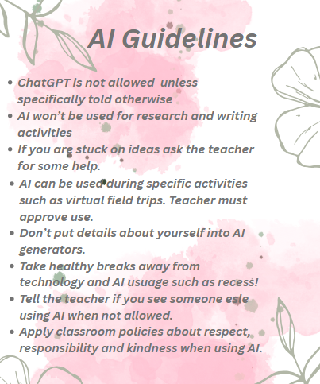
Figure 11. AI Guideline from Elementary Major PSTs
PSTs also went further by addressing issues of plagiarism and the importance of citation to promote academic honesty. They emphasized the need for critical thinking, verifying AI-generated content, and recognizing potential AI bias. Additionally, they highlighted digital privacy concerns, noting that students should not share personal information and should be cautious about their privacy and digital well-being.

Adaptations and Extensions
The instructor provides multiple modes of materials for creating a guideline poster, including both digital and analog options. For example, while some classes offer digital tools such as Canva, Google Slides, or Microsoft PowerPoint, others provide paper, pencils, and markers for PSTs to create AI guideline posters. These options allow for flexible applications depending on the classroom environment or PSTs’ preferences for learning materials, whether digital or analog. An example of a paper-based project is shown in Figure 12.
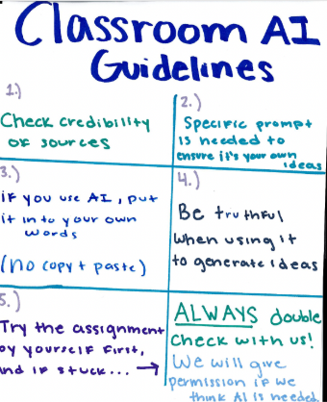
Figure 12. AI Guideline Paper Version.
Regarding AI guidelines, we used the AI guidelines provided by the Indiana Department of Education as a state-level guideline. If other states have different guidelines, those can be used as well. Other options include utilizing existing frameworks, such as the AI Competency Framework for Students developed by UNESCO (2024), which includes four dimensions: “A human-centered mindset,” “Ethics of AI,” “AI techniques and applications,” and “AI system design,” along with three progression levels: “Understanding,” “Applying,” and “Creating.” PSTs would read the materials and develop their own guidelines and philosophy for AI in their classrooms, considering what to focus on.

Critical Reflection

Reflection on Designed Activities
The design and implementation of the lessons successfully met the goals of our lesson development. Five instructors implemented the lessons seven times during spring 2025. The purpose of these activities is to improve PSTs’ AI literacy by enabling them to understand, use, critically evaluate, and collaborate with AI (Long & Magerko, 2020). Each activity works to build foundational knowledge of AI and machine learning and raise awareness of AI ethics and how to apply it in their future classrooms. Considering these goals, assessment opportunities include classroom observations and exit tickets. Overall, our lessons met our primary objective of developing PSTs’ ability to critically evaluate and articulate positions on AI use in education. However, objectives related to applying AI tools within concrete instructional designs were only partially met, indicating a need for additional scaffolding.
Two activities were most successful and resonated with students and instructors. The “AI Ethics: Which Side of the Line are You On?” activity was a particular success because of the in-depth discussion it prompted. Students positioned themselves across the spectrum, with some being open to AI use in various forms and others staunchly opposed to AI. Students shared personal examples of times they used AI, including support with learning disabilities, understanding difficult concepts, or just-in-time support for schoolwork. Others shared ethical considerations beyond the scenarios presented, namely, the environmental and social impact of AI use on the environment, and creative professions such as art and writing. This activity led to conversations about the purpose of education and teachers in society. These discussions synthesized concepts we discussed throughout the unit and created a strong basis for the next activity, where students design a classroom poster articulating their AI Philosophy. The lesson order allowed students to learn the basics of how AI worked before discussions about ethics. By understanding how AI works—using data to find patterns and make predictions, students considered the various perspectives and ethical considerations. These design decisions contributed to successful conversations.
The “Designing Your Classroom AI Guideline Poster” was also especially effective because it allowed PSTs to practically consider what aspects of AI they might address in their own classrooms. This included anticipating the challenges they may face with AI, given the evolving nature of AI in society, as well as the potential benefits for both teachers and students. This activity highlights the way PSTs became familiar with a variety of issues related to AI ethics, reflected on their own values, and connected these insights to their classroom practices. Instructors also identified several opportunities for improvement.
During the second activity, “Tools for AI Literacy,” PSTs generally brought broad ideas about how to integrate tools into their practice. While the activity was effective in exposing them to new tools, the depth of connection to their own practice was relatively limited. Based on this reflection, instructors who are continuing to teach the course plan to adjust the activity by providing PSTs with more time and structure to consider how to integrate a tool of their choice. Instructors designed a lesson design template that included the title, targeted learners, learning objectives, connection to AI4K12 guidelines, and lesson flow. This adjustment enables PSTs to generate more practical ideas and make stronger connections between what they learned and their future teaching practice.
One key area for improvement that emerged was supporting PSTs in making deeper and more meaningful connections between AI tools and their own teaching practice. While the activity was effective in exposing them to new tools, the depth of connection to their own practice was relatively limited. Based on this reflection, instructors who are continuing to teach the course plan to adjust the activity by providing PSTs with more time and structure to consider how to integrate a tool of their choice. Instructors designed a lesson design template that included the title, targeted learners, learning objectives, connection to AI4K12 guidelines, and lesson flow. This adjustment enables PSTs to generate more practical ideas and make stronger connections between what they learned and their future teaching practice. For example, Figure 13 shows how PSTs designed an ELA lesson integrating "Be My Eyes," a visual assistance app for blind or low-vision people. This activity included a rich description task where students take pictures and compare human descriptions with AI-generated descriptions.
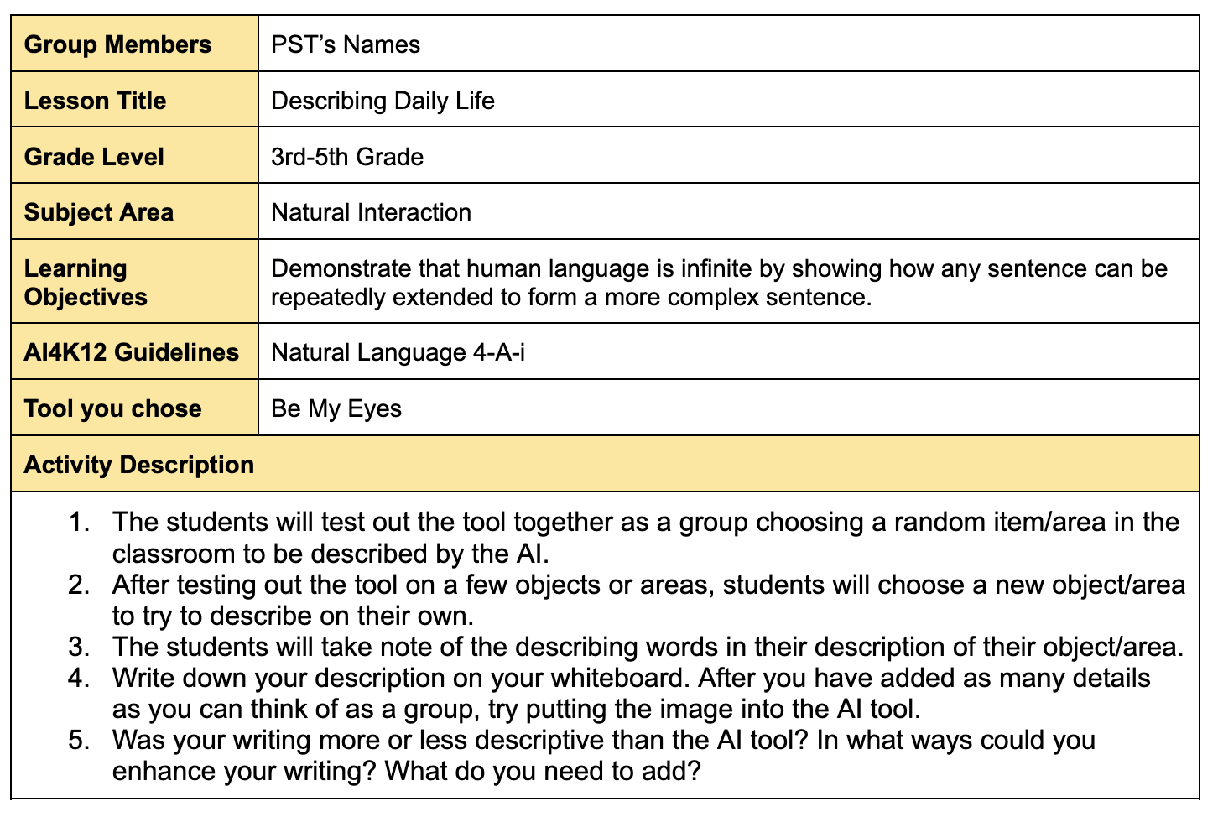
Figure 13. Brief Lesson Plan Integrating “Be My Eyes”

Reflection on PSTs’ Engagement and Learning
Throughout the two weeks of classroom observations, we observed PSTs sharing their philosophies on the use of AI in education, demonstrating their ability to understand and critically evaluate AI in educational contexts. They reflected on their current use of AI as college students and their future use of AI as teachers. Interestingly, many expressed critical perspectives on the use of AI, particularly regarding its potential to limit students’ abilities, such as creativity and writing skills, as well as concerns about its environmental impact.
For example, PSTs majoring in visual arts expressed genuine concern about preserving human originality and creativity. While they acknowledged that some digital tools can support the creation and sharing of art, several emphasized their strong belief that human originality and creativity should take precedence over AI and stated that they would avoid using AI in their classrooms. Similarly, PSTs majoring in English Liberal Arts expressed concerns about the impact of AI on students’ writing development. They noted that K-12 is a critical stage for building foundational writing and critical thinking skills. As a result, some wanted to prohibit the use of AI altogether, while others preferred a more balanced approach, encouraging both human and AI-assisted writing while emphasizing the importance of critical thinking, verification, and proper citation. Some PSTs demonstrated awareness of the environmental issues associated with AI, noting that it consumes large amounts of energy, electricity, and water, and raised fundamental concerns about the use of AI itself.
Additionally, the exit ticket asked PSTs to reflect on the ultimate goal of AI education, factors to consider in its implementation, and ethical considerations for using AI in the classroom (see Figure 14). Although the exit ticket was designed after the first two activities and before the deeper exploration of AI ethics, PSTs were still able to share their initial thoughts on ethical issues related to AI.
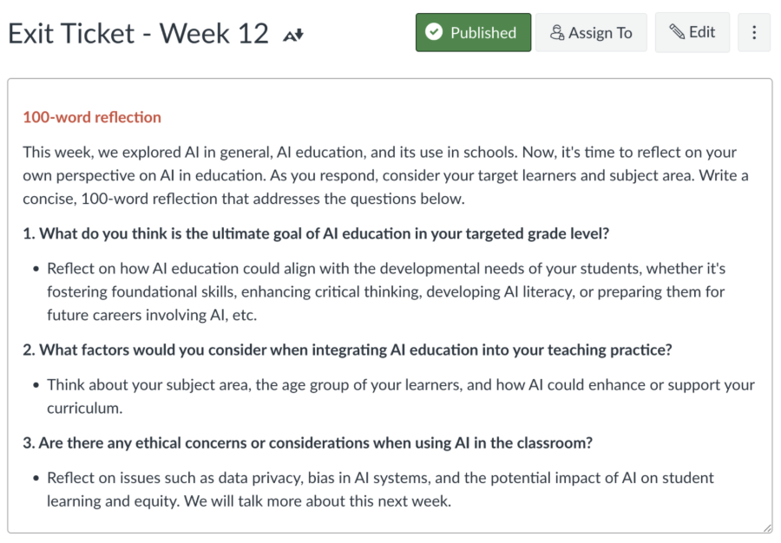
Figure 14. Exit Ticket Instruction
PSTs’ reflections varied by major and prior experience. They identified goals of AI education such as developing AI-related knowledge and skills (e.g., how AI works, responsible and ethical use), subject-related skills (e.g., literacy, locating resources), and broader competencies like curiosity, problem-solving, and creativity. In their teaching practice, they emphasized developmentally appropriate approaches, hands-on and interactive learning, playfulness, and limiting screen time for young children. They also expressed concerns about irresponsible or overly reliant use of GAI, cheating, reduced creativity, privacy issues, environmental impact, human replacement, inequitable access for low-income students, digital safety, fairness, and bias.

Implementation Tips
Given the number of instructors and the wide variety of student interests, the included activities are designed to be flexible and adaptable across many different contexts and environments. A particular strength of our activities is the “Adaptation and Extension” sections, which offer guidelines to tailor the activities to meet classroom or instructor goals. Instructors implementing these activities should also plan ample time for discussion, establish clear norms for respectful disagreement, and be prepared to facilitate conversations that extend beyond predefined scenarios. Small-group discussion before whole-class dialogue may further support participation from quieter students.

Future Modifications
When teaching these lessons in the future, educators could consider several modifications. Currently, the course is designed as a survey course offering a brief overview of many topics. However, AI education and literacy are complex and warrant deeper exploration. The activities described here primarily focus on in-class engagement, but opportunities exist to extend learning beyond the classroom. For example, the lessons could incorporate homework or a flipped classroom model, allowing learners to explore AI tools independently before class without time constraints. Then, class time focuses on collaboration and discussions around how AI tools can be integrated into teaching practice. In our current iteration, some of this reflection occurs in the exit ticket assignment, but integrating this into whole-class or small group discussion could deepen and extend learning.

References
AI4K12 Initiative. (2020). Five big ideas in AI. AI4K12.org. https://ai4k12.org/
AI Goes Rural. (2022). AI for good summer camp. AI Goes Rural. https://aigoesrural.iu.edu/ implementation-research/ai-for-good_ml1.pdf#heading=h.3928wjcxcepg
AI Goes Rural. (2025). 2025 Teaching and learning about AI with tangible approaches (artificial intelligence across Indiana K-12). AI Goes Rural. https://aigoesrural.iu.edu/implementation-research/index.html
Brown, T., Mann, B., Ryder, N., Subbiah, M., Kaplan, J. D., Dhariwal, P., ... & Amodei, D. (2020). Language models are few-shot learners. Advances in neural information processing systems, 33, 1877-1901. https://proceedings.neurips.cc/paper_files/paper/2020/hash/1457c0d6bfcb4967418bfb8ac142f64a-Abstract.html
Busuttil, L., & Calleja, J. (2025). Teachers’ beliefs and practices about the potential of ChatGPT in teaching mathematics in secondary schools. Digital Experiences in Mathematics Education, 11, 140-166. https://doi.org/10.1007/s40751-024-00168-3
Domingos, P. (2015). The master algorithm how the quest for the ultimate learning machine will remake our world. In Master Algorithm. (Online). Basic Books.
Du Boulay, B. (2016). Artificial intelligence as an effective classroom assistant. IEEE Intelligent Systems, 31(6), 76-81. https://doi.org/10.1109/MIS.2016.93
European Commission. (2020). Artificial intelligence – a European approach to excellence and trust [White paper]. https://commission.europa.eu/ document/download/d2ec4039-c5be-423a-81ef-b9e44e79825b_en?filename=commission-white-paper-artificial-intelligence-feb2020_en.pdf
Gillani, N., Eynon, R., Chiabaut, C., & Finkel, K. (2023). Unpacking the “black box” of AI in education. Educational Technology & Society, 26 (1), 99-111. https://doi.org/10.30191/ETS.202301_26(1).0008
Google Creative Lab. (n.d.). Teachable machine. Teachable Machine. https://teachablemachine.withgoogle.com/
Ho, J. W., Scadding, M., Kong, S. C., Andone, D., Biswas, G., Hoppe, H. U., & Hsu, T. C. (2019, June). Classroom activities for teaching artificial intelligence to primary school students. In Proceedings of international conference on computational thinking education (pp. 157-159). The Education University of Hong Kong.
Holmes, W. (2019). Artificial Intelligence in education. In A. Tatnall (ed.) Encyclopedia of education and information technologies. Springer. https:// doi.org/10.1007/978-3-319-60013-0_107-1
Indiana Department of Education. (n.d.). Digital learning and professional development. Indiana Department of Education. https://www.in.gov/ doe/educators/digital-learning/
ISTE (2024). ISTE standards for educators. International Society for Technology in Education. https://www.iste.org/standards/for-educators
Kim, J., Lee, H. & Cho, Y.H. (2022). Learning design to support student-AI collaboration: Perspectives of leading teachers for AI in education. Education and Information Technologies, 27, 6069–6104. https://doi.org/10.1007/s10639-021-10831-6
Kolb, D. A. (1984). Experiences as the source of learning and development. Prentice Hall.
Lee, I., Ali, S., Zhang, H., DiPaola, D., & Breazeal, C. (2021, March). Developing middle school students' AI literacy. In Proceedings of the 52nd ACM technical symposium on computer science education (pp. 191-197). https://doi.org/10.1145/3408877.3432513
Long, D., & Magerko, B. (2020). What is AI literacy? Competencies and design considerations. Proceedings of the 2020 CHI Conference on Human Factors in Computing Systems, 1-16. https://doi.org/10.1145/3313831.3376727
Miao, F., Holmes, W., Huang, R., & Zhang, H. (2021). AI and education: Guidance for policy makers. UNESCO. https://doi.org/10.54675/PCSP7350
Micheuz, P. (2020). Approaches to Artificial Intelligence as a subject in school education. In: T. Brinda, D. Passey, and T. Keane (eds.) Empowering teaching for digital equity and agency. OCCE 2020. IFIP advances in information and communication technology, vol 595. Springer, Cham. https://doi.org/10.1007/978-3-030-59847-1_1
MIT Media Lab. (2019). An ethics of artificial intelligence curriculum for middle school students. MIT Media Lab. https://docs.google. com/document/d/1e9wx9oBg7CR0s5O7YnYHVmX7H7pnITfoDxNdrSGkp60/edit?usp=sharing
Roll, I., & Wylie, R. (2016). Evolution and revolution in artificial intelligence in education. International Journal of Artificial Intelligence in Education, 26, 582-599. https://doi.org/10.1007/s40593-016-0110-3
Ruiz, P., & Fusco, J. (2024). Glossary of artificial intelligence for educators. Educator CIRCLS Blog. https://circls.org/educatorcircls/ai-glossary
UNESCO. (2024). AI competency framework for students. https://doi.org/10.54675/JKJB9835
Van Brummelen, J., Heng, T., & Tabunshchyk, V. (2021). Teaching tech to talk: K-12 conversational artificial intelligence literacy curriculum and development tools. Proceedings of the AAAI Conference on Artificial Intelligence, 35(17), 15655–15663. https://doi.org/10.1609/aaai.v35i17.17844
West, D. M. (2018). The future of work: Robots, AI, and automation. Bloomsbury Publishing USA.

About the Authors
Sohheon Yang is a Ph.D. Candidate at Indiana University specializing in Instructional Systems Technology. Her teaching practice focuses on early childhood and teacher education, with a particular emphasis on technology integration. Recently, she has been facilitating numerous workshops for pre- and in-service teachers on AI education. Her teaching and research aim to foster learners’ agency.
Alyse Harris is an instructional designer and educational researcher. Her teaching and research bridge theory and practice, focusing on practitioner preparation, equitable technology integration, and literacy development. Alyse is a Ph.D. Candidate at Indiana University, Bloomington, in Instructional System Technology.
Leonardo Alba-Lopez is a Ph.D. Candidate in the Instructional Systems Technology program at Indiana University Bloomington. He has 15 years of teaching experience across middle school, high school, and higher education contexts. His research interests focus on two primary strands. The first explores phenomena related to emergent technologies, digital literacy, gamification, and assessment, particularly in higher education. The second examines issues in teacher education, specifically how preservice teachers make decisions about instructional materials and educational technology integration.

Sharing & Modification Permissions
Unless otherwise noted, this article and its resources are published under a Creative Commons Attribution-NonCommercial-ShareAlike 4.0 International license:

You can freely share the article and its resources if you indicate the original authors, identify the Creative Commons license, and use them non-commercially.
You may also make and share modifications by:
- Identifying the original authors.
- Using the resources non-commercially.
- Licensing modifications under the CC BY-NC-SA 4.0 license (and including a link to it).
- Indicating what modifications were made.

